

SOFTWARE REQUIREMENT SPECIFICATION
Boarding House Management Platform
(InnolviaHomie)

Group 5 | SE2014 - NJ
Phạm Anh Tú - HE191044
Lê Thị Thùy Linh - HE191529
Bùi Cửu Đỉnh - HE194782
Nguyễn Minh Quốc - HE195063
Nguyễn Minh Nhật - HE191922

– Hanoi, June 2026 –
Table of Contents
I. Record of Changes 5
II. Glossary and Legend 6
1. Glossary 6
2. Legend 7
2.1. Context Diagram 7
2.2. Business Process Diagram 8
2.3. Use Case Diagram 9
2.4. ERD Diagram 10
3. List figure and table 10
III. Software Requirement Specification 12
1. Overall Requirements 12
1.1 Context Diagram 12
1.2 Main Business Processes 13
1.2.1. Contract & Tenant Management 13
1.2.2. Meter Reading Flow 15
1.2.3. Invoice & Online Payment Flow 17
1.2.4. Ticketing / Incident Management 19
1.2.5. Room & Facility Management 21
1.3 User Requirements 23
1.3.1 Actors Generalization 23
1.3.2 Actors 23
1.3.3 Use Cases (UC) 24
1.3.4 Use Case Diagrams 27
1.3.4.1 UCs for Admin 27
1.3.4.2 UCs for Manager 27
1.3.4.3 UCs for Tenant 27
1.3.4.4 UCs for Operator 27
1.4 System Functionalities 28
1.4.1 Screens Flow 28
1.4.1.1 Admin Screens Flow 28
1.4.1.2 Manager Screens Flow 29
1.4.1.3. Tenant Screens Flow 30
1.4.1.4 Operator Screens Flow 30
1.4.1.5 Screen Descriptions 30
1.4.2 Screen Authorization 32
1.4.3 Non-UI Functions 33
1.5 Entity Relationship Diagram 34
2. Use Case Specifications 36
2.1. Authentication & User Access 36
2.1.1 UC: Forgot Password 36
2.1.2 UC: Login 36
2.1.3 UC: View Profile 37
2.1.4 UC: View Dashboard 38
2.1.5 UC: Logout 38
2.2. Administration & System Management 39
2.2.1 UC: Create Personnel 39
2.2.2 UC: View Personnel 41
2.2.3 UC: Update Personnel 42
2.2.4 UC: View Revenue Report 43
2.2.5 UC: Create Facility 44
2.2.6 UC: View Facility 46
2.2.8 UC: View Audit Log 48
2.2.9 UC: Create Notification 49
2.2.10 UC: View Notification 50
2.2.11 UC: System Config 51
2.3. Manager Functions 52
2.3.1 UC: View Payment 52
2.3.2 UC: View request 54
2.3.3 UC: View Tenant 55
2.3.4 UC: View Contract Manager 56
2.3.5 UC: Create Contract 56
2.3.6 UC: View Room 57
2.3.7 UC: View Notification 58
2.3.8 UC: Create Notification 58
2.3.9 UC: View Invoice 59
2.3.10 UC: View Debt 61
2.3.11 UC: Create Invoice 62
2.3.12 UC: Update Invoice 64
2.3.13 UC: View Service Price 65
2.3.14 UC: Update Service Price 66
2.3.15 UC: Create Community Post 68
2.3.16 UC: View Community Post Detail 69
2.3.17 UC: View News Feed 71
2.4. Tenant Information & Requests 72
2.4.1 UC: View dependent 72
2.4.2 UC: View invoice 74
2.4.3 UC: View Notification 75
2.4.4 UC: View Contract Tenant 77
2.4.5 UC: Create Request 78
2.4.6 UC: View Request 80
2.4.7 UC: Create Community Post 81
2.4.6 UC: View Community Post Detail 82
2.5. Operational Tasks 84
2.5.1 UC: View Meter Reading 84
2.5.2 UC: Update Meter Reading 85
2.5.3 UC: View Request 86
2.5.4 UC: Update Request 87
2.5.5 UC: Create Incident Reporting 87
2.5.6 UC: View Notification 88
3. Functional Requirements 89
3.1 User Interface Mock-ups 89
3.1.1 Login Screen 90
3.1.2 Forgot Password Screen 91
3.1.3 First-Time Password Change Screen 92
3.1.4 Administrator Dashboard 93
3.1.5 Manager Dashboard 94
3.1.6 Operator Dashboard 95
3.1.7 Tenant Dashboard 97
3.2 User Authentication 98
3.3 System Administration 98
4. Non-Functional Requirements 100
4.1 External Interfaces 100
4.2 Quality Attributes 100
4.2.1 Usability 100
4.2.2 Performance 101
4.2.3 Reliability & Availability 101
4.2.4 Security & Privacy 101
4.2.5 Scalability 101
4.2.6 Maintainability 101
4.2.7 Compatibility & Portability 102
4.2.8 Observability 102
4.2.9 Compliance & Legal 102
5. Requirement Appendix 102
5.1 Business Rules 102
5.2 System Messages 104

I. Record of Changes
Date | A*, M, D | In charge | Change Description
15/06/2026 | A |  | Created the SRS document structure, Record of Changes, Glossary, Legend, and Overall Requirements skeleton.
17/06/2026 | A |  | Added Context Diagram and documented the overall system scope and stakeholders.
19/06/2026 | A |  | Added Main Business Process Diagrams for Contract Management, Meter Reading, Invoice & Online Payment, Ticketing, and Room & Facility Management.
21/06/2026 | A |  | Added Actor Generalization, Actors Description, Use Case List, and Use Case Diagrams for Admin, Manager, Tenant, and Operator.
23/06/2026 | A |  | Added Screen Flow diagrams, Screen Authorization Matrix, and Non-UI Functions.
25/06/2026 | A |  | Designed the Entity Relationship Diagram (Crow's Foot ERD) and completed Entity Descriptions.
27/06/2026 | A |  | Added Authentication & User Access Use Case Specifications.
29/06/2026 | A |  | Added Administration & System Management Use Case Specifications.
01/07/2026 | A |  | Added Manager Function Use Case Specifications.
03/07/2026 | A |  | Added Tenant Information & Requests and Operational Tasks Use Case Specifications .
05/07/2026 | A |  | Added User Interface Mock-ups and Screen Descriptions for Login, Forgot Password, Dashboards, and major functional screens.
07/07/2026 | A |  | Added Functional Requirements, User Authentication, and System Administration sections.
16/07/2026 | M |  | Final review, updated List of Figures and Tables, formatting adjustments for final submission.
*A - Added M - Modified D - Deleted

II. Glossary and Legend

1. Glossary

No | Name | Description
1 | Context Diagram | A high-level diagram that presents an overall view of the system, highlighting the external actors and illustrating the primary ways in which they interact with the system.
2 | Use Case | A structured description of a situation where a user engages with the system, outlining the sequence of actions taken and the expected results produced.
3 | Screen Flow | A diagram that maps out the navigation between screens in the user interface, showing the path a user follows throughout the system’s workflow.
4 | Administrator | A person who oversees the entire system, including user account management, configuration changes, content updates, and general system maintenance.
5 | Manager | A staff member assigned to manage specific facilities, handle tenant contracts, generate invoices, process payments, and resolve tenant requests.
6 | Tenant | An individual who rents a room and interacts with the system to view contracts, check invoices, make online payments, and submit support requests.
7 | Operator | An on-site staff member responsible for operational tasks such as capturing monthly meter readings and reporting or handling facility incidents.
8 | VNpay Service | A payment service that enables quick and secure transactions by generating standardized QR codes for users, simplifying the process of making and receiving payments within the system.
9 | Activity Diagram | A diagram that visually represents workflows by breaking down a business process into steps, clarifying the sequence of actions and decision points required to complete a task.
10 | Non-UI Functions | Core system features that operate behind the scenes without direct user interface interaction, including business logic, data processing, and database management operations.
11 | ERD | A model that graphically depicts the entities in the system along with the relationships between them, helping to structure and organize system data.
12 | Conceptual ERD | A high-level version of an ERD that focuses on illustrating entities and their relationships conceptually, without delving into detailed database implementation aspects.
13 | Crow's foot ERD | A specific ERD type that uses the Crow’s Foot notation to clearly represent one-to-many and many-to-many relationships between entities in the system.
14 | Database Schema | The overall blueprint of the database that defines tables, fields, constraints, indexes, and the relationships that structure how data is stored and connected.
15 | Package Diagram | A UML diagram that describes the organization of the system into groups of related modules or classes, showing how these components are structured and interact with each other.
16 | Business Process Diagram | A diagram that visually represents the sequence of business activities, workflows, and decision points within an organization, helping to illustrate how processes operate and interact across different departments or systems.

2. Legend

2.1. Context Diagram
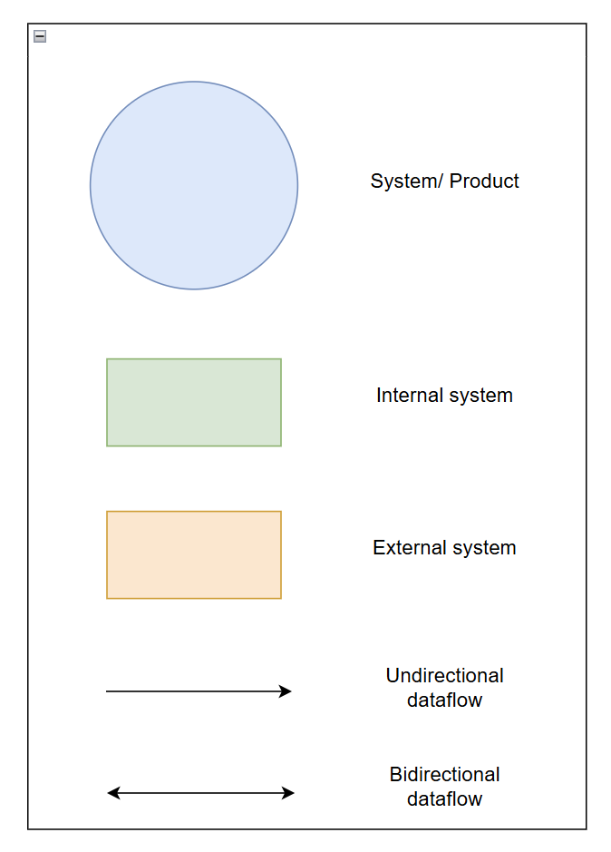
Figure 2.1 - Legend of Context Diagram

2.2. Business Process Diagram

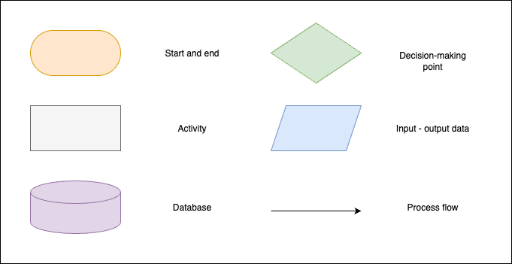
Figure 2.2 - Legend of Business Process Diagram

2.3. Use Case Diagram
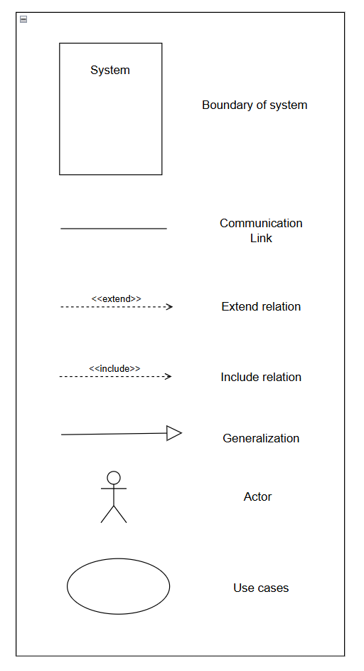
Figure 2.3 - Legend of Use Case Diagram

2.4. ERD Diagram
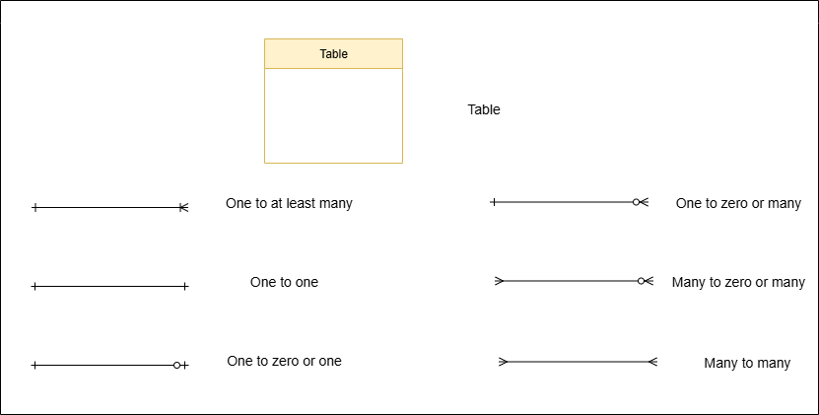
Figure 2.4 - Legend of ERD

3. List figure and table

No. | Figure Title | Pages
Figure 2.1 | Legend of Context Diagram
Figure 2.2 | Legend of Business Process Diagram
Figure 2.3 | Legend of Use Case Diagram
Figure 2.4 | Legend of Screen Flow Diagram
Figure 2.5 | Legend of ERD Diagram
Figure 1.1 | Context diagram of RoomEase System
Figure 1.2.1 | Business process of Contract & Tenant Management
Figure 1.2.2 | Business process of Meter Reading
Figure 1.2.3 | Business process of Invoice & Online Payments
Figure 1.2.4 | Business process of Ticketing / Incident Management
Figure 1.2.5 | Business process of Room & Facility Management
Figure 1.3.1 | Actors Generalization
Figure 1.3.4.1 | Use case diagram for Admin
Figure 1.3.4.2 | Use case diagram for Manager
Figure 1.3.4.3 | Use case diagram for Tenant
Figure 1.3.4.4 | Use case diagram for Operator
Figure 1.4.1.1 | Admin Screens Flow
Figure 1.4.1.2 | Manager Screens Flow
Figure 1.4.1.3 | Tenant Screens Flow
Figure 1.4.1.4 | Operator Screens Flow
Figure 1.5 | Entity Relationship Diagram
Figure 3.1.2
Figure 3.1.3
Figure 3.1.4
Figure 3.1.5
Figure 3.1.6
Figure 3.1.7
Figure 3.1.8
Figure 3.1.9

III. Software Requirement Specification

1. Overall Requirements

1.1 Context Diagram
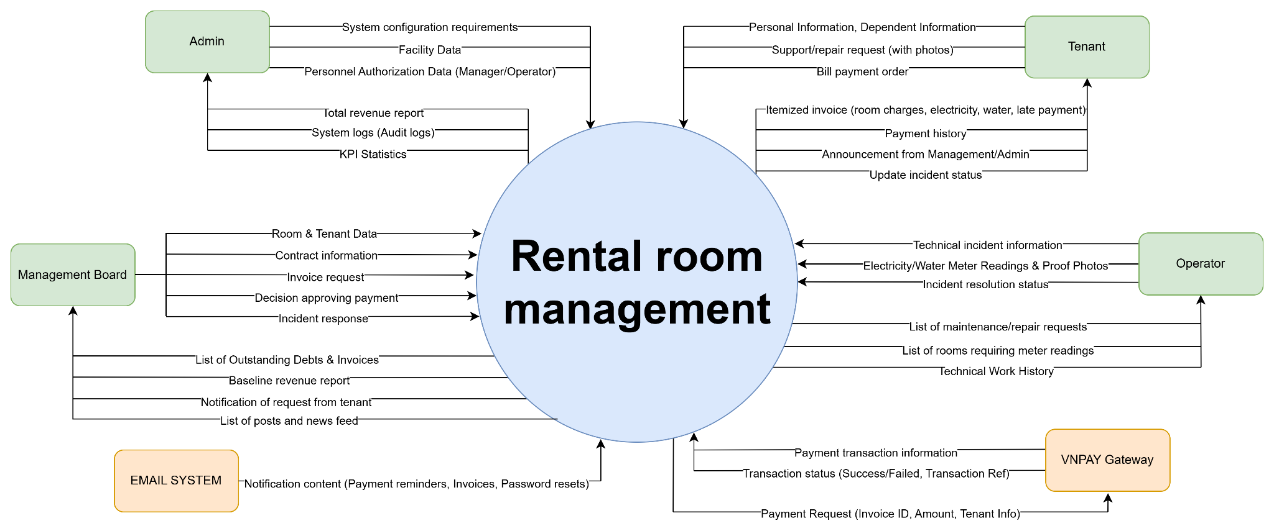
Figure 1.1 - Context diagram of RoomEase System
Link detail: Context diagram

1.2 Main Business Processes

1.2.1. Contract & Tenant Management
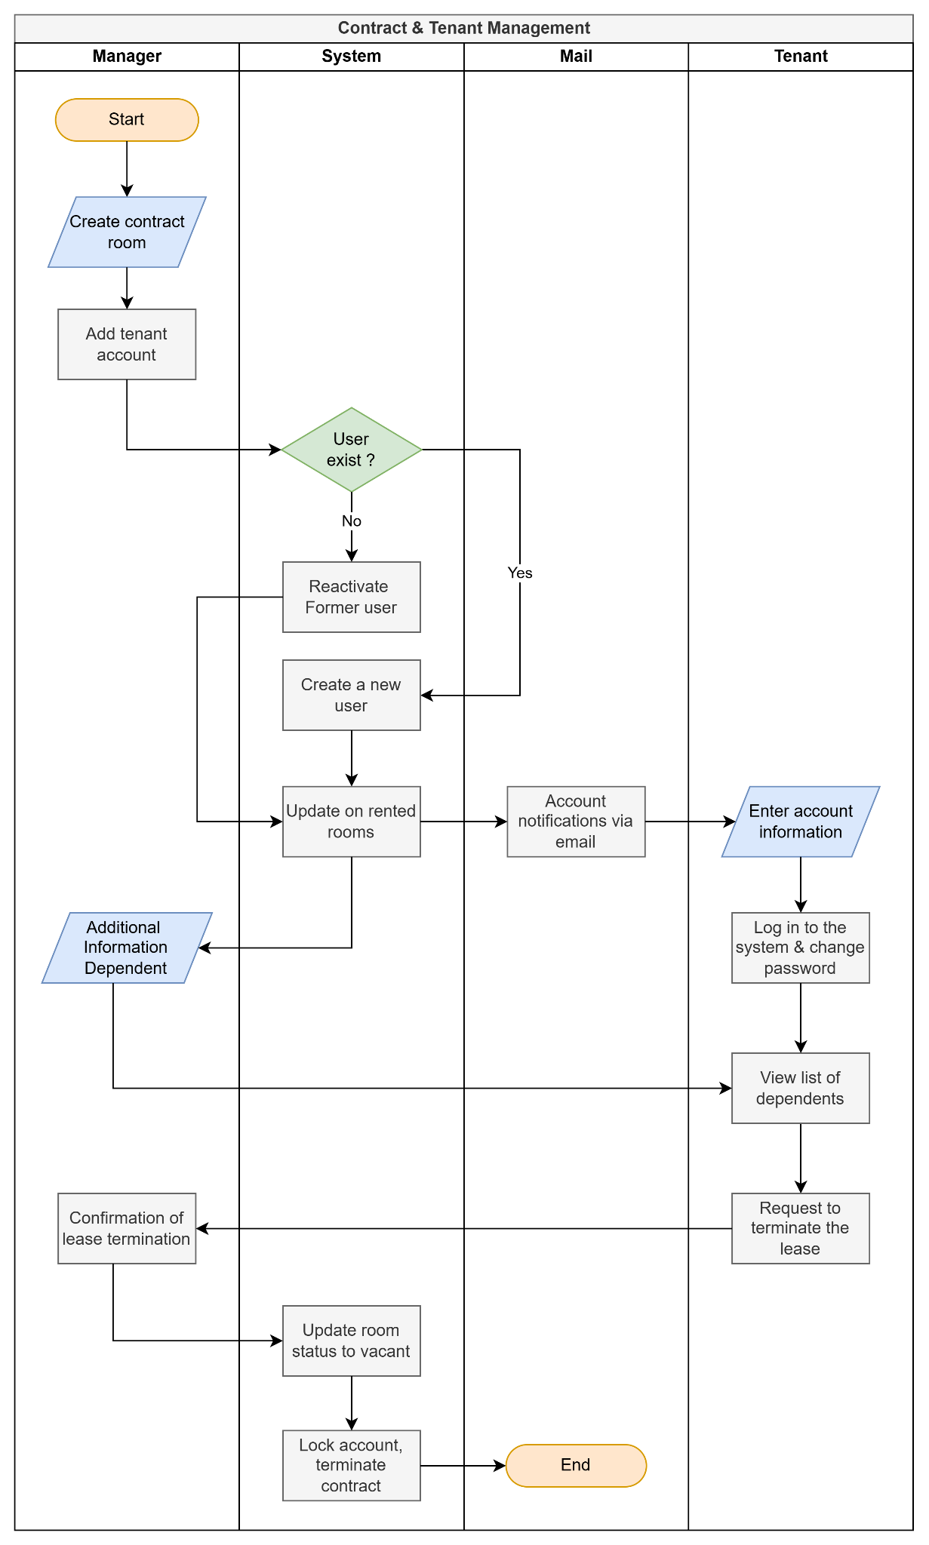
Figure 1.2.1 - Business process of Contract & Tenant Management
Link detail: Swimland Diagram - Contract & Tenant Management
Step # | Step name | Step description | Role | Notes
1 | Create Contract | Manager selects an available room from the facility to create a new contract. | Manager | Room status must be AVAILABLE.
2 | Input Tenant Info | Manager enters tenant details (Name, ID number, Phone, etc.). | Manager | Verification of identity required.
3 | Define Timeframe & Fees | Manager sets signed date, start date, end date, deposit amount, and room fee. | Manager | End date must be after start date.
4 | Generate Contract | System validates logic, generates a unique contract code, and saves it. | System | Status defaults to ACTIVE.
5 | Create Tenant Account | If the tenant doesn't have an account, Manager initializes a system account for them. | Manager / System | Links account to the contract.
6 | Sign & Export Contract | Contract is printed/exported to PDF for physical signature. | Manager / Tenant
7 | Add Dependents | Tenant logs in and adds dependents (roommates/family) living in the same room. | Tenant
8 | End | Contract and tenant setup is complete. | Manager / Tenant | End of flow.

1.2.2. Meter Reading Flow
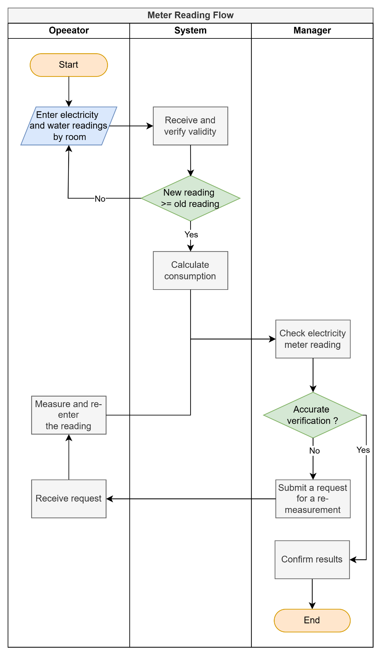
Figure 1.2.2 - Business process of Meter Reading Flow
Link detail: Swimland Diagram - Meter Reading Flow
Step # | Step name | Step description | Role | Notes
1 | Select Room & Cycle | Operator selects a specific room and the current billing cycle (month/year). | Operator | Start of flow.
2 | Input Readings | Operator enters the new electric and water meter numbers. | Operator | Must be ≥ previous readings.
3 | Upload Proof | Operator captures and uploads images of the meters as evidence. | Operator | Mandatory for transparency.
4 | Validate Data | System checks if the new readings are valid compared to previous ones. | System
5 | Save Readings | System stores readings and images, updating status to UPDATED. | System
6 | Review Readings | Manager reviews the updated meter readings before generating invoices. | Manager | Optional step for verification.
7 | End | Meter reading process for the room is complete. | Operator | End of flow.

1.2.3. Invoice & Online Payment Flow
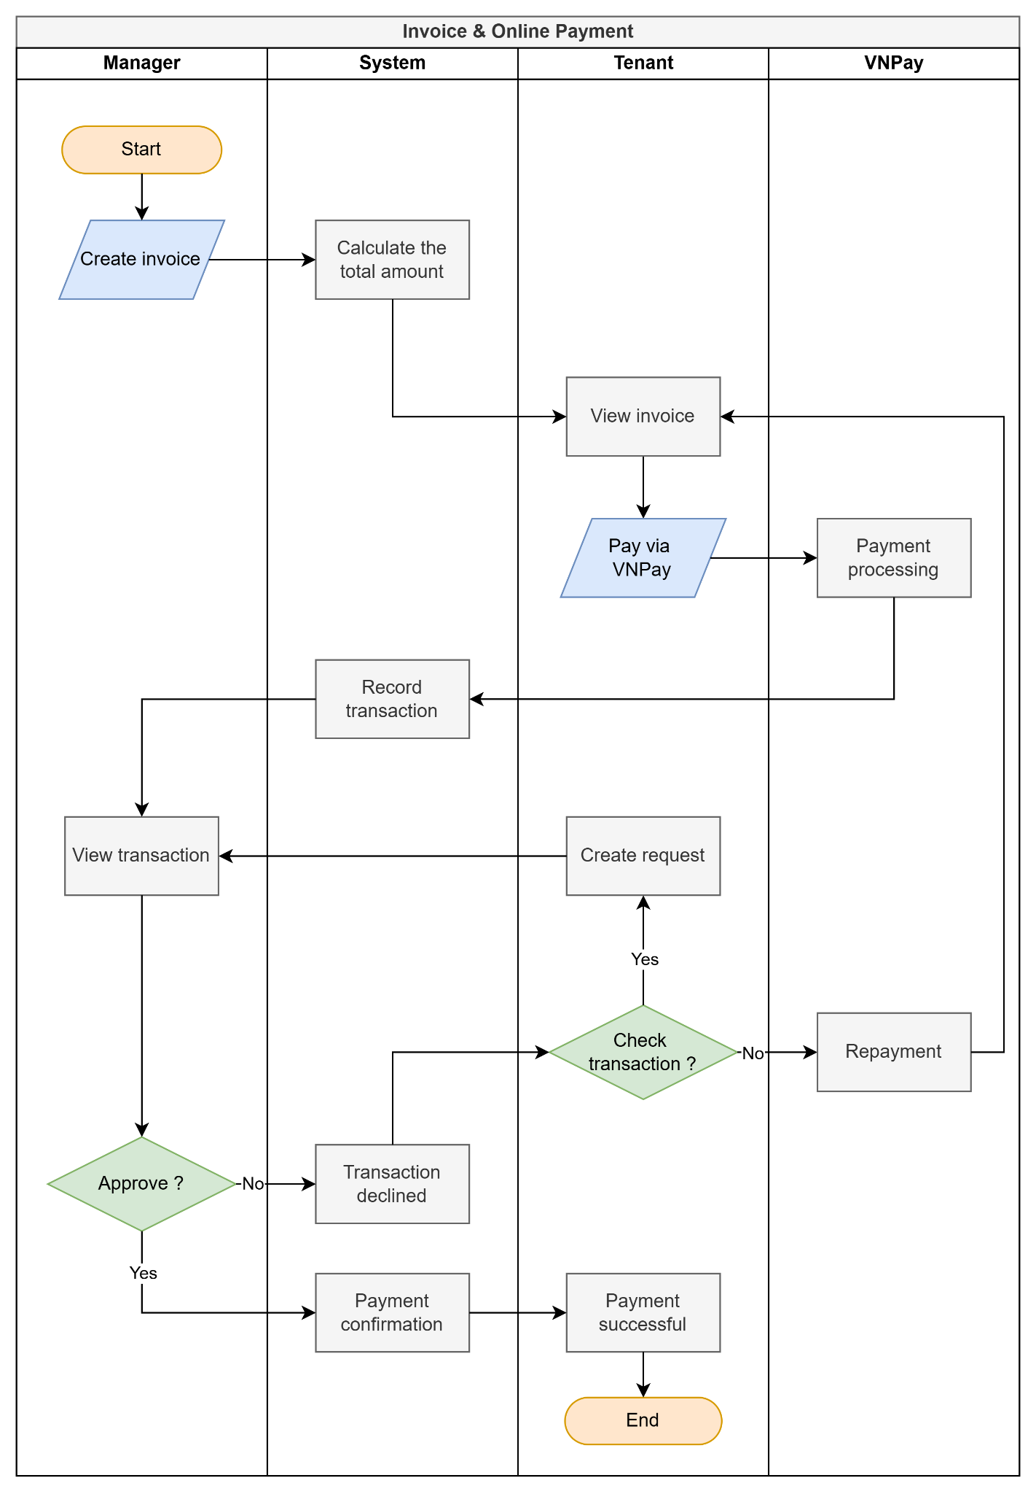
Figure 1.2.3 - Business process of Invoice & Online Payment Flow
Link detail: Swimland Diagram - Invoice & Online Payment Flow

Step # | Step name | Step description | Role | Notes
1 | Create Invoice | Manager generates an invoice including room fee, electricity, water, and services. | Manager | Status defaults to UNPAID.
2 | Notify Tenant | System sends an automated notification to the tenant about the new invoice. | System | In-app notification.
3 | View Invoice | Tenant opens the invoice to review the detailed charges. | Tenant | Must be logged in.
4 | Select VNPAY Payment | Tenant clicks "Pay with VNPAY" and is redirected to the payment gateway. | Tenant | Triggers payment.
5 | Process Transaction | VNPAY processes the user's banking/card information. | VNPAY System | Secure transaction.
6 | Return Payment Status | VNPAY returns the transaction status (Success/Fail) via IPN/Return URL. | VNPAY System
7 | Update Invoice & Record | System validates signature, marks invoice as PAID/PROCESSING, and creates payment log. | System | Rollback on failure.
8 | End | Process ends. | Tenant / System | End of flow.

1.2.4. Ticketing / Incident Management
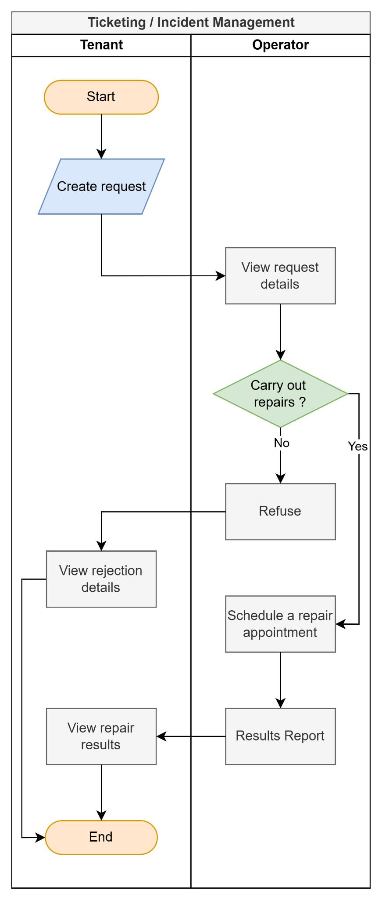
Figure 1.2.4 - Business process of Ticketing / Incident Management
Link detail: Swimland Diagram - Ticketing / Incident Management

Step # | Step name | Step description | Role | Notes
1 | Create Request/Incident | Tenant or Operator submits a request/incident with category, description, and photos. | Tenant / Operator | Start of flow.
2 | Log Request | The system generates a unique request code with PENDING status. | System
3 | Review Assignment | The operator views the assigned request details. | Operator
4 | Update to IN_PROGRESS | The operator marks the request as IN_PROGRESS and starts working on the issue. | Operator | Indicates work has started.
5 | Report Completion | The operator inputs resolution notes and uploads post-repair proof images. | Operator | Proof image is mandatory.
6 | Mark as COMPLETED | System validates input and changes request status to COMPLETED. | System
7 | Notify Creator | The system sends a notification to the Tenant/Operator who created the ticket. | System
8 | End | The incident was successfully resolved. | Operator / System | End of flow.

1.2.5. Room & Facility Management
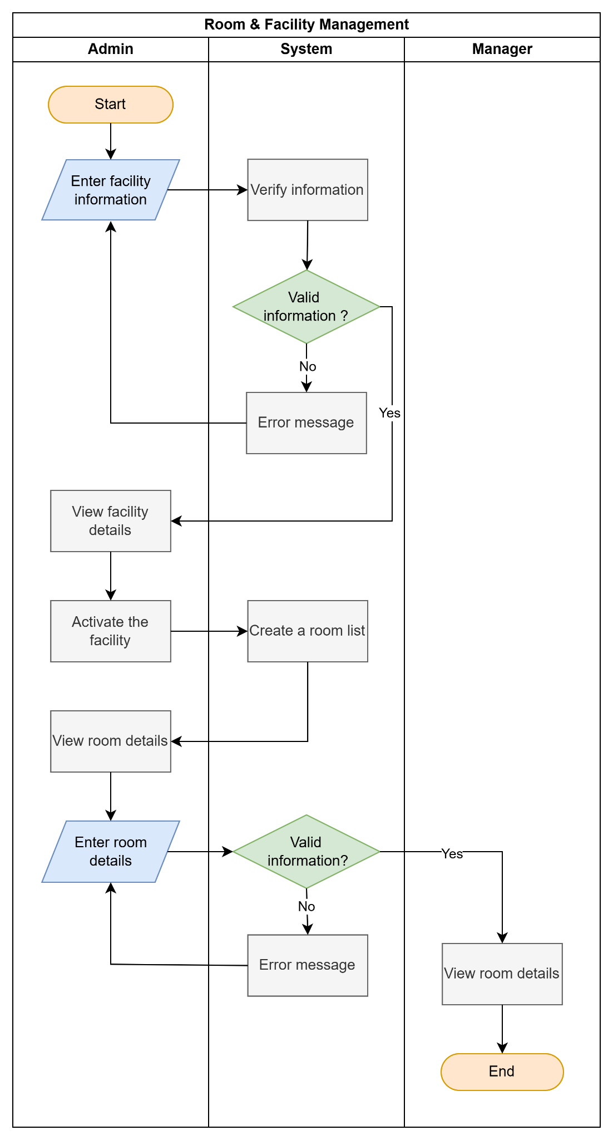
Figure 1.2.5 - Business process of Room & Facility Management
Link detail: Swimland Diagram - Room & Facility Management
Step # | Step name | Step description | Role | Notes
1 | Create Facility | Admin inputs facility details (name, address, floors, rooms per floor, utility prices). | Admin | Status defaults to DRAFT/INACTIVE.
2 | Assign Personnel | Admin assigns a Manager and an Operator to handle the new facility. | Admin
3 | Activate Facility | Admin changes the facility status from DRAFT to ACTIVE. | Admin | Triggers room creation.
4 | Auto-generate Rooms | System automatically generates room records based on floor count and rooms per floor. | System | Status defaults to AVAILABLE.
5 | Update Room Specs | Administrator (or Manager if authorized) updates specific areas and prices for individual rooms. | Admin / Manager | Customizing default rooms.
6 | Setup Service Prices | The manager configures base service prices (internet, cleaning, etc.) for the facility. | Manager | Recorded in history logs.
8 | End | The facility is ready to accept tenants. | Admin / System | End of flow.

1.2.6. Post & Articles Management
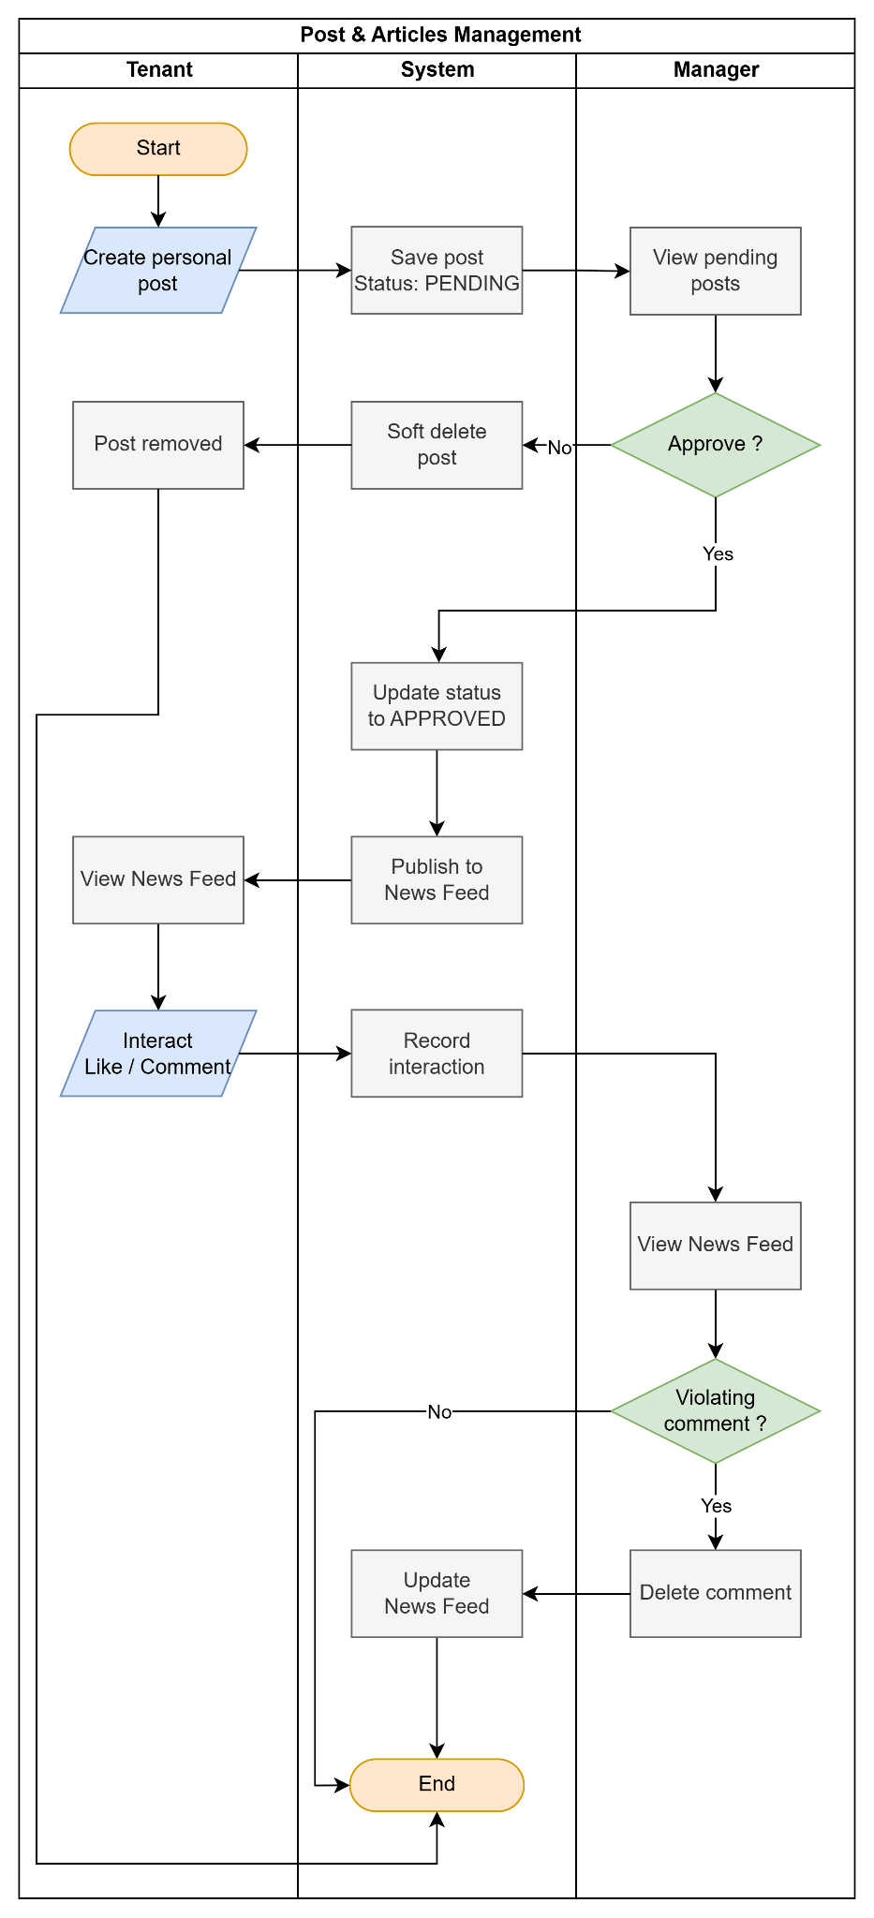
Figure 1.2.6 - Business process of Post & Articles Management
Link detail: Swimland Diagram - Post & Articles Management
Step # | Step name | Step description | Role | Notes
1 | Create Post | Create a new community post. | Tenant | Submit for approval.
2 | Save Post | Save the post with PENDING status. | System | Default status = PENDING.
3 | View Pending Posts | View pending posts. | Manager | Awaiting approval.
4 | Approve Post | Review and approve/reject the post. | Manager | Decision point.
5 | Remove Post | Remove rejected posts. | System | Soft delete.
6 | Publish Post | Publish approved post to News Feed. | System | Status = APPROVED.
7 | View News Feed | View published posts. | Tenant / Manager | Approved posts only.
8 | Interact with Post | Like or comment on a post. | Tenant | Optional action.
9 | Record Interaction | Save likes/comments. | System | Update interaction data.
10 | Review Comment | Check whether a comment violates rules. | Manager | Decision point.
11 | Delete Comment | Remove inappropriate comments. | Manager | If a violation is detected.
12 | Update News Feed | Refresh News Feed. | System | Reflecting the latest changes.
13 | End | Complete the workflow. | System | End of process.

1.3 User Requirements

1.3.1 Actors Generalization
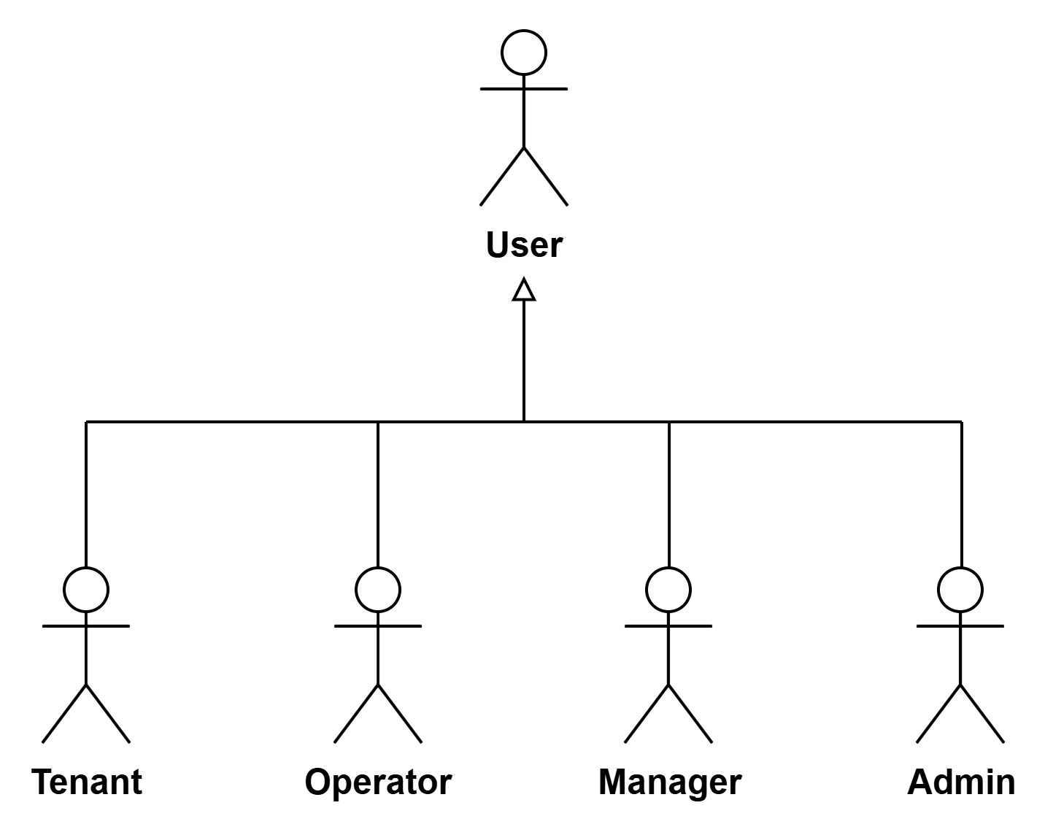
Figure 1.3.1 - Actors Generalization
Link detail: Actors Generalization

1.3.2 Actors
# | Actor | Description
1 | Administrator (Admin) | Oversees the entire system, including creating and managing personnel accounts, managing hostel facilities (create, update, activate), managing system-wide notifications, and viewing overall revenue reports and audit logs.
2 | Manager | Manages specific facilities assigned to them. Responsibilities include managing tenants and contracts, handling invoices and payments, processing tenant requests, updating service prices, and broadcasting facility-level notifications.
3 | Operator | Handles on-site operational tasks. Responsibilities include recording and updating monthly utility meter readings (electricity, water), reporting facility incidents, and viewing and resolving assigned maintenance requests.
4 | Tenant | The renter who uses the system to view their contracts, manage dependents, view invoices, make online payments via VNPAY, submit support requests, and view notifications from the management board.
5 | User | A generalization representing any authenticated individual interacting with the RoomEase system (Admin, Manager, Operator, Tenant) who can log in, log out, view their profile, change passwords, and access a role-specific dashboard

1.3.3 Use Cases (UC)
ID | Use Case | Feature | Use Case Description
1 | Forgot Password | Admin, Tenant, Manager, Operator | Allows a user who has forgotten their password to request a password reset link via their registered email address.
2 | Login | Admin, Tenant, Manager, Operator | The user logs into the system using their registered credentials to access personalized features and their dashboard.
3 | View Profile | Admin, Tenant, Manager, Operator | Users view their personal profile details, including personal information, contact details, and account settings.
4 | View Dashboard | Admin, Tenant, Manager, Operator | Displays a role-specific overview of the system (e.g., upcoming rent for tenants, overall occupancy for managers).
5 | Logout | Admin, Tenant, Manager, Operator | Users securely end their current session and exit the authenticated area of the system.
6 | Create Personnel | Admin | An administrator creates a new staff account by entering the required information and assigning an appropriate role.
7 | View Personnel | Admin | Views the list of personnel in the system, displaying basic information and allowing searching and filtering by role or status.
8 | Update Personnel | Admin | Updates the information of an existing personnel record in the system.
9 | View Revenue Report | Admin | Views the monthly revenue report, including overall revenue metrics, revenue by facility, and statistics for the last six months.
10 | Create Facility | Admin | Creates a new hostel facility in the system (saved with a default Inactive status until activated).
11 | View Facility | Admin | Views the list of hostel facilities, allowing the administrator to search, filter by status, or access detailed facility information.
12 | View Audit Log | Admin | Views the list of audit logs to monitor system activities, including timestamps, users, actions, and target objects.
13 | Create Notification | Admin | Creates and sends a notification to all residents in the system.
14 | View Notification | Admin | Views the list of notifications that have been created in the system and searches by notification title.
15 | System Config | Admin | Configures global system settings such as application parameters, email templates, payment settings, and other administrative options.
16 | View Payment | Manager | Views payment records of tenants to monitor payment status, rental fees, due dates, and approves or rejects pending payments.
17 | View and Process Request | Manager | Views the list of tenant support requests directed to the Manager and updates their progress until resolution or rejection.
18 | View Tenant | Manager | Views the list and details of tenants within their assigned facility.
19 | View Contract Manager | Manager | Views contracts within their facility, initializes system accounts for tenants, and extracts data to print contracts.
20 | Create Contract | Manager | Sets up a new rental contract for a room, auto-generating the contract code and validating timeframe constraints.
21 | View Room | Manager | Views the list, statuses of the rooms in the facility, and current tenant information.
22 | View Notification | Manager | Views the history of notifications sent within their facility scope to manage communication flow with tenants.
23 | Create Notification | Manager | Composes a new notification and distributes it to specific tenants or the entire facility.
24 | View Invoice | Manager | Views invoices generated by the system, deletes invoices, exports PDFs, or reports billing issues to the operator.
25 | View Debt | Manager | Views overdue debts to monitor unpaid invoices, penalty fees, and overdue days.
26 | Create Invoice | Manager | Creates a new invoice for a room by entering billing information such as period, due date, tax, and additional fees.
27 | Update Invoice | Manager | Updates an existing unpaid invoice (due date, tax, additional fees, notes) and recalculates the total.
28 | View Service Price | Manager | Views the list of fixed service prices (electricity, water, internet) and their update history.
29 | Update Service Price | Manager | Updates the unit price of a fixed service and records the change in the service price history.
30 | Create Community Post | Manager | Creates a community post to share announcements, events, or useful information with tenants.
31 | View Community Post Detail | Manager | Views the detailed content of a selected community post, including attachments and comments if available.
32 | View News Feed | Manager | Views the community news feed containing announcements, events, and posts shared within the facility.
33 | View Dependent | Tenant | Views the list and detailed information of the dependents living in the same room with the tenant.
34 | View Invoice | Tenant | Views the list of invoices and makes online payments through the VNPAY payment gateway.
35 | View Notification | Tenant | Views the list and detailed content of notifications sent by the Landlord or Management Board.
36 | View Contract Tenant | Tenant | Views the list and read-only details of their own rental contracts.
37 | Create Request | Tenant | Creates and submits a new support request with attached images for the Management Board to resolve.
38 | View Request | Tenant | Views the list of submitted requests and tracks the detailed processing status of each request.
39 | Create Community Post | Tenant | Creates a community post to share information, ask questions, or interact with other residents.
40 | View Community Post Detail | Tenant | Views the detailed content of community posts, including comments and attached media.
41 | View Meter Reading | Operator | Views a list of electricity and water meter readings and their update statuses for all rooms.
42 | Update Meter Reading | Operator | Records or modifies the utility meter readings for a specific room and billing cycle, uploading a photo as proof.
43 | View Request Operator | Operator | Views a list of assigned service/maintenance requests and their full details.
44 | Update Request | Operator | Reports the completion of a maintenance request by inputting resolution notes and uploading post-repair images.
45 | Create Incident Reporting | Operator | Reports a problem or incident discovered during operations (e.g., broken equipment, leaks) with photo evidence.
46 | View Notification | Operator | Views system alerts and task assignments sent by the Admin or Manager.

1.3.4 Use Case Diagrams

1.3.4.1 UCs for Admin
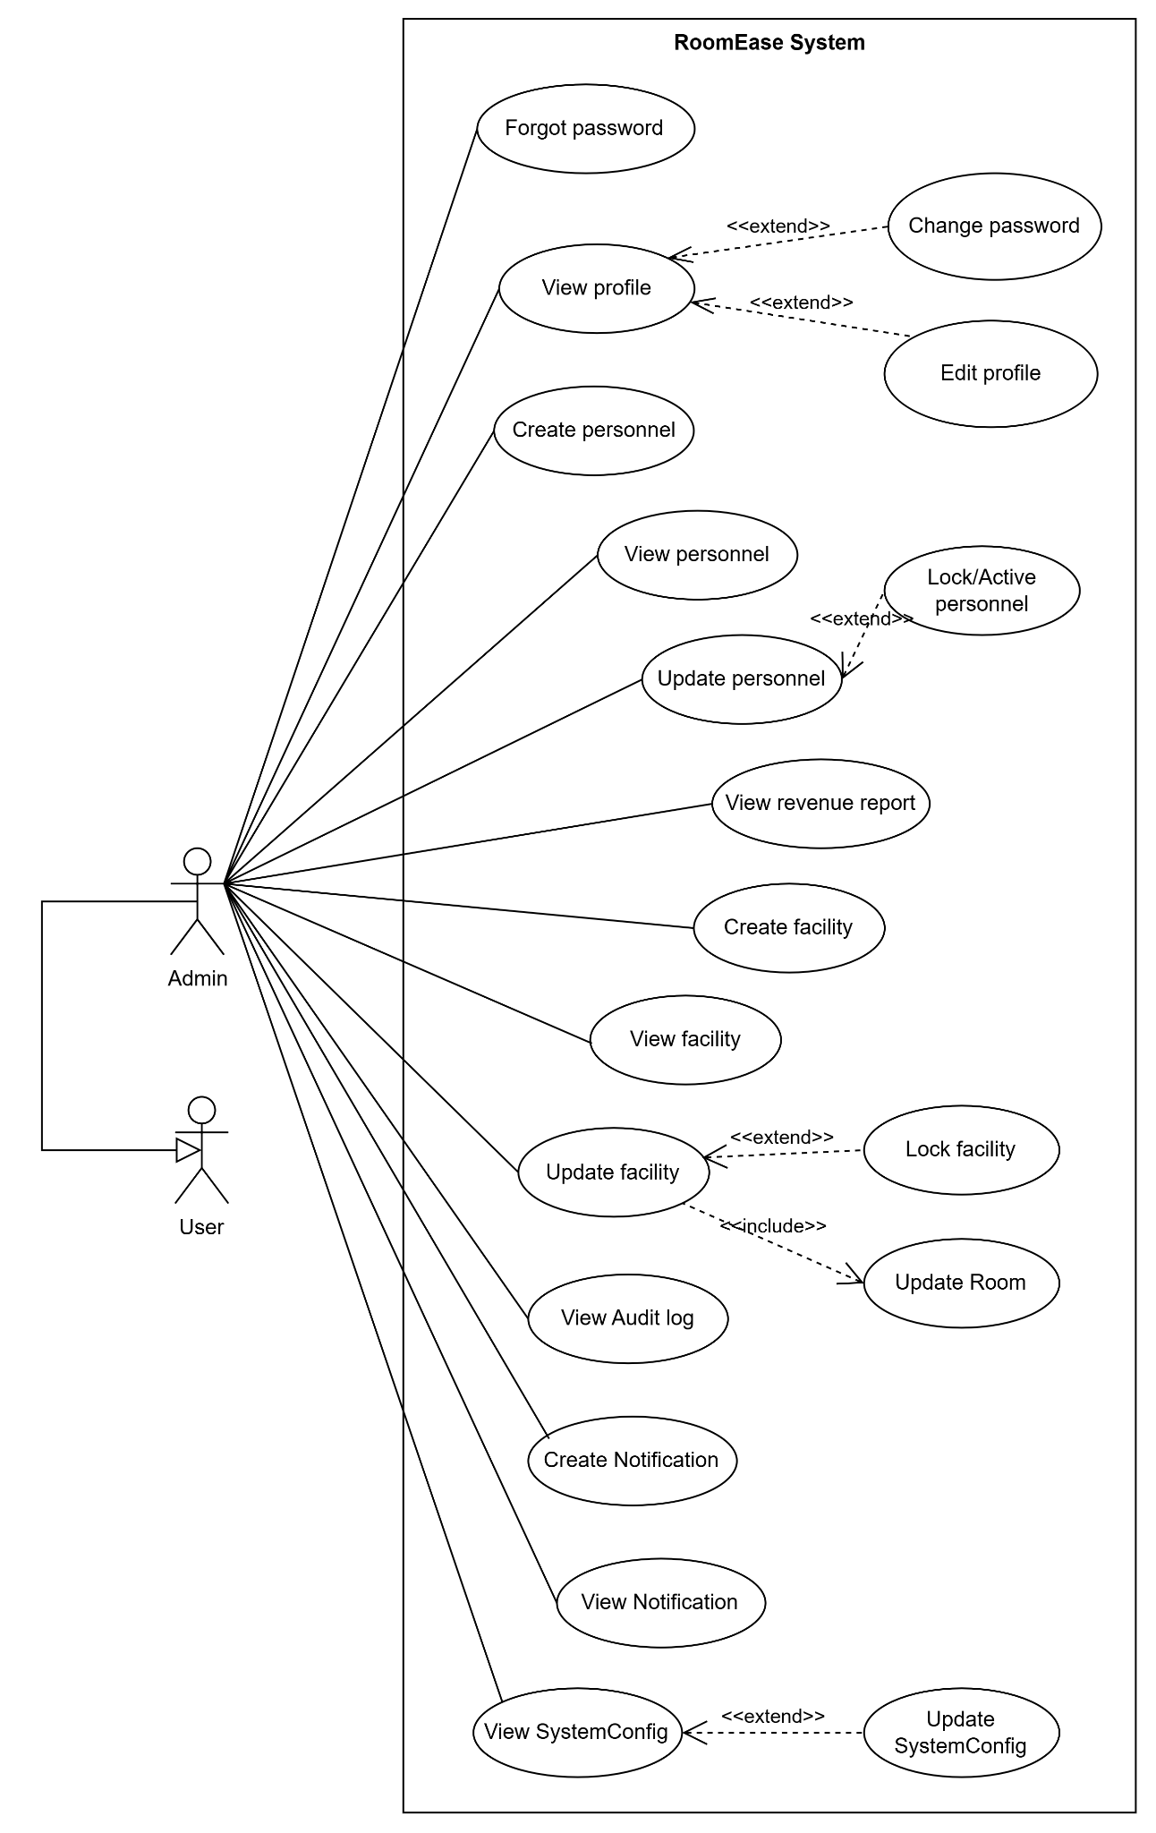
Figure 1.3.4.1 - Use case diagram for Admin
Link Detail: UCs for Admin

1.3.4.2 UCs for Manager
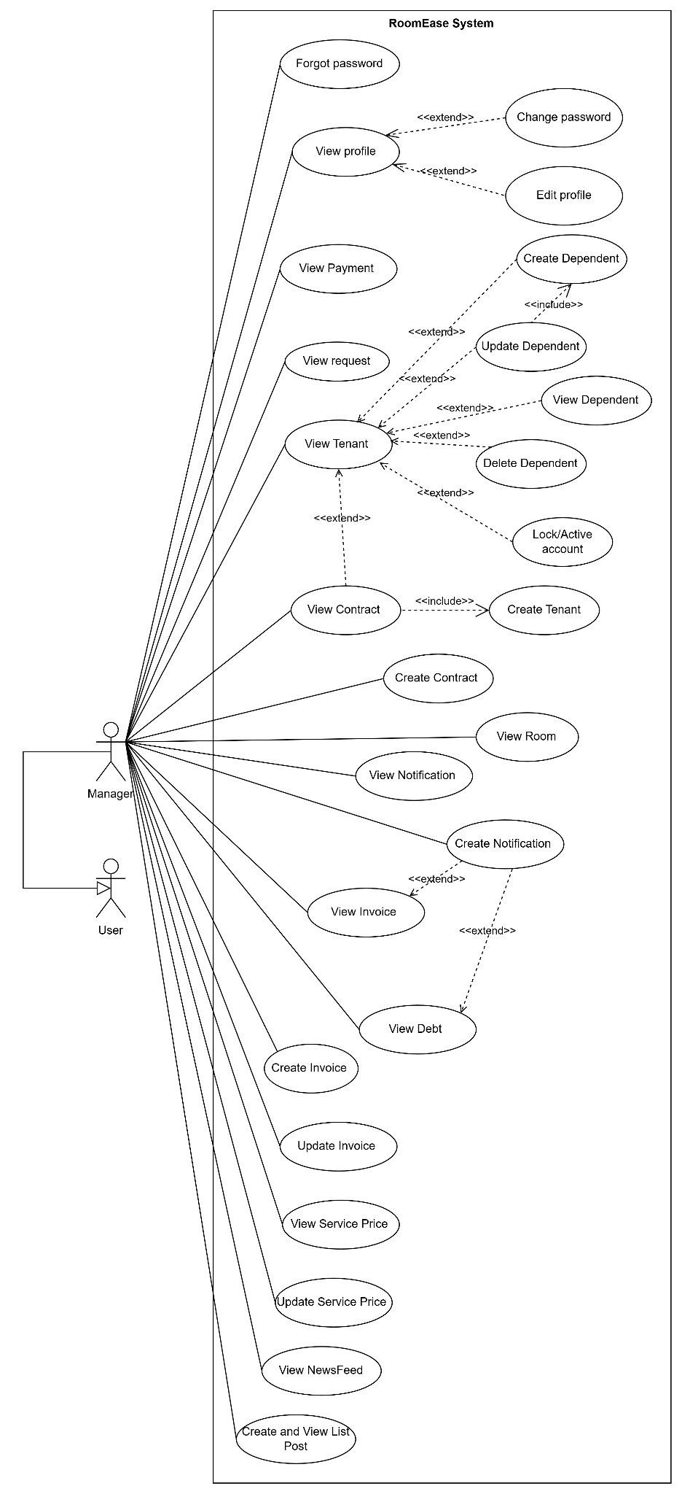
Figure 1.3.4.2 - Use case diagram for Manager
Link Detail: UCs for Manager

1.3.4.3 UCs for Tenant
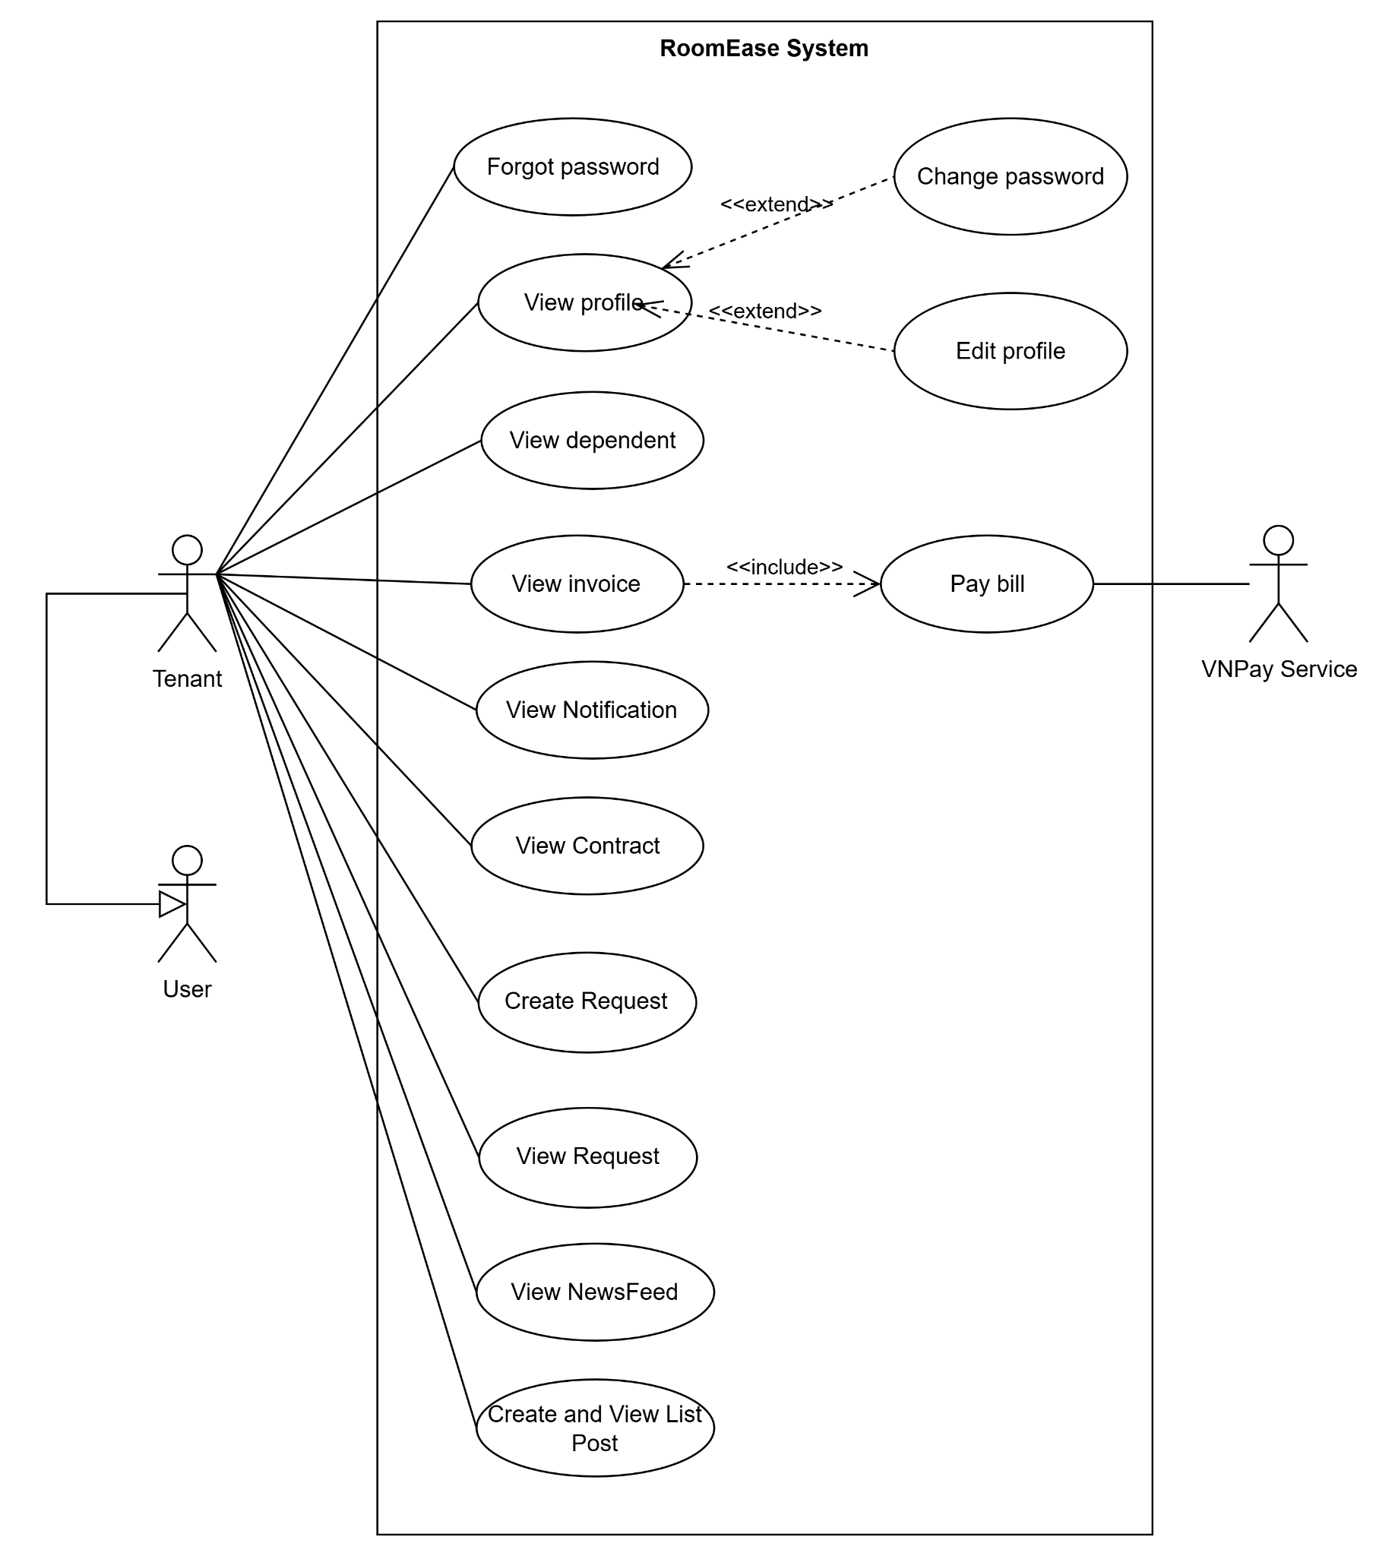
Figure 1.3.4.3 - Use case diagram for Tenant
Link Detail: UCs for Tenant

1.3.4.4 UCs for Operator
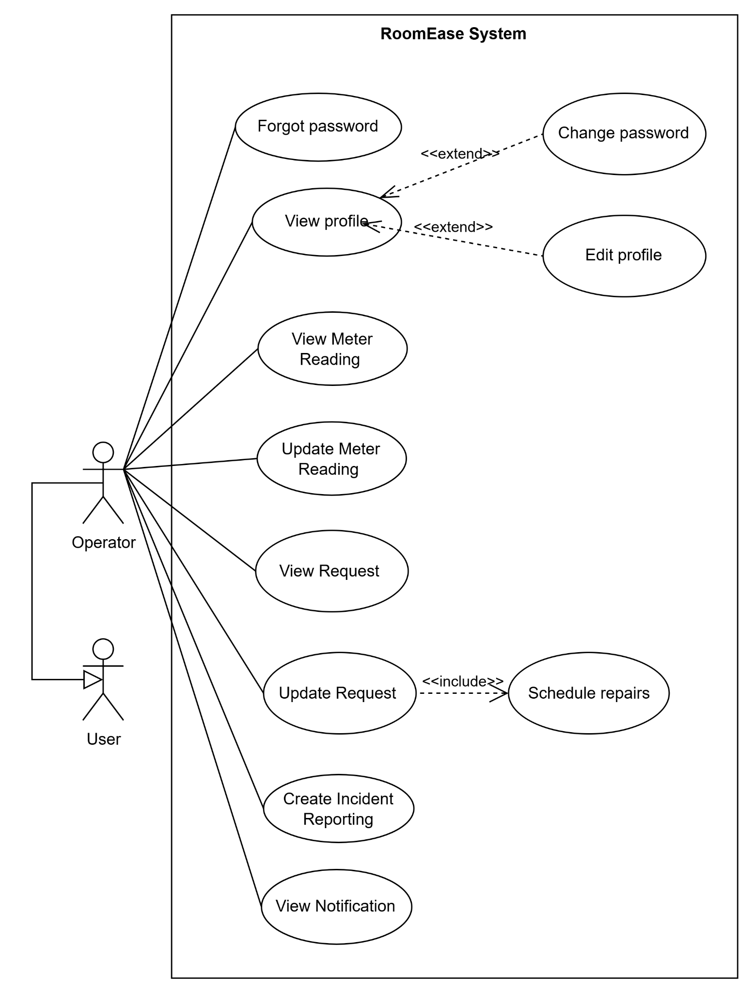
Figure 1.3.4.4 - Use case diagram for Operator
Link Detail: UCs for Operator

1.4 System Functionalities

1.4.1 Screens Flow

1.4.1.1 Admin Screens Flow
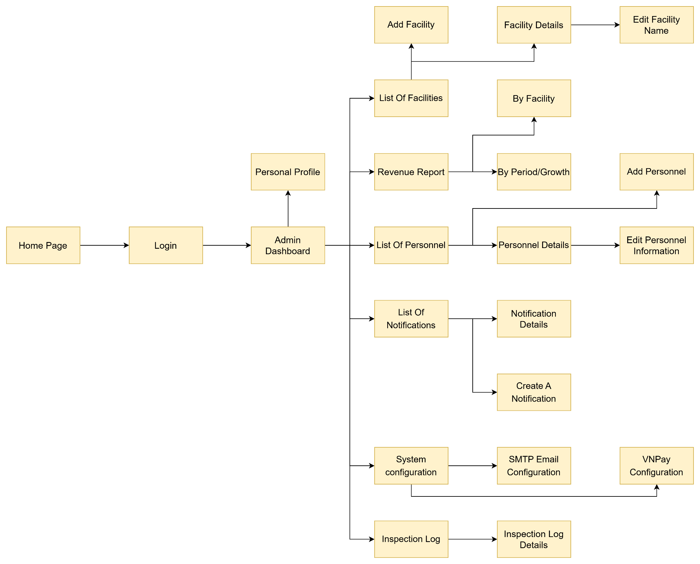
Figure 1.4.1.1 - Admin Screens Flow
Link Detail: Admin Screens Flow

1.4.1.2 Manager Screens Flow
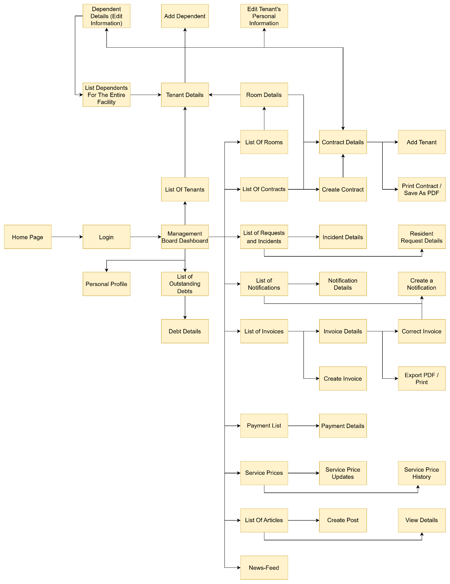
Figure 1.4.1.2 - Screens Flow
Link Detail: Manager Screens Flow

1.4.1.3. Tenant Screens Flow
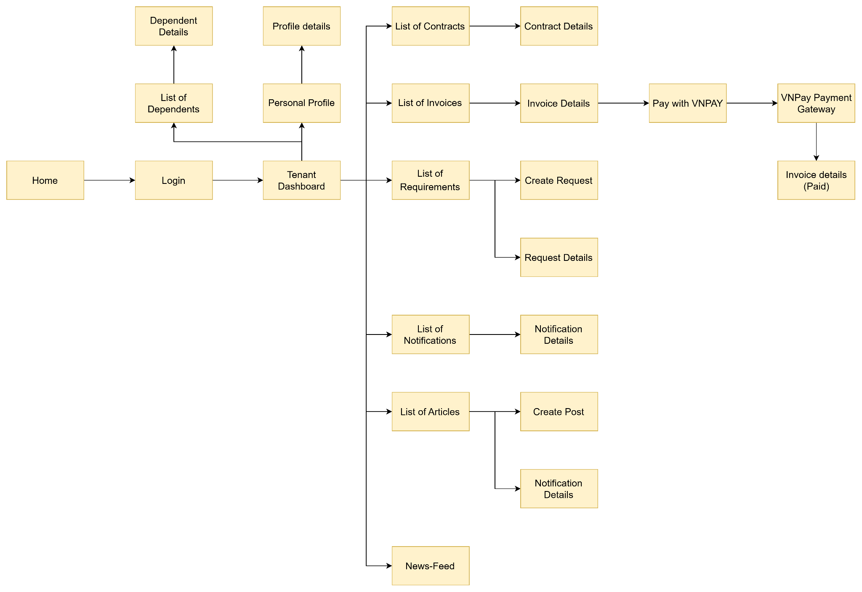
Figure 1.4.1.3 - Tenant Screens Flow
Link Detail: Tenant Screens Flow

1.4.1.4 Operator Screens Flow
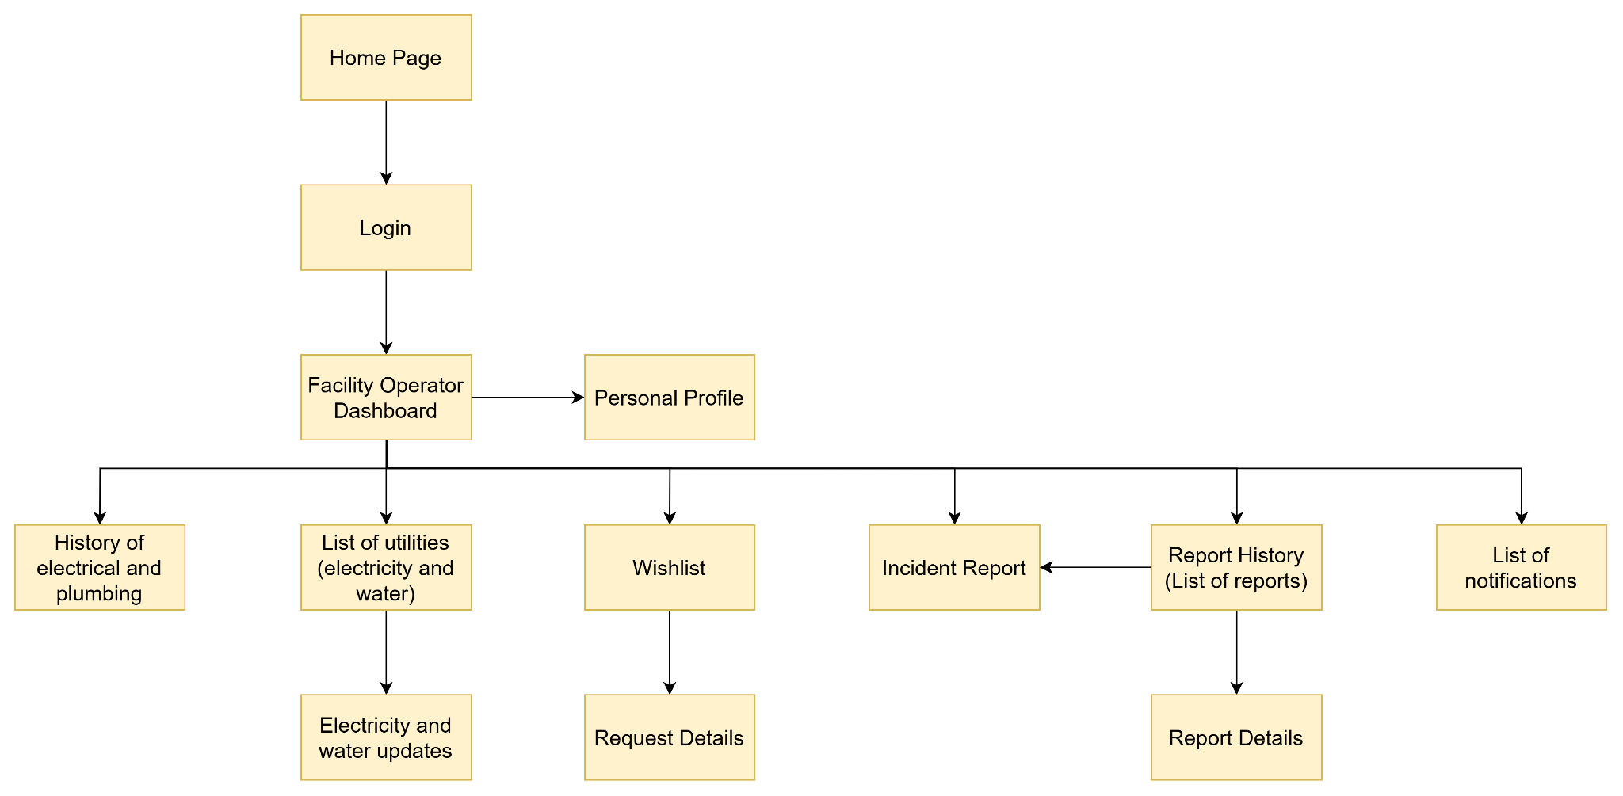
Figure 1.4.1.4 - Operator Screens Flow
Link Detail: Operator Screens Flow

1.4.1.5 Screen Descriptions
ID | Feature |  | Description
1 | Authentication | Home Page | Entry page that automatically redirects unauthenticated users to the login screen.
2 | Authentication | Login | Allows users to authenticate and access the system based on their role.
3 | Common | Personal Profile | Displays and updates personal contact info (email, phone, avatar) for logged-in users.
4 | Dashboard | Tenant Dashboard | Displays active contract summaries, current invoice due states, and quick shortcuts for tenants.
5 | Contract Management | Contract Details | Shows lease agreements, rents, deposits, and allows downloading PDFs.
6 | Billing & Payment | Invoice Details | Shows utility counters, service fees, VNPay portal links, and transfer QR codes.
7 | Ticket Management | Create Request (Tenant) | Form for tenants to submit property maintenance tickets or register overnight guests.
8 | Community Board | News-Feed | Timeline displaying property announcements, resident articles, likes, and comments.
9 | Dashboard | Facility Operator Dashboard | Operator landing page showing assigned maintenance work orders and pending meter reading tasks.
10 | Utility Tracking | Electricity and water updates | Form for operators to record current utility indexes and upload counter pictures.
11 | Task Handling | Request Details (Operator) | Detail screen for operators to review assigned tasks, update progress, and post resolution images.
12 | Incident Reporting | Incident Report | Form for operators to log and request refund for self-detected facility repairs. .
13 | Dashboard | Management Board Dashboard | Manager dashboard detailing KPIs, room occupancies, and pending items.
14 | Debt Management | List of Outstanding Debts | Displays rooms and tenants with overdue invoice balances.
15 | Contract Management | Create Contract (Manager) | Form to draft new lease agreements, assign tenants, deposit parameters, and price scales.
16 | Billing & Payment | Create Invoice (Manager) | Form for managers to generate monthly room statements from utility index inputs.
17 | Payment Control | Payment Details (Manager) | Interface to approve or reject tenant-submitted bank transfer screenshots.
18 | Dashboard | Admin Dashboard | Analyzes income reports, facility growth, and staff accounts globally.
19 | System Config | System configuration | Admin portal to adjust email SMTP servers and VNPay gateway properties.
20 | System Audit | Inspection Log | Tabular view of audit trails logging critical data manipulations in the system.

1.4.2 Screen Authorization
Screen | Tenant | Operator | Manager | Admin
Home Page | X | X | X | X
Login | X | X | X | X
Personal Profile | X | X | X | X
Tenant Dashboard | X
Contract Details | X |  | X
Invoice Details | X |  | X
Create Request (Tenant) | X
News-Feed | X |  | X
Operator Dashboard |  | X
Electricity and water updates |  | X
Request Details (Operator) |  | X
Incident Report |  | X
Management Board Dashboard |  |  | X
List of Outstanding Debts |  |  | X
Create Contract (Manager) |  |  | X
Create Invoice (Manager) |  |  | X
Payment Details (Manager) |  |  | X
Admin Dashboard |  |  |  | X
System configuration |  |  |  | X
Inspection Log |  |  |  | X

1.4.3 Non-UI Functions
ID | Feature | System Function | Description
1 | User Authentication | Manage user login, first login password setup, and role-based access | Verifies accounts, restricts resource access by user role via Servlet Filters, and handles idle session timeouts.
2 | Payment Processing | Process payments through payment gateways | Integrates with VNPay gateway API to prepare parameters and verify transaction outputs.
3 | Auto Billing Calculation | Calculate utility usage and room fees | Automatically subtracts old utility index entries from new entries, applies tariffs, and adds fixed service rates.
4 | Late Payment Penalty | Calculate interest for late payment | Applies a daily interest charge (1% of the monthly room fee) automatically when invoices exceed due dates.
5 | Notification System | Send email notifications | Dispatches automated notifications (invoice updates, transaction logs) through SMTP protocol.
6 | Audit Logging | Track and record system activities | Logs critical administrative actions (pricing, configurations) to the database audit logs table.

1.5 Entity Relationship Diagram
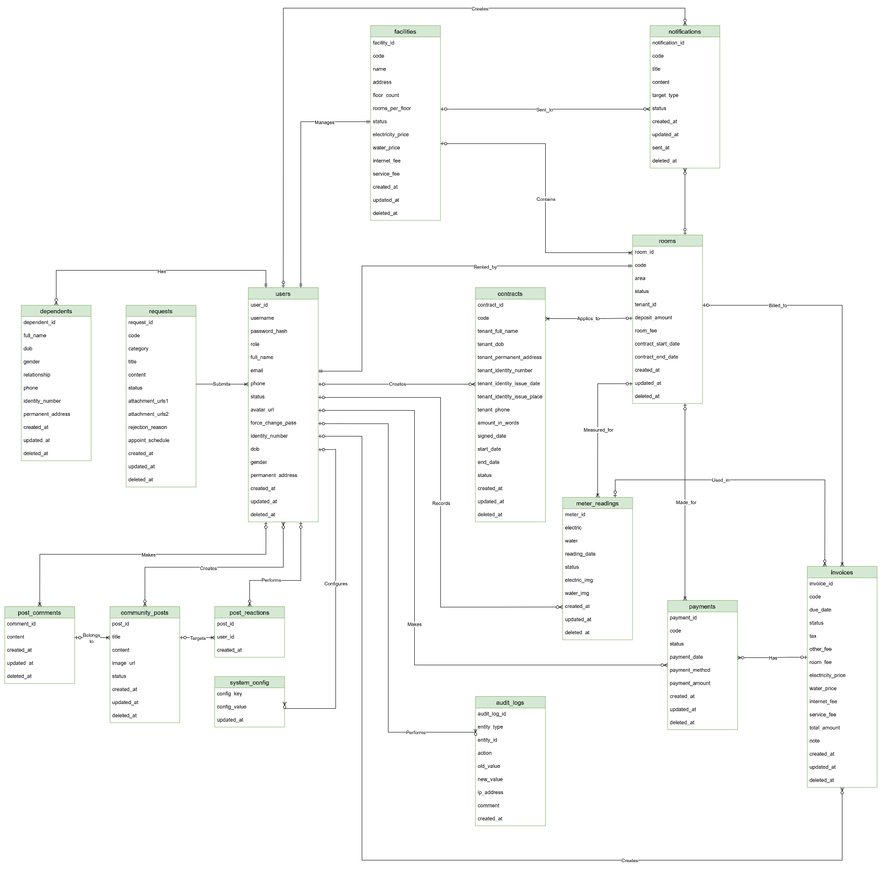
Figure 1.5 - Entity Relationship Diagram
Link Detail: ERD Diagram
Entities Description
# | Entity | Description
1 | users | Stores account credentials, personal profiles, and access roles (Admin, Manager, Operator, Tenant) for all individuals using the system.
2 | facilities | Manages hostel/building details including address, capacity (floors, rooms), assigned staff, and baseline utility/service prices.
3 | rooms | Contains specific room details such as area, monthly fee, deposit amount, current tenant, and room status within a specific facility.
4 | dependents | Stores information about roommates or family members living with the primary tenant in a rented room.
5 | meter_readings | Records periodic electricity and water meter numbers along with photographic proof for accurate billing purposes.
6 | invoices | Manages monthly billing statements for each room, aggregating room fees, utility costs (electricity, water), and other service charges.
7 | payments | Tracks payment transactions made by tenants to settle invoices, including the payment amount, method (e.g., VNPAY/Bank Transfer), and date.
8 | requests | Stores maintenance or support tickets submitted by tenants or staff, tracking their resolution status, attachments, and assigned personnel.
9 | notifications | Manages announcements and alerts created by management to be broadcasted to all users, specific facilities, or individual rooms.
10 | audit_logs | Keeps a chronological record of critical system actions and data modifications for security, compliance, and auditing purposes.
11 | contracts | Manages room rental agreements between the facility and the tenant, including identity details, lease duration, terms, and signature dates.
12 | community_posts | Stores posts and announcements shared on the community board, including text content, images, and approval status.
13 | post_reactions | Tracks user interactions and engagement (e.g., likes or reactions) on specific community posts.
14 | post_comments | Stores user comments and discussions associated with community posts.
15 | system_config | Contains global system configuration parameters and settings stored as key-value pairs for system operations.

2. Use Case Specifications

2.1. Authentication & User Access

2.1.1 UC: Forgot Password

ID and Name: | UC-01 – Forgot Password
Primary Actor: | Admin, Tenant, Manager, Operator | Secondary Actors: | None
Description: | Allows a user who has forgotten their password to request a password reset link via their registered email address.
Trigger: | The user clicks the "Forgot Password" link on the login page.
Preconditions: | - The user is not logged in.  - The user has a registered email address in the system.
Postconditions: | - A password reset link is sent to the user's email.  - Users can successfully reset their password and log in.
Normal Flow: | - The user enters their registered email address.  - The user clicks the "Send Reset Link" button.  - The system verifies if the email exists in the database.  - The system generates a secure, time-limited reset token.  - The system sends an email containing the reset link to the user.  - The system displays a confirmation message MSG001 (Reset link sent if email exists).
Alternative Flows: | AF1: Email not found → System still displays MSG001 to prevent email enumeration attacks.
Exceptions: | EX1: Email service unavailable → MSG002 (Unable to send email, please try again later).
Priority: | High
Frequency of Use: | Occasional
Business Rules: | BR-01: Reset link expires in 15 minutes.
Other Information: | - After resetting, the user is redirected to the Login page.
Assumptions: | - Users have access to their email account.

2.1.2 UC: Login

ID and Name: | UC-02 – Login
Primary Actor: | Admin, Tenant, Manager, Operator | Secondary Actors: | None
Description: | The user logs into the system using their registered credentials (email/username and password) to access personalized features and their dashboard.
Trigger: | The user navigates to the login page and selects the "Login" option.
Preconditions: | - Users must have an active and registered account.  - The user is currently logged out.
Postconditions: | - Users are successfully authenticated and redirected to their respective dashboard.  - A session is created.
Normal Flow: | - The user enters their email/username and password.  - The user clicks the "Login" button.  - The system validates the credentials against the database.  - The system authenticates the user and generates a session token.  - The system redirects the user to the dashboard corresponding to their role.
Alternative Flows: | AF1: Incorrect credentials → System displays error message MSG003 (Invalid email or password) and prompts users to try again.  AF2: Account locked/inactive → System displays error message MSG004 (Account is locked or inactive, please contact support).
Exceptions: | EX1: Network error → MSG005 (Network error).  EX2: System error → MSG006 (System error, please try again later).
Priority: | High
Frequency of Use: | Frequent
Business Rules: | BR-02: Passwords must be encrypted/hashed. Max failed attempts policy applies.
Other Information: | - Links to "Forgot Password" available on the login screen.
Assumptions: | - The user has a stable internet connection.  - The user remembers their credentials.

2.1.3 UC: View Profile

ID and Name: | UC-03 – View Profile
Primary Actor: | Admin, Tenant, Manager, Operator | Secondary Actors: | None
Description: | Users view their personal profile details, including personal information, contact details, and account settings.
Trigger: | Users click on their profile picture or "Profile" link from the navigation menu.
Preconditions: | - The user is logged into the system.
Postconditions: | - Users are able to view their current profile information.
Normal Flow: | - The user navigates to the Profile section.  - The system retrieves user's profile data from the database.  - The system displays the profile information (Name, Email, Phone, Role, etc.).
Alternative Flows: | None
Exceptions: | EX1: Data retrieval error → MSG007 (Unable to load profile data).
Priority: | Medium
Frequency of Use: | Moderate
Business Rules: | BR-03: Profile details are read-only in this view unless "Edit Profile" is selected.
Other Information: | - Serves as the starting point for updating personal information.
Assumptions: | - The database is accessible and data is intact.

2.1.4 UC: View Dashboard

ID and Name: | UC-04 – View Dashboard
Primary Actor: | Admin, Tenant, Manager, Operator | Secondary Actors: | None
Description: | Displays a role-specific overview of the system. For a tenant, it may show upcoming rent, recent notifications, and active requests. For an admin/manager, it shows overall occupancy, total revenue, pending incidents, etc.
Trigger: | The user successfully logs in, or clicks the "Dashboard" link in the navigation menu.
Preconditions: | - The user is logged into the system.
Postconditions: | - Users see relevant summary data and quick action links based on their role.
Normal Flow: | - The user requests the Dashboard page.  - The system checks the user's role.  - The system aggregates necessary data (stats, notifications, pending items).  - The system displays the role-specific dashboard interface.
Alternative Flows: | AF1: Dashboard customization → User reorganizes widgets (if supported), system saves layout preferences.
Exceptions: | EX1: Failure to load specific widget data → System displays placeholder "Data unavailable" for that widget without crashing the whole dashboard.
Priority: | High
Frequency of Use: | High
Business Rules: | BR-04: Data shown must be strictly filtered by the user's role and permissions.
Other Information: | - Dashboard is the central hub for navigation.
Assumptions: | - The dashboard metrics can be calculated reasonably fast.

2.1.5 UC: Logout

ID and Name: | UC-05 – Logout
Primary Actor: | Admin, Tenant, Manager, Operator | Secondary Actors: | None
Description: | Users securely end their current session and exit the authenticated area of the system.
Trigger: | The user clicks the "Logout" button/link.
Preconditions: | - The user is currently logged into the system.
Postconditions: | - The user session is destroyed.  - The user is redirected to the login page or public homepage.
Normal Flow: | - The user initiates the logout action.  - System prompts for confirmation (optional).  - System invalidates the current session token.  - The system clears user data from local storage/cookies.  - The system redirects users to the Login page.
Alternative Flows: | None
Exceptions: | EX1: Session already expired → System treats as successful logout and redirects to login.
Priority: | High
Frequency of Use: | Frequent
Business Rules: | BR-05: All session data must be cleared securely from the client side and server side.
Other Information: | - Helps maintain account security on shared devices.
Assumptions: | - Logout requests are processed immediately.

2.2. Administration & System Management

2.2.1 UC: Create Personnel

ID and Name: | UC-06 – Create Personnel
Primary Actor: | Admin |  | Secondary Actors: | None
Description: | An administrator creates a new staff account by entering the required information and assigning an appropriate role. The system validates the data, creates the account, generates a temporary password, and sends the login credentials to the staff member's email. The account can be used immediately after successful creation.
Trigger: | The admin selects "Add personnel" from the Personnel Management screen.
Preconditions: | - The admin has logged into the system.
Postconditions: | - The personnel account is successfully created.  - A temporary password is automatically generated.  - Account details and the temporary password are sent to the staff member's email.  - The new staff member appears in the personnel list.  - The staff member can log in immediately using the assigned account.
Normal Flow: | - The Admin opens the Personnel Management screen.  - The Admin selects "Add Personnel".  - The system displays the personnel information entry form.  - The Admin enters the following information:  - Full name  - Date of birth  - Citizen ID  - Gender  - Phone number  - Email  - Address  - Role  - Work location  - The Admin clicks "Create Personnel".  - The system validates the data.  - The system creates the personnel account.  - The system generates a temporary password and sends the account details and password to the personnel's email.  - The system displays a success notification.  - The system redirects the Admin to the personnel list.
Alternative Flows: | AF1: Admin cancels the operation:  - At step 5, the Admin selects "Cancel".  - The system does not save the data.  - Return to the personnel list.
Exceptions: | EX1: Missing mandatory information:  - The system detects one or more mandatory fields that have not been filled in.  - The system highlights the invalid fields.  - The system displays the corresponding error message.  - The account is not created.  - The admin provides the missing information and retries the operation.  EX2: Data in incorrect format:  - Email format is incorrect.  - The citizen ID number does not have 12 digits.  - The phone number is invalid.  - Date of birth is invalid.  - The system displays the corresponding error message.  - The account is not created.  - The admin corrects the information and retries the operation.  EX3: Unique data already exists:  - The system detects that the Email, Citizen ID number, or Phone number already exists.  - The system displays the corresponding error message.  - The account is not created.  - The admin corrects the information and retries the operation.  EX4: System error → MSG006 (System error, please try again later).
Priority: | High
Frequency of Use: | Frequent – ​​whenever new personnel need to be added to the system.
Business Rules: | BR-06: Only administrators are permitted to create personnel accounts.  BR-07: Each staff member is allowed only one account.  BR-08: Temporary passwords are generated in accordance with the system's security policy.  BR-09: Accounts are activated immediately upon successful creation.  BR-14: Email, National ID number, and Phone Number must be unique within the system.
Other Information: | - A temporary password is automatically generated.  - Account details and the password are sent to the staff member's email.  - The new staff member appears in the staff list immediately after creation.  - Access rights depend on the assigned role.
Assumptions: | - The administrator enters complete and accurate personnel information.  - The provided personnel information is valid.  - The personnel's email address is capable of receiving emails.  - The database and network connection are functioning normally.  - The email service is functioning normally.

2.2.2 UC: View Personnel

ID and Name: | UC-07 – View Personnel
Primary Actor: | Admin | Secondary Actors: | None
Description: | Administrators can view the detailed information of an employee in the system. The system displays complete personal information, account information, and the organization the employee is responsible for.
Trigger: | The administrator selects "View Details" in the personnel management list.
Preconditions: | - The administrator has logged into the system.  - The selected personnel exist in the system.
Postconditions: | - The employee details page is displayed.  - No data has been changed.
Normal Flow: | - The administrator selects "View details" for an employee.  - The system retrieves the employee's information from the database.  - The system displays the Employee Details page.  - The system displays the Personal Information section, including:  - Full name  - Date of birth  - Citizen ID number  - Gender  - Email  - Phone number  - Permanent address  - The system displays the Account Information section, including:  - Username  - Role  - Account status  - First password change status  - Creation date  - Update date  - The system displays the Assigned facility section, including:  - Name of assigned facility
Alternative Flows: | AF1: Personnel Not Assigned to a Facility  - The system could not find the facility assigned to this personnel.  - The system displays the message:  - MSG008 (Not assigned to a facility)
Exceptions: | EX1: System error → MSG006 (System error, please try again later).
Priority: | High
Frequency of Use: | Frequent – whenever the Admin needs to search for or manage personnel.
Business Rules: | BR-03: Displayed information is read-only and cannot be modified unless the authorized user selects the corresponding Edit function.  BR-10: Only Administrators are allowed to view employee details.  BR-11: Each Manager or Operator is only assigned to one facility at a time.  BR-12: The system must not display passwords or any other account security information.
Other Information: | - The personnel details page is divided into three areas:  - Personal Information  - Account Information  - Responsible Unit  - Function buttons include:  - Edit  - Lock  - Update  - List
Assumptions: | - The Admin is successfully authenticated.  - Personnel data exists in the system.  - The database is operating normally.  - The network connection is stable.

2.2.3 UC: Update Personnel

ID and Name: | UC-08 – Update Personnel
Primary Actor: | Admin | Secondary Actors: | None
Description: | The Admin updates the information of an existing personnel record in the system. The system validates the input data before saving the changes.
Trigger: | The Admin selects Details for a personnel from the Personnel Management screen, then chooses Edit.
Preconditions: | - The Admin is logged in.
Postconditions: | - The personnel information is successfully updated and the latest information is displayed.
Normal Flow: | - The Admin opens the Personnel Details screen.  - The Admin selects Edit.  - The system displays the edit form with the current personnel information.  - The Admin updates the required information.  - The Admin clicks Save Changes.  - The system validates the entered data.  - The system updates the personnel information.  - The system displays a successful update message.
Alternative Flows: | AF1: Admin cancels the operation  - The Admin clicks Cancel.  - The system discards all changes.  - The system returns to the Personnel Details screen.
Exceptions: | EX1: Required information is missing:  - The system detects that one or more required fields are empty.  - The system displays validation error messages for the corresponding fields.  - The system does not update the personnel information.  - The Admin corrects the information and submits it again.  EX2: Invalid data:  - The system detects one or more invalid values, such as:  - Invalid email format.  - The national ID number is not 12 digits.  - Invalid phone number format.  - Invalid date of birth.  - The system displays the corresponding validation error messages.  - The system does not update the personnel information.  - The Admin corrects the information and submits it again.  EX3: Duplicate unique data:  - The system detects that the Email, National ID number, or Phone Number is already used by another personnel.  - The system displays the corresponding error message.  - The system does not update the personnel information.  - The Admin corrects the information and submits it again.  EX4: System error:  - A system error occurs while updating the personnel information.  - The system displays the message: MSG006 – "System error, please try again later".
Priority: | High
Frequency of Use: | Frequent - whenever personnel information needs to be updated.
Business Rules: | BR-13: Only the Admin is authorized to edit personnel information.  BR-14: Email, National ID number, and Phone Number must be unique within the system.  BR-15: The selected Role must be one of the roles supported by the system.  BR-16: Only facilities with Active status and without an assigned manager are available for selection.
Other Information: | - After a successful update, the Personnel Management list displays the personnel's latest information
Assumptions: | - The Admin enters valid information.  - The personnel account exists in the system.  - The database is operating normally.  - Personnel data exists in the system.

2.2.4 UC: View Revenue Report

ID and Name: | UC-09 – View Revenue Report
Primary Actor: | Admin | Secondary Actors: | None
Description: | The administrator views the monthly revenue report of the hostel management system. The system displays overall revenue metrics, revenue by facility, and revenue statistics for the last six months.
Trigger: | Admin selects Revenue Report from the navigation menu.
Preconditions: | - Admin is logged into the system.  - Payment/revenue data is available in the system.
Postconditions: | - The revenue report is displayed.  - No data in the system is modified.
Normal Flow: | - Admin selects Revenue Report from the navigation menu.  - The system displays the current month's report by default, including:  - Total Revenue.  - Outstanding Payments.  - Total Charges.  - Revenue by Facility table for the selected month.  - Revenue statistics for the last six months.  - Admin reviews the revenue report
Alternative Flows: | AF1: View Revenue Report for Another Month  - Admin selects the month to view.  - Admin clicks View Month.  - The system retrieves the revenue data for the selected month.  - The system updates and displays the corresponding revenue report.
Exceptions: | EX1: System Error:  - A system error occurs while retrieving the revenue report.  - The system displays the message: MSG006 – "System error, please try again later."
Priority: | High
Frequency of Use: | Frequent - Whenever the Admin needs to monitor the system's revenue performance
Business Rules: | BR-17: Only the Admin is authorized to view revenue reports.  BR-18: Revenue is calculated based on invoices/payments recorded in the system.  BR-19: The report is read-only and cannot be modified.  BR-20: The current month's report is displayed by default.
Other Information: | - The report is updated immediately whenever payment data changes.  - All monetary values are displayed in VND (Vietnamese Dong) format.
Assumptions: | - Invoice and payment data exists in the system.  - The database is operating normally.  - The Admin has permission to access the Revenue Report function.

2.2.5 UC: Create Facility

ID and Name: | UC-10 – Create Facility
Primary Actor: | Admin | Secondary Actors: | None
Description: | The administrator creates a new hostel facility in the system by entering the required information. After the facility is created successfully, it is saved with the default status of Inactive and can be activated later, at which point the system will automatically generate rooms.
Trigger: | Admin selects Facility Management and clicks Add Facility.
Preconditions: | - Admin has logged into the system.  - The system is operating normally.
Postconditions: | - A new facility was created successfully.  - The facility is saved in the system with the default status of Inactive.  - The facility information appears in the Facility Management list.
Normal Flow: | - Admin opens the Facility Management screen.  - Admin clicks Add Facility.  - The system displays the Create Facility form containing the following fields:  - Facility Code.  - Facility Name.  - Address.  - Maximum Number of Floors.  - Maximum Number of Rooms per Floor.  - Admin enters all required information.  - Admin clicks Create Facility.  - The system validates the entered data.  - The system displays a success message indicating that the facility has been created successfully.  - The system redirects the Admin to the Facility Management list.  - The system creates the facility with the default status of Inactive.
Alternative Flows: | AF1: Admin Cancels the Operation  - Admin clicks Cancel.  - The system discards all entered information.  - The system returns to the Facility Management list.
Exceptions: | EX1: Facility Code Already Exists:  - The system detects that the facility code already exists.  - The system displays the message: MSG009 (Facility code already exists)  - The facility is not created.  - Admin modifies the facility code and resumes from Step 4 of the Main Flow.  EX2: Invalid Input Data:  - The system detects one or more validation errors:  - Facility Code is empty or in an invalid format.  - Facility Name is empty.  - The address is empty.  - Maximum Number of Floors is not between 1 and 99.  - Maximum Number of Rooms per Floor is not between 1 and 99.  - The system highlights the invalid fields and displays the corresponding validation messages.  - The facility is not created.  - Admin corrects the information and resumes from Step 4 of the Main Flow.  EX3: System Error  - A system error occurs while creating the facility.  - The system displays MSG006: "System error, please try again later."
Priority: | High
Frequency of Use: | Occasional – When a new hostel facility needs to be created.
Business Rules: | BR-21: Only the Admin is authorized to create facilities.  BR-22: Facility Code must be unique and contain only uppercase letters (A–Z).  BR-23: Facility Name is required.  BR-24: Address is required.  BR-25: Maximum Number of Floors must be between 1 and 99.  BR-26: Maximum Number of Rooms per Floor must be between 1 and 99.  BR-27: A newly created facility has the default status of Inactive.  BR-28: When the facility is activated, the system automatically generates rooms based on the configured maximum number of floors and maximum number of rooms per floor.
Other Information: | - The default status of a newly created facility is Inactive.  - Rooms are not generated immediately after the facility is created.  - Rooms are generated only when the facility is activated.
Assumptions: | - Admin enters valid information.  - The database is operating normally.  - The system has sufficient permissions to save the data.  - No existing facility has the same Facility Code.

2.2.6 UC: View Facility

ID and Name: | UC-11 – View facility
Primary Actor: | Admin | Secondary Actors: | None
Description: | Administrators view detailed information about a facility within the system. The system displays basic information about the facility along with a list of the rooms belonging to that facility.
Trigger: | The Admin selects Facility Management from the navigation menu.
Preconditions: | - The administrator is logged into the system.  - The selected facility exists in the system.
Postconditions: | - The facility details page is displayed.  - No data in the system has been changed.
Normal Flow: | - The administrator selects the details of a facility.  - The system retrieves facility information from the database.  - The system displays the Facility Information section, including:  - Facility Code  - Facility Name  - Address  - Number of Floors  - Number of Rooms per Floor  - Total Number of Rooms  - Status  - Creation Date  - The system displays the Room List section of the facility, including:  - Room Code  - Floor  - Area  - Tenant  - Room Status  - The administrator can select a room from the list to view detailed information  - The system opens the Room Details screen for the selected room.  - The administrator can perform one of the following actions:  - Select Edit to modify facility information.  - Select Disable to change the facility status.  - Select List to return to the Facility Management screen.
Alternative Flows: | AF1: No rooms available  - The system found no rooms for the facility.  - The system displays the message: MSG010 (No rooms are available in the facility)  AF2: Room is currently vacant  - One room is vacant.  - The system displays the symbol "—" in the Tenant column.  AF3: Return to facility list  - The administrator selects List.  - The system returns to the Facility Management screen.
Exceptions: | EX1: System error → MSG006 (System error, please try again later).
Priority: | High
Frequency of Use: | Frequent – When the Admin needs to manage or look up facility information.
Business Rules: | BR-29: Only Administrators are allowed to view property details.  BR-30: The room list only includes rooms belonging to the property currently being viewed.  BR-31: Each room appears only once in the list.  BR-32: Room status must accurately reflect the current system data (e.g., Vacant, Occupied, Under Maintenance).
Other Information: | - The property details page is divided into two areas:  - Property Information  - Room List  - Each line in the room list can be selected to view room details.  - The on-screen function buttons include:  - Edit  - Lock  - List
Assumptions: | - Administrator authentication was successful.  - The selected property exists in the database.  - Room data for the property has been saved in the system.  - The database is functioning normally.  - Network connection is stable.

2.2.8 UC: View Audit Log

ID and Name: | UC-12 – View Audit Log
Primary Actor: | Admin | Secondary Actors: | None
Description: | The administrator views the list of audit logs in the system. The system displays information for each log entry, including the timestamp, the user who performed the action, the target object, the action performed, and allows the administrator to filter the data using search criteria to support system activity monitoring.
Trigger: | The Admin selects Audit Log from the navigation menu.
Preconditions: | - The Admin has logged into the system.  - The system is operating normally.
Postconditions: | - The audit log list is displayed.  - No data in the system is modified.
Normal Flow: | - The Admin opens the Audit Log function.  - The system displays the audit log list together with search criteria and filter options.  - The system displays the following information for each log entry:  - Log ID  - Timestamp  - Performed By  - Target Object  - Action  - Details
Alternative Flows: | AF1: Filter Audit Logs:  - The Admin enters a search keyword and/or selects filter criteria (Role, Target Object, Time).  - The Admin clicks Filter.  - The system displays the matching audit log entries.  AF2: Clear Filters:  - The Admin clicks Clear Filters.  - The system removes all search criteria and filter conditions.  - The system displays the complete audit log list again.  AF3: Refresh Data:  - The Admin clicks Refresh.  - The system reloads the latest audit log data.  AF4: View Audit Log Details  - The Admin selects Details for a log entry.  - The system navigates to the screen displaying the detailed information of the selected audit log entry.
Exceptions: | EX1: Invalid Time Range:  - The Admin selects a start date that is later than the end date.  - The system displays a message requesting the Admin to enter a valid time range.  - The system does not perform the filtering operation.  EX2: System error → MSG006 (System error, please try again later).
Priority: | High
Frequency of Use: | Frequent – When the Admin needs to monitor the history of system activities.
Business Rules: | BR-33: Only Administrators may access audit logs, and audit logs are read-only.  BR-34: Audit logs can be filtered by the user who performed the action, role, target object, and time range.  BR-35: Filter results must satisfy all selected criteria simultaneously.  BR-36: Audit log entries are sorted in descending order by timestamp (newest first).
Other Information: | - The audit log list supports pagination when there is a large number of log entries.  - Each log entry can be viewed in detail to display complete information about the performed action.
Assumptions: | - The Admin has permission to access this function.  - The database is operating normally.

2.2.9 UC: Create Notification

ID and Name: | UC-13 – Create Notification
Primary Actor: | Admin | Secondary Actors: | None
Description: | The administrator creates and sends a notification to all residents in the system by entering a notification title and content. The system validates the input data before sending the notification.
Trigger: | The Admin selects Notification and clicks Create Notification.
Preconditions: | - The Admin has logged into the system.  - The system is operating normally.  - The system has at least one resident who can receive notifications.
Postconditions: | - The notification is successfully sent to all residents in the system and is stored in the system.
Normal Flow: | - The Admin opens the Notification function.  - The system displays the Create Notification form.  - The Admin enters the notification title and content.  - The Admin clicks Send Notification.  - The system validates the input data.  - The system sends the notification to all residents in the system.  - The system displays a notification indicating that the notification has been sent successfully.
Alternative Flows: | AF1: Admin Cancels the Operation  - The Admin clicks Cancel.  - The system does not save the notification.  - The system returns to the Notification screen.
Exceptions: | EX1: Required Information is Missing:  - The system detects that the notification title or content has not been entered.  - The system displays an error message next to the corresponding field.  - The system does not send the notification.  - The Admin provides the missing information and retries the operation.  EX2: Title or Content Exceeds the Maximum Length:  - The system detects that the notification title or content exceeds the allowed limit.  - The system displays an error message.  - The system does not send the notification.  - The Admin modifies the content and retries the operation.  EX3: System error → MSG006 (System error, please try again later).
Priority: | High
Frequency of Use: | Frequent – When the Admin needs to send notifications to residents.
Business Rules: | BR-37: The notification title and content are required.  BR-38: The notification title must not exceed 100 characters.  BR-39: The notification content must not exceed 1,000 characters.  BR-40: The notification is sent to all residents in the system.  BR-41: The notification is stored in the system after it is sent successfully.
Other Information: | - After the notification is sent successfully, residents will receive it when they access the system.
Assumptions: | - The Admin enters complete and accurate notification information.  - The system has active residents.  - The database is operating normally.

2.2.10 UC: View Notification

ID and Name: | UC-14 – View Notification
Primary Actor: | Admin | Secondary Actors: | Audit Log System
Description: | Administrators view the details of a notification within the system. The system displays the full content and relevant information of the notification
Trigger: | Admin selects the Details of a notification from the list of notifications.
Preconditions: | - The administrator is logged into the system.  - The selected message exists in the system.
Postconditions: | - The notification details page is displayed.  - No data in the system has been changed.
Normal Flow: | - The administrator selects the details of a notification.  - The system retrieves the notification details.  - The system displays the notification content, including:  - Notification title.  - Notification content.  - The system displays the information, including:  - Notification code.  - Created by.  - Creation date.  - Sending time.  - Recipient.  - Sending status.  - The administrator views the notification information.
Alternative Flows: | AF1: Notification has no content  - The notification has no content.  - The system displays the message: MSG011 (No notification content)  AF2: Return to notification list  - The administrator selects List.  - The system returns to the Notification Management screen.
Exceptions: | EX1: System error → MSG006 (System error, please try again later).
Priority: | High
Frequency of Use: | Frequent
Business Rules: | BR-03: Displayed information is read-only and cannot be modified unless the authorized user selects the corresponding Edit function.  BR-42: Only administrators are permitted to view the details of all system notifications.
Other Information: | - The details page consists of two areas:  - Notification content  - Information  - Users can only view the information on this screen.  - This screen does not support editing or deleting notifications.
Assumptions: | - Administrator authentication successful.  - The message exists in the database.  - The database is functioning correctly.  - Network connection is stable.

2.2.11 UC: System Config

ID and Name: | UC-15 – System Config
Primary Actor: | Admin | Secondary Actors: | Audit Log System
Description: | Administrators can view system configurations, including SMTP email configuration and VNPAY payment gateway configuration. The system displays current parameters and provides usage instructions
Trigger: | Administrators select System Configuration from the navigation menu.
Preconditions: | - The administrator is logged into the system.  - The administrator has access to the System Configuration function.
Postconditions: | - System configuration information is displayed.  - No data in the system has been changed.
Normal Flow: | - The administrator selects the System Configuration function.  - The system displays the configuration categories:  - SMTP Email Configuration.  - VNPAY Configuration.  - By default, the system displays the information of the selected item.  - When selecting SMTP Email Configuration, the system displays:  - SMTP Host.  - SMTP Port.  - Email Account.  - Password (hidden)..
Alternative Flows: | AF1: Switch to VNPAY configuration  - Administrator selects VNPAY configuration.  - The system displays the current VNPAY configuration information.
Exceptions: | EX1: System error → MSG006 (System error, please try again later).
Priority: | High
Frequency of Use: | Frequent
Business Rules: | BR-43:. Only administrators are allowed to access the System Configuration function.  BR-44: SMTP passwords must not be displayed in plain text but must be masked.  BR-45: The Hash Secret must not be displayed as plain text but must be masked.
Other Information: | - The page is divided into two parts:  - Configuration Information  - Instructions  - Supports various configuration types through tabs (SMTP, VNPAY, etc.).  - Configuration passwords are always hidden to ensure security.
Assumptions: | - Administrator authentication was successful.  - Configuration data has been saved in the system.  - The database is functioning normally.  - Network connection is stable.

2.3. Manager Functions

2.3.1 UC: View Payment

ID and Name: | UC-16 – View Payment
Primary Actor: | Manager | Secondary Actors: | Tenant
Description: | Management views payment records of tenants to monitor payment status, rental fees, utility charges, due dates, and payment history. The system provides filtering and searching options to quickly locate specific payment records.
Trigger: | Management selects "Payment" from the dashboard.
Preconditions: | - Management has successfully logged into the system.  - Payment records exist in the database.
Postconditions: | - Payment information is displayed.  - If a payment is approved, its status is updated to Paid.  - If a payment is rejected, its status is updated to Rejected.
Normal Flow: | - Management opens the Payment Management page.  - The system displays the list of payment records.  - Management searches or filters payment records (optional).  - Management selects a payment record.  - The system displays the payment details, including:  - Tenant information  - Room information  - Rental fee  - Utility charges  - Total amount  - Payment method  - Payment proof (if available)  - Payment status  - Payment date  - Due date  - If the payment status is Pending, management chooses one of the following actions:  - Approve: The system updates the payment status to Paid, records the confirmation, and sends a notification to the tenant → MSG012 (Payment approved successfully).  - Reject: Management enters a rejection reason. The system updates the payment status to Rejected and notifies the tenant → MSG013 (Payment rejected: {reason}).  - The system records the action in the audit log.
Alternative Flows: | AF1: No payment records match the search or filter criteria.  → The system displays MSG014 (No payment records found).  AF2: The selected payment has already been approved or rejected.  → The system displays the payment details in read-only mode. No approval or rejection actions are available.
Exceptions: | EX1: Network error while retrieving or updating payment information.  → MSG005 (Network error).  EX2: System error occurs while processing the request.  → MSG006 (System error, please try again later).
Priority: | High
Frequency of Use: | Frequent – whenever management needs to review or verify tenant payment transactions.
Business Rules: | BR-46: Only Management is authorized to approve or reject payment transactions.  BR-47: Only payments with Pending status can be approved or rejected.  BR-48: When a payment is approved, its status is updated to Paid and the corresponding invoice is marked as settled.  BR-49: When a payment is rejected, management must provide a rejection reason.  BR-50: The system must notify the tenant after the payment is approved or rejected.  BR-51: All payment verification actions must be recorded in the audit log.
Other Information: | - Approved payments are reflected in the tenant's payment history and financial reports.  - Rejected payments remain available for the tenant to review and resubmit with a new payment proof.  - Every approval or rejection action is stored for auditing and reporting purposes.
Assumptions: | - The notification service successfully delivers approval or rejection messages to the tenant.  - Payment status changes are immediately synchronized across the system.  - Only one management user can process a pending payment transaction at a time to avoid conflicting decisions.

2.3.2 UC: View request

ID and Name: | UC-17 – View and Process Request
Primary Actor: | Manager | Secondary Actors: | None
Description: | Allows the Manager to view the list of tenant support requests that are explicitly directed to the Manager. Depending on the current status of the request, the Manager can receive it, independently process it, update its progress until completion, or reject it.
Trigger: | The user is logged in with a valid Manager session.<br>- The user is assigned to at least one facility.
Preconditions: | - The user is logged in with a valid Manager session. The user is assigned to at least one facility.
Postconditions: | - The system updates the request status according to the Manager's internal processing workflow.
Normal Flow: | - The user requests to view the support request list.  - System displays requests that belong to the user's assigned facility (BR-01) AND are specifically addressed to the Manager (BR-09).  - The user selects a specific request to view its details.  - Depending on the current status, the user performs valid actions (BR-07):  - If NEW: Select "Receive". System changes status to RECEIVED.  - If RECEIVED: Confirm the start of work. System changes status to IN_PROGRESS.  - If IN_PROGRESS: Confirm the task is complete. System changes status to RESOLVED.  - The system saves the status change and refreshes the user interface.
Alternative Flows: | AF1: Reject request: At step 4, if the request is NEW or RECEIVED, the user selects "Reject" and provides a reason. System changes status to REJECTED (BR-08).
Exceptions: | EX1: Missing rejection reason: In AF1, if the reason is left blank, the system prompts for the mandatory data (BR-08).
Priority: | High
Frequency of Use: | Frequent
Business Rules: | BR-52: The Manager is only permitted to access, view, and manipulate data (Rooms, Tenants, Contracts, Requests, Notifications) belonging to the facilities assigned by the Admin. Any out-of-scope access request is denied by the system.  BR-58: Support requests (Tickets) must follow a strict linear state flow: NEW → RECEIVED → IN_PROGRESS → RESOLVED.  BR-59: When rejecting a support request, the Manager must provide a reason. Requests that are in the REJECTED or RESOLVED states cannot be received again.  BR-60: The Manager is only permitted to view and process support requests that are explicitly directed to the "Manager" role by the tenant. Requests directed to an "Operator" are excluded from the Manager's view.
Other Information: | - The action button corresponding to each status is only displayed if the request is currently in the correct state, preventing the Manager from skipping steps in the workflow.
Assumptions: | - Requests directed to the Operator are handled independently by a different module and are irrelevant to this flow.

2.3.3 UC: View Tenant

ID and Name: | UC-18 – View Tenant
Primary Actor: | Manager | Secondary Actors: | None
Description: | Allows the Manager to view the list and details of tenants within their assigned facility, supporting quick information lookup.
Trigger: | The user selects the "Tenants" menu item from the main navigation.
Preconditions: | - The user is logged in with a valid Manager session. The user is assigned to at least one facility.
Postconditions: | - The system displays accurate, scope-restricted tenant data.
Normal Flow: | - The user opens the tenant list page.  - The system displays a paginated list of tenants who rent rooms within the assigned facility (BR-01).  - The user searches for tenants by ID, name, email, phone number, or ID card.  - The user selects a specific tenant.  - The system displays the tenant's detailed personal information, account status, and current rented room.
Alternative Flows: | AF1: Empty list: If the facility has no tenants or no search results match the criteria, the system displays a "No data" message.
Exceptions: | EX1: Out of scope access: If the user attempts to view a tenant belonging to another facility (e.g., via URL), the system denies access (BR-01).
Priority: | High
Frequency of Use: | Frequent
Business Rules: | BR-52: The Manager is only permitted to access, view, and manipulate data (Rooms, Tenants, Contracts, Requests, Notifications) belonging to the facilities assigned by the Admin. Any out-of-scope access request is denied by the system.
Other Information: | - The tenant's status (ACTIVE/INACTIVE) inherently reflects the condition of their current contract.
Assumptions: | - Tenant data has been accurately initialized through the contract creation process.

2.3.4 UC: View Contract Manager

ID and Name: | UC-19 – View Contract Manager
Primary Actor: | Manager | Secondary Actors: | None
Description: | Allows the Manager to view the list, search, and view details of room rental contracts within their facility. From the contract details page, the Manager can initialize a system account for the tenant. Includes the ability to extract data to print contracts.
Trigger: | The user selects the "Contracts" menu item from the main navigation.
Preconditions: | - The user is logged in with a valid Manager session.
Postconditions: | - The system displays valid and scope-restricted contract information.
Normal Flow: | - The user requests to view the contract list.  - The system displays contracts for rooms managed by the user (BR-01).  - The user selects a specific contract to view details.  - The system displays contract details (linked with corresponding room and facility data).  - If the contract is not linked to any tenant account, the system displays a "Create Tenant Account" button. When the user clicks this button, the system triggers the account creation process, then automatically assigns the newly created account to the room and links it to the current contract.  - The user requests to print the contract. The system automatically extracts data and populates an available printable format.
Alternative Flows: | AF1: Empty list: If there are no contracts, the system displays an empty list message.
Exceptions: | EX1: Unauthorized access: Requests to view contracts from another facility are blocked with an access denied message (BR-01).
Priority: | High
Frequency of Use: | Frequent
Business Rules: | BR-52: The Manager is only permitted to access, view, and manipulate data (Rooms, Tenants, Contracts, Requests, Notifications) belonging to the facilities assigned by the Admin. Any out-of-scope access request is denied by the system.
Other Information: | - The "Create Tenant Account" button will be hidden if the contract already has a linked account.
Assumptions: | - PDF rendering functionality operates stably across browsers.

2.3.5 UC: Create Contract

ID and Name: | UC-20 – Create Contract
Primary Actor: | Manager | Secondary Actors: | None
Description: | Allows the Manager to set up a new rental contract for a room. The system auto-generates the contract code and strictly validates timeframe constraints.
Trigger: | The user selects the "Create" menu item from the main navigation.
Preconditions: | - There is at least one room in the facility without an ACTIVE contract (BR-03).
Postconditions: | - The new contract is successfully saved in the system with a default status of ACTIVE.
Normal Flow: | - The user requests to create a contract and selects a room from the list of valid rooms.  - The system automatically extracts room configuration information (room code, floor, room price, deposit amount).  - The user inputs tenant information: Full Name, ID Card/Passport (BR-06).  - The user inputs timeframe details: Signed Date, Start Date, End Date.  - The system validates the timeframe logic (BR-05).  - The system auto-generates a unique contract code (BR-04).  - The system saves the contract and redirects the user to the newly created contract details page.
Alternative Flows: | AF1: Missing start date: At step 4, if the user leaves the Start Date blank, the system automatically uses the Signed Date as the Start Date (BR-05) and proceeds.
Exceptions: | EX1 - Room status conflict: If another ACTIVE contract is generated for the selected room concurrently, the system rejects the save action and shows an error (BR-03).  EX2 - Missing required fields: If mandatory fields are empty, the system prompts the user to provide them (BR-06).  EX3 - Invalid timeframe: If the End Date is prior to the Signed Date, the system blocks the save action and requests a correction (BR-05).
Priority: | High
Frequency of Use: | Occasional
Business Rules: | BR-52: The Manager is only permitted to access, view, and manipulate data (Rooms, Tenants, Contracts, Requests, Notifications) belonging to the facilities assigned by the Admin. Any out-of-scope access request is denied by the system.  BR-54: When creating a new contract, the user is not allowed to select a room that currently has an ACTIVE contract.  BR-55: The contract code is automatically generated by the system using a standard format. Manual entry or editing is not permitted.  BR-56:The End Date of a contract must be greater than or equal to the Signed Date. If the Start Date is not provided, the system defaults it to the Signed Date.  BR-57:Required fields for creating a contract are: Tenant Full Name, ID Card/Passport Number, Valid Room, Signed Date, and End Date.
Other Information: | - The generated contract code cannot be manually altered by the user, ensuring data consistency.
Assumptions: | - The Manager has physically verified the tenant's identity documents prior to data entry.

2.3.6 UC: View Room

ID and Name: | UC-21 – View Room
Primary Actor: | Manager | Secondary Actors: | None
Description: | Allows the Manager to view the list, statuses of the rooms in the facility, and current tenant information. This Use Case provides read-only access.
Trigger: | The user selects the "Rooms" menu item from the main navigation.
Preconditions: | - The user is logged in with a valid Manager session.
Postconditions: | - The UI accurately displays room statuses and current tenant information (if any).
Normal Flow: | - The user requests to view the room list.  - The system displays a paginated list of rooms belonging to the assigned facility (BR-01).  - The user selects a specific room to view details.  - System retrieves and displays room details (area, status) and the current tenant's info (if any).
Alternative Flows: | None
Exceptions: | EX1 - Unauthorized action: If the user attempts to invoke add/edit/delete functions for rooms via URL, the system immediately blocks it and notifies of insufficient access rights (BR-02).
Priority: | Medium
Frequency of Use: | Frequent
Business Rules: | BR-52: The Manager is only permitted to access, view, and manipulate data (Rooms, Tenants, Contracts, Requests, Notifications) belonging to the facilities assigned by the Admin. Any out-of-scope access request is denied by the system.  BR-53: The Manager has read-only access to room lists and room details. They cannot create, edit, or delete rooms.
Other Information: | - To enforce BR-02, Add/Edit/Delete action buttons are not rendered on the UI for the Manager account.
Assumptions: | - Room lists are pre-configured and set up by the Administrator's management system.

2.3.7 UC: View Notification

ID and Name: | UC-22 – View Notification
Primary Actor: | Manager | Secondary Actors: | None
Description: | Allows the Manager to view the history of notifications sent (such as maintenance schedules, payment reminders, facility rules, etc.) within their facility scope to manage the communication flow with tenants and reference it when needed.
Trigger: | The user selects the "Notifications" menu item from the main navigation.
Preconditions: | - The user is logged in with a valid Manager session.
Postconditions: | - The notification list is successfully retrieved and displayed.
Normal Flow: | - The user requests to access the notifications page.  - System displays a paginated list of created notifications within the user's scope (BR-01).  - The user searches for notifications by entering a title or content.  - The user selects a notification to view its detailed content and the list of recipients.
Alternative Flows: | AF1 - Empty list: If no notifications have been sent, the system displays an empty list message.
Exceptions: | None
Priority: | Low
Frequency of Use: | Occasional
Business Rules: | BR-52: The Manager is only permitted to access, view, and manipulate data (Rooms, Tenants, Contracts, Requests, Notifications) belonging to the facilities assigned by the Admin. Any out-of-scope access request is denied by the system.
Other Information: | - The UI supports filtering and sorting notifications by creation date.
Assumptions: | None

2.3.8 UC: Create Notification

ID and Name: | UC-23 – Create Notification
Primary Actor: | Manager | Secondary Actors: | None
Description: | Allows the Manager to compose a new notification and distribute it to specific tenants within their managed facility. The notification will display directly on the tenant's system interface.
Trigger: | The user selects the "Create Notification" menu item from the main navigation.
Preconditions: | - The user is logged in with a valid Manager session.
Postconditions: | - The notification is successfully created with a SENT status and is available on the recipients' interfaces.
Normal Flow: | - The user provides the notification Title and Content.  - The user selects the target audience as either the Entire Facility or a Specific Room (BR-10).System only displays rooms that are currently occupied by at least one tenant.  - System validates content length limits and target audience validity.  - System retrieves the list of ACTIVE tenants matching the target audience (BR-11).  - The system saves the notification record and grants display permission for that notification on the interface modules of the selected tenants.  - The system displays a success message and redirects the Manager back to the list page.
Alternative Flows: | None
Exceptions: | EX1 - Out of bounds audience: If the user attempts to select "Entire System" (ALL) or a room outside their facility, the system rejects the save action and issues a permission warning (BR-10).  EX2 - Content too long: If the content exceeds 5,000 characters, the system blocks the save action and prompts for a reduction (BR-11).  EX3 - Empty Room Target (API Validation): If the system receives a request to send a notification to a room that has no active tenant, the system rejects the action, denies access, and logs the invalid attempt.
Priority: | Medium
Frequency of Use: | Occasional
Business Rules: | BR-52: The Manager is only permitted to access, view, and manipulate data (Rooms, Tenants, Contracts, Requests, Notifications) belonging to the facilities assigned by the Admin. Any out-of-scope access request is denied by the system.  BR-61: The target audience for a notification must be restricted to either the Facility level or a specific Room level. The Manager is not permitted to send notifications to all tenants across the entire system. Additionally, notifications can only be directed to occupied rooms  BR-62: Only tenants with an ACTIVE status can receive notifications. The notification content must not exceed 1,000 characters.
Other Information: | - This is an In-app Notification type. When tenants log into the system, they will see this notification in their Notifications section.
Assumptions: | - ACTIVE tenants log into the system to read notifications.

2.3.9 UC: View Invoice

ID and Name: | UC-24 – View Invoice
Primary Actor: | Manager | Secondary Actors: | Operator
Description: | Management views invoices generated by the system to monitor rental and utility charges. Management can review invoice details, delete an invoice if necessary, export the invoice as a PDF file, or report an issue to the operator if incorrect information is found.
Trigger: | Management selects "Invoice" from the dashboard.
Preconditions: | - Management has successfully logged into the system.  - At least one invoice exists in the system.
Postconditions: | - Invoice information is displayed.  - The selected invoice may be deleted.  - A PDF version of the invoice may be generated and downloaded.  - An issue report may be created and forwarded to the Operator.
Normal Flow: | - Management opens the Invoice Management page.  - The system displays the list of invoices.  - Management may search or filter invoices by tenant, room, invoice status, or billing period.  - Management selects an invoice.  - The system displays the invoice details, including:  - Invoice ID  - Tenant information  - Room information  - Billing period  - Rental fee  - Utility charges  - Additional fees (if any)  - Total amount  - Invoice status  - Issue date  - Due date  - Management reviews the invoice details.  - Management may perform one of the following actions:  - Export PDF: The system generates and downloads the invoice as a PDF file.  - Delete Invoice: The system asks for confirmation. After confirmation, the invoice is removed from the invoice list.  - Report Issue: The system redirects management to UC: Report Issue, with the selected invoice information pre-filled.  - The system completes the requested action.
Alternative Flows: | AF1: No invoices match the search or filter criteria.  → The system displays MSG015 (No invoices found).  AF2: Management chooses Report Issue.  → The system opens UC: Create Notification and automatically fills in the invoice information.
Exceptions: | EX1: Network error while retrieving invoice information.  → MSG005 (Network error).  EX2: System error occurs while loading or deleting the invoice.  → MSG006 (System error, please try again later).  EX3: PDF generation fails.  → MSG016 (Unable to generate PDF. Please try again later).
Priority: | Medium
Frequency of Use: | Frequent – whenever management needs to review invoices, export invoice records, or verify billing information.
Business Rules: | BR-63: Only authorized Management users can view invoice information, and all invoice details are read-only.  BR-64: Management must confirm before deleting an invoice.  BR-65: Deleted invoices are removed from the invoice list and recorded in the audit log.  BR-66: The exported PDF must contain the complete invoice information shown on the detail page.  BR-67: Reporting an issue automatically links the report to the selected invoice and assigns it to the Operator for handling.
Other Information: | - Report Issue redirects to UC: Create Notification with the invoice ID pre-filled.  - Exported PDF files follow the system's standard invoice template.  - Deleted invoices are recorded in the audit log for traceability.
Assumptions: | - Invoice information has already been generated by the system.  - The PDF generation service is available.  - Management reports issues only when invoice information is inaccurate or inconsistent.  - Operators are responsible for reviewing and resolving reported invoice issues.  - Management has permission to delete invoices according to the organization's policy.

2.3.10 UC: View Debt

ID and Name: | UC-25 – View Debt
Primary Actor: | Manager | Secondary Actors: | None
Description: | Management views overdue debts to monitor unpaid invoices. The system displays overdue information, including the number of overdue days and penalty fees. Management can review debt details and navigate to the corresponding invoice details.
Trigger: | Management selects "Debt " from the dashboard.
Preconditions: | - Management has successfully logged into the system.  - At least one overdue invoice exists in the system.
Postconditions: | - Debt information is displayed.  - No debt information is modified.  - Management may navigate to the related invoice details.
Normal Flow: | - Management opens the Debt Management page.  - The system displays the list of overdue debts.  - Management may search or filter debts by tenant, room, or overdue status.  - The system displays the matching debt records.  - Management selects a debt record.  - The system displays the debt details, including:  - Debt ID  - Tenant information  - Room information  - Invoice ID  - Original invoice amount  - Outstanding amount  - Due date  - Number of overdue days  - Overdue penalty fee  - Total amount payable  - Debt status  - Management reviews the debt details.  - Management selects View Invoice.  - The system redirects to the corresponding UC: View Invoice page and displays the related invoice details.
Alternative Flows: | AF1: No overdue debts match the search or filter criteria.  → The system displays MSG017 (No overdue debts found).  AF2: The related invoice has been archived or is unavailable.  → The system displays MSG018 (Invoice not available).
Exceptions: | EX1: Network error while retrieving invoice information.  → MSG005 (Network error).  EX2: System error occurs while loading or deleting the invoice.  → MSG006 (System error, please try again later).
Priority: | Medium
Frequency of Use: | Frequent – whenever management needs to monitor overdue invoices and outstanding debts.
Business Rules: | BR-68: A debt is created only when an invoice remains unpaid after its due date.  BR-69: The system automatically calculates the number of overdue days based on the current date and the invoice due date.  BR-70: The system automatically calculates the overdue penalty according to the configured penalty policy.  BR-71: Each debt record must be linked to exactly one invoice.  BR-72: Management can only view debt information and cannot modify debt records from this use case.  BR-73: Selecting View Invoice shall open the corresponding invoice details.
Other Information: | - Each debt record is generated from an overdue invoice.  - Overdue days and penalty fees are updated automatically whenever the debt information is displayed.  - View Invoice redirects to UC: View Invoice for detailed invoice information.
Assumptions: | - Invoice due dates and payment statuses are accurate.  - The overdue penalty policy has been configured in the system.  - Overdue days and penalty fees are calculated automatically by the system.  - Every debt record has a valid associated invoice.

2.3.11 UC: Create Invoice

ID and Name: | UC-26 – Create Invoice
Primary Actor: | Manager | Secondary Actors: | Tenant
Description: | Management creates a new invoice for a room by entering billing information such as billing period, payment due date, tax, additional fees, and notes. After validation, the system generates and stores the invoice.
Trigger: | Management clicks the "Create Invoice" button on the Invoice Management page.
Preconditions: | - Management has successfully logged into the system.  - The selected room exists and is active.  - The billing period has not already been invoiced for the selected room.
Postconditions: | - A new invoice is created and saved in the system.  - The invoice status is set to Pending.  - The invoice is available in UC: View Invoice.  - The tenant can view the invoice.
Normal Flow: | - Management clicks Create Invoice.  - The system displays the invoice creation form.  - Management enters the required information:  - Room  - Billing period  - Payment due date  - Tax  - Additional fees  - Notes (optional)  - The system validates the entered information.  - Management clicks Create.  - The system calculates the invoice total amount.  - The system creates and stores the invoice.  - The system displays a success message → MSG019 (Invoice created successfully).  - The new invoice appears in the invoice list.
Alternative Flows: | AF1: Management clicks Cancel.  → The system discards all entered information and returns to the Invoice Management page.
Exceptions: | EX1: Required information is missing or invalid.  → MSG020 (Please complete all required fields).  EX2: An invoice already exists for the selected room and billing period.  → MSG021 (Invoice already exists for this billing period).  EX3: Network error while saving the invoice.  → MSG005 (Network error).  EX4: System error occurs while creating the invoice.  → MSG006 (System error, please try again later).
Priority: | High
Frequency of Use: | Frequent – at the beginning of each billing period or whenever a new invoice needs to be generated.
Business Rules: | BR-74: Each room can have only one invoice for the same billing period.  BR-75: Room, billing period, and payment due date are mandatory fields.  BR-76: Tax and additional fees are optional and are included in the total invoice amount if provided.  BR-77: The system automatically calculates the total invoice amount.  BR-78: Newly created invoices are assigned the Pending status.  BR-79: Every invoice creation action must be recorded in the audit log.
Other Information: | - After creation, the invoice is immediately available in UC: View Invoice.  - The invoice can later be paid by the tenant through the payment module.  - The system may automatically notify the tenant that a new invoice has been created.
Assumptions: | - Room information and tenant assignments already exist in the system.  - The billing period entered is valid.  - Tax and additional fee values are entered in the correct currency and format.  - The system successfully calculates the invoice total before saving.  - Management has permission to create invoices.

2.3.12 UC: Update Invoice

ID and Name: | UC-27 – Update Invoice
Primary Actor: | Manager | Secondary Actors: | Tenant
Description: | Management updates an existing invoice that has not yet been paid. Only the payment due date, tax, additional fees, and notes can be modified. After validation, the system saves the updated invoice information.
Trigger: | Management selects an invoice from the invoice list and clicks "Update Invoice".
Preconditions: | - Management has successfully logged into the system.  - The selected invoice exists.  - The invoice status is Pending (not yet paid).
Postconditions: | - The invoice information is updated and saved.  - The modified invoice is displayed with the latest information.
Normal Flow: | - Management opens the Invoice Management page.  - Management selects an invoice with Pending status.  - Management clicks Update Invoice.  - The system displays the invoice information.  - The following fields are editable:  - Payment due date  - Tax  - Additional fees  - Notes  - Management updates the desired information.  - Management clicks Save.  - The system validates the entered data.  - The system recalculates the invoice total amount if tax or additional fees are changed.  - The system updates and stores the invoice.  - The system displays MSG022 (Invoice updated successfully).
Alternative Flows: | AF1: Management clicks Cancel.  → The system discards all changes and returns to the invoice details page.
Exceptions: | EX1: The selected invoice has already been paid.  → MSG023 (Paid invoices cannot be modified).  EX2: Required information is missing or invalid.  → MSG020 (Please complete all required fields).  EX3: Network error while saving the invoice.  → MSG005 (Network error).  EX4: System error occurs while creating the invoice.  → MSG006 (System error, please try again later).
Priority: | High
Frequency of Use: | Occasional – whenever management needs to correct or adjust an unpaid invoice before payment is completed.
Business Rules: | BR-74: Each room can have only one invoice for the same billing period.  BR-80: Only invoices with Pending status can be updated.  BR-81: Only the following fields are editable:  - Payment due date  - Tax  - Additional fees  - Notes  BR-82: Room, tenant, billing period, and invoice amount generated from the billing period cannot be modified.  BR-83: If tax or additional fees are updated, the system must automatically recalculate the total invoice amount.  BR-84: Every invoice update must be recorded in the audit log.
Other Information: | - Updated invoice information is immediately reflected in UC: View Invoice.  - If the invoice has already been paid, the invoice is displayed in read-only mode.  - The system may notify the tenant if significant invoice information (such as the payment due date or total amount) has been changed.
Assumptions: | - The invoice exists and belongs to a valid room.  - The invoice has not been paid at the time of editing.  - The system automatically recalculates the invoice total after any change to tax or additional fees.  - Management has permission to update invoices.

2.3.13 UC: View Service Price

ID and Name: | UC-28 – View Service Price
Primary Actor: | Manager | Secondary Actors:
Description: | Management views the list of fixed service prices used by the hostel, such as electricity, water, internet, and other service fees. Management can review the current service prices and view the update history of each service.
Trigger: | Management selects "Service Price" from the dashboard.
Preconditions: | - Management has successfully logged into the system.  - At least one service price exists in the system.
Postconditions: | - Service price information is displayed.  - Service price history is displayed upon request.  - No service price data is modified.
Normal Flow: | - Management opens the Service Price Management page.  - The system displays the list of service prices.  - Management may search or filter services by name or status.  - Management selects a service.  - The system displays the service details, including:  - Service name  - Current unit price  - Unit (kWh, m³, month, etc.)  - Effective date  - Last updated date  - Management clicks View History.  - The system displays the update history, including:  - Previous price  - New price  - Effective date  - Updated by  - Updated time  - Management reviews the information.
Alternative Flows: | AF1: No service prices match the search criteria.  → The system displays MSG024 (No service prices found).  AF2: The selected service has no update history.  → The system displays MSG025 (No update history available).
Exceptions: | EX1: Network error while retrieving service price information.  → MSG005 (Network error).  EX2: System error occurs while loading service price data or history.  → MSG006 (System error, please try again later).
Priority: | Medium
Frequency of Use: | Occasional – whenever management needs to review current service prices or check previous price changes.
Business Rules: | BR-85: Only authorized Management users can view invoice information, and all invoice details are read-only.  BR-86: Every service price update must be recorded in the history, including: old price new price effective date update reason updated by update time  BR-87: Any modification of service prices must be performed through UC: Update Service Price only.
Other Information: | - Selecting Update Service Price redirects to UC: Update Service Price.  - The update history is displayed in chronological order, with the most recent change first.  - Service prices shown in this use case are used when generating invoices.
Assumptions: | - All fixed service prices have been configured in the system.  - Every price change is automatically logged by the system.  - Management has permission to view service prices and their update history.  - Historical records cannot be edited or deleted through this use case.

2.3.14 UC: Update Service Price

ID and Name: | UC-29 – Update Service Price
Primary Actor: | Manager | Secondary Actors: | Audit Log System
Description: | Management updates the unit price of a fixed service. The management selects a service from the service price list, enters a new unit price and the reason for the update. The system validates the information, updates the service price, and records the change in the service price history.
Trigger: | Management clicks the "Update" button for a service in the Service Price page.
Preconditions: | - Management has successfully logged into the system.  - The selected service exists.  - The service is active.
Postconditions: | - The service price is updated.  - A new service price history record is created.  - The updated price is displayed in UC: View Service Price.
Normal Flow: | - Management opens the Service Price Management page.  - Management clicks Update for a service.  - The system displays the update form with the current service information.  - Management enters:  - New unit price  - Reason for the price update  - Management clicks Save.  - The system validates the entered information.  - The system updates the service price.  - The system records the previous price, new price, update reason, update time, and updates by information in the service price history.  - The system displays MSG026 (Service price updated successfully).
Alternative Flows: | AF1: Management clicks Cancel.  → The system discards all changes and returns to the Service Price Management page.
Exceptions: | EX1: The new unit price is invalid (empty, zero, or negative).  → MSG027 (Invalid service price).  EX2: The update reason is empty.  → MSG028 (Update reason is required).  EX3: Network error while updating the service price.  → MSG005 (Network error).  EX4: System error occurs while saving the update.  → MSG006 (System error, please try again later).
Priority: | High
Frequency of Use: | Occasional – whenever service prices need to be adjusted due to policy or operational changes.
Business Rules: | BR-86: Every service price update must be recorded in the history, including: old price new price effective date update reason updated by update time  BR-88: Only authorized Management users can update service prices.  BR-89: The new unit price must be greater than zero.  BR-90: An update reason is mandatory for every price change.  BR-91: The updated service price is applied only to invoices created after the update and does not affect existing invoices.
Other Information: | - After a successful update, the new price is immediately displayed in UC: View Service Price.  - The previous unit price remains available in the service price history for auditing purposes.  - Each update generates a new history record rather than modifying existing history.
Assumptions: | - The selected service exists and is available for update.  - The entered unit price follows the organization's pricing policy.  - The system automatically records the user performing the update and the update timestamp.

2.3.15 UC: Create Community Post

ID and Name: | UC-30 – Create Community Post
Primary Actor: | Manager | Secondary Actors: | None
Description: | Allows a Manager to write a post, optionally attach an image, and publish it to all residents in the managed facility.
Trigger: | The actor requests to create a new post.
Preconditions: | - The actor is authenticated and logged in as a Manager.
Postconditions: | - A new community post is successfully registered on the system with a PENDING status.
Normal Flow: | - The actor requests to create a new post.  - The system checks the operational status of the managed facility.  - The system prompts the actor to provide post details.  - The actor enters the title, content, optionally selects an image file, and submits the save request.  - The system validates the title and content inputs.  - The system validates the attached image if one is provided.  - The system saves the post to the database with a PENDING status and automatically assigns the reviewer to the current Manager.  - The system displays a success message.
Alternative Flows: | AF1: Invalid Image Upload  - At step 6 of the normal flow, the system determines the uploaded image violates validation criteria.  - The system displays a validation error message.  - The system retains the text inputs and directs the actor back to step 4 of the normal flow.  AF2: Invalid Title or Content  - At step 5 of the normal flow, the system determines the title or content is empty, or the title exceeds the character limit.  - The system displays a validation error message.  - The system retains the input fields and directs the actor back to step 4 of the normal flow.
Exceptions: | EX1: Write Operation Blocked by Facility Status  At step 2 of the normal flow, the system detects that the manager's assigned facility is inactive.  The system displays an error message regarding write restrictions. The Use Case terminates without saving any data.
Priority: | Medium
Frequency of Use: | Moderate
Business Rules: | BR-92: Users with the Manager role can only perform write operations (create, edit, delete articles/posts) when their assigned Facility status is ACTIVE. Write requests are blocked if the facility status is INACTIVE.  BR-93: Every community post must have a non-empty Title and Content.  BR-94: The title of a community post must not exceed 250 characters.  BR-95: Attached images are optional. If provided, they must be in .jpg, .jpeg, or .png format, and the file size must not exceed 5 Megabytes (5 MB).  BR-96: All new community posts default to PENDING status. If created by a Manager, the reviewer field (reviewed_by) is automatically set to the Manager's own user ID.
Other Information: | - None
Assumptions: | - The server file system is functional and has sufficient space to store image uploads.

2.3.16 UC: View Community Post Detail

ID and Name: | UC-31 – View Community Post Detail
Primary Actor: | Manager | Secondary Actors: | None
Description: | Allows a Manager to access and view the full detailed information of a specific community post, inspect its approval status, view attached images (if any), approve pending posts, or soft-delete posts.
Trigger: | The actor requests to view details of a specific community post.
Preconditions: | - The actor is authenticated and logged in as a Manager.
Postconditions: | - The system provides the complete post content, author information, publication timestamp, attached image, approval status, and interaction counts to the actor.
Normal Flow: | - The actor requests to view details of a community post by providing the post identifier.  - The system verifies the existence and validity of the post identifier in the database (Refer to BR-69). If the post does not exist, the identifier is invalid, or the post has been soft-deleted, the system branches to Exception EX1.  - The system retrieves post data from the database, including title, content, attached image, author details, creation timestamp, approval status, total likes, and total comments.  - The system displays the detailed post information to the actor.  - The Use Case ends.
Alternative Flows: | AF1: Approve Post from Detail View  - This flow starts from step 4 of the normal flow when the post is in PENDING status.  - The actor submits a request to approve the currently viewed post.  - The system checks the facility operational status (Refer to BR-57). If the facility is inactive, the system branches to Exception EX2.  - The system updates the post status to APPROVED, records the reviewer ID, and updates the timestamp (Refer to BR-67).  - The system displays an approval success notification and updates the displayed post status.  - The Use Case ends.  AF2: Soft-Delete Post from Detail View  - This flow starts from step 4 of the normal flow.  - The actor submits a request to delete the currently viewed post.  - The system checks the facility operational status (Refer to BR-57). If the facility is inactive, the system branches to Exception EX2.  - The system prompts the actor for confirmation.  - The actor confirms the deletion.  - The system soft-deletes the post in the database by setting the deletion timestamp (Refer to BR-68).  - The system displays a deletion success notification.  - The Use Case ends.
Exceptions: | EX1: Post Not Found or Unauthorized  - At step 2 of the normal flow, the system determines the post identifier is invalid, non-existent, or soft-deleted (deleted_at is not NULL) (Refer to BR-69).  - The system displays an error message indicating the post was not found or access is unauthorized.  - The Use Case ends.  EX2: Write Operation Blocked by Facility Status  - At step 2 of AF1 or AF2, the system detects that the manager's assigned facility is inactive (Refer to BR-57).  - The system displays an error message regarding write restrictions due to facility status.  - The approval or deletion request is aborted and the system returns to step 4 of the normal flow.
Priority: | Medium
Frequency of Use: | Moderate
Business Rules: | BR-92: Users with the Manager role can only perform write operations (create, edit, delete articles/posts) when their assigned Facility status is ACTIVE. Write requests are blocked if the facility status is INACTIVE.  BR-97: Only Managers are authorized to approve posts in PENDING status. Upon approval, the status changes to APPROVED, recording the reviewer's ID (reviewed_by) and update timestamp (updated_at).  BR-98: When a post is deleted by a Manager or authorized actor, the system assigns a timestamp to deleted_at (soft delete) instead of permanent physical deletion. Soft-deleted posts are excluded from normal queries.  BR-99: Managers can only view details of community posts that exist in the system (deleted_at IS NULL) and belong to their managed facility scope or assigned review queue.
Other Information: | - None
Assumptions: | - None

2.3.17 UC: View News Feed

ID and Name: | UC-32 – View News Feed
Primary Actor: | Manager | Secondary Actors: | None
Description: | Allows a Manager to view the community news feed (approved posts within the last 24 hours), react (like/unlike) to posts, view/write comments, and delete comments.
Trigger: | The actor requests to access the community News Feed.
Preconditions: | - The actor is authenticated and logged in as a Manager.
Postconditions: | - The system displays the valid community news feed.  - The top interactive posts.
Normal Flow: | - The actor requests to view the News Feed.  - The system retrieves and displays the news feed entries (Refer to BR-62).  - The system retrieves and displays the top interactive posts (Refer to BR-63).  - The Use Case ends.
Alternative Flows: | AF1: Like or Unlike a Post  - This flow starts from step 2 of the normal flow when the actor reacts to a post.  - The actor selects the option to react (like) to a post.  - The system checks the actor's current reaction status for this post (Refer to BR-64).  - The system updates the reaction status, updates the total reaction count, and displays the state change.  AF2: View and Add Comment  - This flow starts from step 2 of the normal flow when the actor views comments.  - The actor requests to view the comments of a post.  - The system retrieves and displays the comments.  - The actor inputs comment text and submits.  - The system validates the comment input.  - The system registers the comment and updates the comment list.  AF3: Delete Comment  - This flow starts from AF2 step 2 after comments are loaded.  - The actor selects the action to delete a comment.  - The system prompts the actor for confirmation.  - The actor confirms the deletion.  - The system soft-deletes the comment in the database, updates the comment count, and removes the comment from the list.
Exceptions: | EX1: Comment Input Validation Fails  - At step 4 of AF2, the system determines the comment is empty or exceeds the character limit (Refer to BR-65, BR-66).  - The system displays a validation error message.  - The system retains the input and returns the actor to step 3 of AF2.
Priority: | High
Frequency of Use: | Frequent
Business Rules: | BR-100: The News Feed displays only non-deleted (deleted_at is NULL), APPROVED posts published within the last 24 hours. The list is sorted in chronological descending order (newest first).  BR-101: The top interactive posts list displays up to 5 posts with the highest combined interactions (total likes + non-deleted comments count) approved within the last 24 hours.  BR-102: The like reaction uses a toggle mechanism. A user can only like a post once. Re-submitting the like removes the reaction.  BR-103: Comments on community posts must contain non-empty text content.  BR-104: A single comment must not exceed 1000 characters.
Other Information: | - None
Assumptions: | - None

2.4. Tenant Information & Requests

2.4.1 UC: View dependent

ID and Name: | UC-33 – View Dependent
Primary Actor: | Tenant | Secondary Actors: | None
Description: | As a tenant, I want to view the list and detailed information of the dependents living in the same room with me so that I can keep track of the resident information registered with the Management Board.
Trigger: | The tenant selects the Dependent Management function from the system menu.
Preconditions: | - The tenant has successfully logged into the system with the TENANT role.
Postconditions: | - The system displays the correct list and detailed information of the dependents managed by the tenant.
Normal Flow: | - The tenant selects the Dependent Management function.  - The system retrieves the list of dependents based on the current tenant's ID.  - The system displays the list of dependents, including:  - Dependent ID  - Full Name  - Relationship  - Phone Number  - Verification Status  - The tenant selects a specific dependent to view the details.  - The system retrieves the dependent's detailed information and verifies the tenant's ownership of the record.  - The system automatically masks sensitive characters in the Citizen ID/Identity Card number.  - The system displays the complete dependent information in read-only mode.
Alternative Flows: | AF1: The tenant has no dependents registered in the system. After Step 2:  - The system determines that the dependent list is empty.  - The system displays the following empty state message: MSG029 (There are currently no registered dependents)  - Continue with Step 4 of the Normal Flow.
Exceptions: | EX1: The tenant attempts to access or submits the ID of a dependent who is not under their management.  System:  The system detects a failed IDOR (Insecure Direct Object Reference) validation, denies access, and returns HTTP 403 Forbidden with the message:MSG41 (You do not have permission to access this resource.)→ The Use Case ends.  EX2: The tenant accesses the ID of a dependent that does not exist or has been soft deleted.  System:  The system cannot find the data and returns HTTP 404 Not Found. → The Use Case ends.  EX3: The system encounters an internal error or a network connection failure and cannot load the data (HTTP 500).  System:  The system displays an appropriate error message and provides a Retry button for the tenant. → The Use Case ends.
Priority: | High
Frequency of Use: | On Demand
Business Rules: | BR-105: The tenant may ONLY view dependents whose tenant_id matches their own account.  BR-106: The system must never display dependent records that have been soft deleted.  BR-107: The Citizen ID/Identity Card number must be partially masked before being displayed to the tenant (e.g., 0790******123) to comply with personal data protection regulations.  BR-108: Within the scope of this function, the tenant is not allowed to create, edit, delete, or submit approval requests for dependent information. All functionality is read-only.
Other Information: | - Performance Requirement: The API response time must be less than 200 ms (P95).  - Availability: The API must achieve 99.9% uptime.
Assumptions: | - Dependent data has already been created by the system or the Management Board.  - The tenant's device has a stable Internet connection.

2.4.2 UC: View invoice

ID and Name: | UC-34 – View Invoice
Primary Actor: | Tenant | Secondary Actors: | VNPAY System
Description: | As a tenant, I want to view the list of invoices, view invoice details, and make online payments through the VNPAY payment gateway so that I can fulfill my payment obligations.
Trigger: | The tenant selects the Invoice Management function from the system menu.
Preconditions: | - The tenant has successfully logged into the system with the TENANT role.  - The system has been properly configured with valid connection parameters for VNPAY.
Postconditions: | - The invoice status is updated to "Processing" or "Paid" if the transaction is successful.  - The transaction information maintains data integrity (no data loss or duplication).
Normal Flow: | - The tenant selects the Invoice Management function.  - The system retrieves the list of invoices based on the current tenant's ID and sorts them by billing period in descending order.  - The system displays the invoice list.  - The tenant clicks the View Details button for an invoice with the "Unpaid" status.  - The system retrieves the invoice details, verifies ownership, and displays the complete invoice information (room fee, electricity fee, water fee, additional charges, etc.) together with the "Pay with VNPAY" button.  - The tenant clicks the "Pay with VNPAY" button, and the system automatically redirects the tenant to the VNPAY payment screen.  - VNPAY displays the payment interface.  - The tenant enters the payment information and confirms the payment.  - VNPAY processes the transaction successfully, stores the transaction information in the database, and automatically updates the invoice status to "Processing", pending approval by the Management Board.
Alternative Flows: | AF1: The tenant wants to view the payment history.  - The tenant selects the Payment History function instead of viewing invoice details.  - The system retrieves the list of successful transactions.  - The system displays the payment history, including:  - Transaction ID  - Invoice ID  - Amount  - Transaction Time  - Payment Method (VNPAY)  - Status  - Continue with Step 3 of the Normal Flow (the tenant may return to the invoice list page).
Exceptions: | EX1: The tenant cancels the transaction or the payment fails on VNPAY.  System:  The system receives the failed transaction result from VNPAY, records an error log, updates the invoice status back to "Unpaid", and displays a payment failure message to the tenant. → The Use Case ends. (The tenant may attempt the payment again.)  EX2: The system receives a response from VNPAY with an invalid Secure Hash signature or a mismatched payment amount.  System:  The system rejects the database update, ignores the transaction to prevent fraud, and records the event in the Security Log. → The Use Case ends.  EX3: Unauthorized Invoice Access  Condition: The tenant intentionally attempts to access the ID of an invoice that does not belong to them.  System:  The system fails the authorization check, denies access, and returns HTTP 403 Forbidden. → The Use Case ends.
Priority: | High
Frequency of Use: | Monthly
Business Rules: | BR-109: The tenant may only view and pay invoices that belong to the room they are renting.  BR-110: The system does not allow payment for invoices that are already in the "Processing" or "Paid" status.  BR-111: Before updating an invoice to the PAID status, the system must verify that the vnp_SecureHash signature is valid and that the received payment amount matches the total invoice amount.  BR-112: Updating the status in the invoices table and inserting a payment history record into the payments table must be executed within the same database transaction. If any error occurs, the entire transaction must be rolled back.  BR-113: The system must implement an Idempotency mechanism when processing VNPAY IPN (Instant Payment Notification) requests to ensure that duplicate transactions are not processed if the IPN is received multiple times.
Other Information: | - Performance: The API for generating the VNPAY payment URL must respond within 500 ms.  - Security: The vnp_HashSecret parameter must never be logged or hardcoded.
Assumptions: | - The network connection between the internal system and the VNPAY server is stable and is not blocked by a firewall.  - The tenant provides valid payment information and has sufficient account balance.  - The system server clock is accurately synchronized with the international standard time to match the VNPAY timestamp.

2.4.3 UC: View Notification

ID and Name: | UC-35 – View Notification
Primary Actor: | Tenant | Secondary Actors: | None
Description: | As a tenant, I want to view the list and detailed content of notifications from the Landlord or the Management Board so that I can stay updated with important information in a timely manner.
Trigger: | The tenant clicks Notification from the menu.
Preconditions: | - The tenant has successfully logged into the system with the TENANT role.
Postconditions: | - The system correctly displays the notification list or the detailed notification content.  - No data in the system is modified.
Normal Flow: | - The tenant selects the Notification function.  - The system retrieves the list of notifications that the tenant is authorized to view, sorted by the most recently created.  - The system displays a paginated notification list, including:  - Title  - Created Date  - Created Time  - The tenant selects a specific notification to view its details.  - The system retrieves the detailed information of the selected notification.  - The system displays the complete notification information, including:  - Title  - Content  - Created Date  - Created Time  - in read-only mode.  - The tenant clicks the Back button.  - The system navigates back to the notification list screen.
Alternative Flows: | AF1: The tenant currently has no notifications to display. After Step 2:  - The system determines that the returned notification list is empty.  - The system displays an Empty State message: "There are currently no notifications."  - Continue with Step 4 of the Normal Flow.
Exceptions: | EX1: The tenant directly accesses the ID of a notification that does not exist or an internal notification that they are not authorized to access.  System:  The system fails the authorization check, rejects the request, and returns HTTP 404 Not Found with the message: "The notification does not exist or you do not have permission to access it." → The Use Case ends.  EX2: The system encounters an internal error, cannot establish a connection, or fails to load the notification data (HTTP 500).  System:  The system displays an appropriate error message on the screen and provides a ”Retry” button.→ The Use Case ends.
Priority: | Frequent
Frequency of Use: | On Demand
Business Rules: | BR-114: The tenant may ONLY view personal notifications addressed specifically to them or public notifications intended for all residents of the hostel.  BR-115: The notification list must be sorted in chronological order from the newest to the oldest.  BR-116: The tenant is not allowed to create, edit, recall, or delete any notifications in the system.
Other Information: | - The notification list and detail APIs must respond within 300 ms (P95).  - By default, the notification list is paginated with 10 notifications per page.
Assumptions: | - The tenant's device has a stable Internet connection.  - The Landlord or the Management Board has created and sent notifications through the system.

2.4.4 UC: View Contract Tenant

ID and Name: | UC-36 – View Contract Tenant
Primary Actor: | Tenant | Secondary Actors: | None
Description: | As a tenant, I want to view the list and details of my contracts so that I can review the agreed terms and contract duration.
Trigger: | The tenant clicks My Contracts from the menu.
Preconditions: | - The tenant has successfully logged into the system with the TENANT role.
Postconditions: | - The system displays the correct contract information that belongs to the tenant.
Normal Flow: | - The tenant selects the My Contracts function.  - The system retrieves the list of contracts based on the current tenant's ID.  - The system displays the contract list, including:  - Contract ID  - Room ID  - Start Date  - End Date  - Rental Fee  - Deposit Amount  - Status  - The tenant clicks the View Details button for a specific contract.  - The system retrieves the detailed contract information and verifies ownership.  - The system displays the complete contract details in read-only mode.
Alternative Flows: | AF1: The tenant has no contracts recorded in the system. After Step 2:  - The system determines that the contract list is empty.  - The system displays the message: MSG030 (You do not have any rental contracts)  - Continue with Step 4 of the Normal Flow.
Exceptions: | EX1: The tenant intentionally attempts to access the ID of a contract that does not belong to them.  System:  The system detects that the tenant ID does not match the contract owner and denies access by returning HTTP 403 (CONTRACT_ACCESS_DENIED). → The Use Case ends.  EX2: The tenant directly accesses the ID of a contract that does not exist in the system.  System:  The system cannot find the contract data and returns HTTP 404 (CONTRACT_NOT_FOUND). → The Use Case ends.
Priority: | Medium
Frequency of Use: | On Demand
Business Rules: | BR-117: A tenant may only view their own contracts.  BR-118: A tenant must not be allowed to view contracts belonging to other tenants.  BR-119: A tenant is not permitted to create, edit, delete, or change the status of any contract.  BR-120: The contract information displayed must exactly match the data created and confirmed by the Management Board.  BR-121: The entire user interface and all contract data must be displayed in read-only mode.
Other Information: | - Contract creation, editing, and deletion operations are specified in the use case specification for the Management Board.
Assumptions: | - The tenant has a device with a stable Internet connection.  - The tenant has been correctly assigned to the contract through the tenant_id by the Management Board.  - The system's authentication service is operating normally.

2.4.5 UC: Create Request

ID and Name: | UC-37 – Create Request
Primary Actor: | Tenant | Secondary Actors: | None
Description: | As a tenant, I want to create and submit a new support request with attached images so that the Management Board can receive and resolve my issue.
Trigger: | The tenant clicks the Create New Request button on the Request Management screen.
Preconditions: | - The tenant has successfully logged into the system with the TENANT role.
Postconditions: | - A new support request is successfully created and stored in the database with the default status of "Processing".  - The request is correctly associated with the current tenant.
Normal Flow: | - The tenant clicks the Create New Request button.  - The system displays the Create Request form, including the following fields:  - Category  - Title  - Content  - Attachment  - The tenant enters all required information (Category, Title, and Content) and uploads an attachment image (if any).  - The tenant clicks the Submit button.  - The system receives the request and validates all input data.  - The system stores the new request in the database with the status "Processing".  - The system displays the message MSG031 (Request created successfully) and automatically redirects the tenant back to the request list page.
Alternative Flows: | None
Exceptions: | EX1: The tenant leaves the required fields (Title or Content) empty or selects a request category that does not exist in the system.  System:  The system fails input validation, rejects the request creation, and displays the corresponding validation error message on the interface (Error Code: REQ_001 or REQ_002, HTTP 400 Bad Request). → The Use Case ends. (The tenant must correct the information and click Submit again.)  EX2: The tenant uploads an attachment with an unsupported file format (other than JPG, JPEG, or PNG) or a file larger than 5 MB.  System:  The system fails file validation, rejects the upload operation, and displays an invalid file warning (Error Code: REQ_003, HTTP 400 Bad Request). → The Use Case ends.
Priority: | High
Frequency of Use: | On Demand (Only occurs when the tenant encounters an issue or needs assistance.)
Business Rules: | BR-122: Every newly created request must be associated with the ID of the currently logged-in tenant.  BR-123: The default status of every newly created request must always be "Pending".  BR-124: Title and Content are mandatory fields. The Category must be selected from the predefined list configured by the Management Board.  BR-125: Attached images (if any) are only allowed in JPG, JPEG, or PNG formats, and the maximum file size must not exceed 5 MB.
Other Information: | - Performance: The Create Request API must respond within 500 ms (P95).  - Out of Scope: No email notification is sent after a request is successfully created.
Assumptions: | - The File Storage Service is operating normally to receive uploaded attachments.  - The list of request categories has already been initialized in the database.  - The tenant's network connection is stable enough to upload images.

2.4.6 UC: View Request

ID and Name: | UC-38 – View Request
Primary Actor: | Tenant | Secondary Actors: | None
Description: | As a tenant, I want to view the list of requests I have submitted and track the detailed processing status of each request so that I can monitor the progress of support provided by the Management Board.
Trigger: | The operator selects "Request Management" from the menu.
Preconditions: | - The tenant has successfully logged into the system with the TENANT role.
Postconditions: | - The system correctly displays the list and detailed information of the requests created by the tenant.
Normal Flow: | - The tenant selects the Request Management function.  - The system retrieves the list of requests that belong to the current tenant.  - The system displays the request list sorted by creation time in descending order, including:  - Request ID  - Category  - Title  - Created Date  - Status  - The tenant selects a specific request to view its details.  - The system verifies the tenant's access permission and retrieves the detailed information of the selected request.  - The system displays the complete request information, attached images (if any), and the current processing status.
Alternative Flows: | AF1: The tenant has not created any requests in the system. After Step 2:  - The system determines that the returned request list is empty.  - The system displays an Empty State message: MSG032 (You do not have any support requests)  - Continue with Step 4 of the Normal Flow. (In practice, the flow ends here because there is no data available to view details.)
Exceptions: | EX1: The tenant intentionally attempts to access the ID of a request created by another tenant directly through the URL (IDOR).  System:  The system fails the authorization check (data isolation), denies the request, and returns HTTP 403 Forbidden. → The Use Case ends.
Priority: | High
Frequency of Use: | On Demand (When the tenant needs to track the processing progress.)
Business Rules: | BR-126: The tenant may ONLY view requests that they have created. The system must strictly prevent access to requests created by other tenants.  BR-127: On the request list screen, requests must be sorted by submission time from the newest to the oldest by default.  BR-128: The tenant is only allowed to view the request status and is not permitted to change the status of any request.
Other Information: | - Performance: The API response time must be less than 500 ms (P95).  - Rate Limit: The system limits requests to 100 requests per minute per user.
Assumptions: | - The tenant's device has a stable Internet connection.  - The backend has fully implemented the logic to filter request data based on the currently authenticated tenant.

2.4.7 UC: Create Community Post

ID and Name: | UC-39 – Create Community Post
Primary Actor: | Tenant | Secondary Actors: | None
Description: | Allows a tenant to draft a post, optionally attach an image, and submit it to the assigned Facility Manager for review before it is published on the News Feed.
Trigger: | The actor submits a request to create a new community post.
Preconditions: | - The actor is authenticated and logged in as a tenant.
Postconditions: | - A new community post is registered in the database with a PENDING status and is automatically assigned to the Manager overseeing the Tenant's facility for review.
Normal Flow: | - The actor requests to create a new community post.  - The system checks the tenancy status and operational status of the actor's facility. If the tenant is not associated with an active room contract or the facility is inactive, the system branches to Exception EX1.  - The system prompts the actor to provide post details.  - The actor enters the title, content, optionally selects an image file, and submits the post.  - The system validates the title, content, and attached image file simultaneously. If validation fails, the system branches to Alternative Flow AF1.  - The system saves the attached image (if provided) to physical storage, automatically identifies the Manager overseeing the tenant's facility, and stores the post in the database with a PENDING status. If a file storage failure or database connection error occurs, the system branches to Exception EX2.  - The system displays a notification stating that the post has been submitted and is pending approval.  - The Use Case ends.
Alternative Flows: | AF1: Invalid Input Data  - At step 5 of the normal flow, the system detects one or more validation errors including: empty title/content, title exceeding character limit, or invalid image format/size.  - The system displays a consolidated validation error message detailing all invalid fields.  - The system retains the input fields and returns the actor to step 4 of the normal flow.
Exceptions: | EX1: Ineligible to Create Post  - At step 2 of the normal flow, the system detects that the actor is not assigned to a valid active room contract or the facility is inactive.  - The system displays an authorization error message.  - The Use Case ends without creating any post.  EX2: System or File Storage Failure  - At step 6 of the normal flow, the system encounters a file storage write error or a database connection failure.  - The system displays a generic system error message instructing the actor to try again later.  - The Use Case ends without creating any post.
Priority: | Medium
Frequency of Use: | Moderate
Business Rules: | BR-93: Every community post must have a non-empty Title and Content.  BR-94: The title of a community post must not exceed 250 characters.  BR-95: Attached images are optional. If provided, they must be in .jpg, .jpeg, or .png format, and the file size must not exceed 5 Megabytes (5 MB).  BR-129: When a Tenant creates a new post, the post defaults to PENDING status, and the system automatically assigns the reviewed_by field to the ID of the Manager overseeing the Tenant's facility.  BR-130: Tenants are eligible to create community posts only if they hold an active room tenancy contract in a facility currently in ACTIVE status.
Other Information: | - None
Assumptions: | - The server file system is functional and has sufficient space to store image uploads.

2.4.8 UC: View Community Post Detail

ID and Name: | UC-40 – View Community Post Detail
Primary Actor: | Tenant | Secondary Actors: | None
Description: | Allows a Tenant to access and view the full detailed information of a community post, inspect the approval status of self-authored posts, follow comments/reactions, react (like/unlike), or soft-delete their own unapproved posts.
Trigger: | The actor submits a request to view details of a community post.
Preconditions: | - The actor is authenticated and logged in as a tenant.
Postconditions: | - The system displays the complete post content, author info, attached image (if any), approval status, reaction counts, and comment list to the actor.  - If the actor performs a like reaction or posts a new comment, the reaction state and comment records are updated in the database.  - If the actor soft-deletes an unapproved self-authored post, the post's status is updated to soft-deleted in the database and the actor is redirected away from the detail view.
Normal Flow: | - The actor requests to view details of a community post by providing the post identifier.  - The system verifies post existence and tenancy access authorization in the database (Refer to BR-73).  - The system retrieves detailed post information (title, content, attached image, author details, creation timestamp, approval status, total likes, total comments) and the list of active comments.  - The system displays the full post details and comment list to the actor.  - The Use Case ends.
Alternative Flows: | AF1: Like or Unlike a Post  - This flow starts from step 4 of the normal flow.  - The actor selects the option to react (like) to a post.  - The system checks the actor's current reaction status for this post.  - The system updates the reaction status and adjusts the displayed reaction count.  - The Use Case ends.  AF2: Submit New Comment  - This flow starts from step 4 of the normal flow.  - The actor inputs comment text and submits.  - The system validates the comment input.  - The system registers the new comment in the database and updates the comment list.  - The Use Case ends.  AF3: Soft-Delete Unapproved Own Post  - This flow starts from step 4 of the normal flow for unapproved posts created by the actor.  - The actor submits a request to delete their self-created post.  - The system verifies ownership and approval status.  - The system prompts the actor for confirmation.  - The actor confirms the deletion.  - The system soft-deletes the post in the database by updating the deletion timestamp.  - The system displays a deletion success notification.  - The system redirects the actor away from the detail view back to their personal posts list.  - The Use Case ends.  AF4: Invalid Comment Input  - At step 2 of AF2, the system detects empty text or length exceeding 1000 characters.  - The system displays a comment validation error message.  - The system retains the draft comment text and returns the actor to step 1 of AF2.  AF5: Unauthorized Delete Request  - At step 2 of AF3, the system detects the post is already APPROVED or authored by another user.  - The system displays an error message stating approved posts cannot be deleted.  - The deletion request is aborted and the system returns to step 4 of the normal flow.
Exceptions: | EX1: Post Not Found or Unauthorized  - At step 2 of the normal flow, the system determines the post identifier is invalid, non-existent, soft-deleted, or outside the tenant's access scope (Refer to BR-73).  - The system displays an error message stating the post was not found or access is unauthorized.  - The Use Case ends.  EX2: System or Database Failure  - At step 3 of AF2 or step 5 of AF3, the system encounters a database connection failure or internal server error.  - The system displays a generic system error message instructing the actor to try again later.  - The Use Case ends.
Priority: | High
Frequency of Use: | Frequent
Business Rules: | BR-98: When a post is deleted by a Manager or authorized actor, the system assigns a timestamp to deleted_at (soft delete) instead of permanent physical deletion. Soft-deleted posts are excluded from normal queries.  BR-102: The like reaction uses a toggle mechanism. A user can only like a post once. Re-submitting the like removes the reaction.  BR-103: Comments on community posts must contain non-empty text content.  BR-104: A single comment must not exceed 1000 characters.  BR-131: Tenants are authorized to view details of community posts that are in APPROVED status or posts authored by themselves (in any status: PENDING, APPROVED, REJECTED) that have not been soft-deleted (deleted_at IS NULL).  BR-132: Tenants are only permitted to soft-delete posts authored by themselves that have NOT yet been approved (status != 'APPROVED'). Approved posts cannot be deleted by tenants.
Other Information: | - None
Assumptions: | - None

2.5. Operational Tasks

2.5.1 UC: View Meter Reading

ID and Name: | UC-41 – View Meter Reading
Primary Actor: | Operator | Secondary Actors: | None
Description: | Allows the Operator to view a list of electricity and water meter readings for all rooms. The list shows the room code, previous readings, last updated time, and current update status (e.g., DA_CAP_NHAT, CHUA_CAP_NHAT) to monitor which rooms have updated meter readings for the current billing cycle.
Trigger: | The operator selects "Meter Readings" from the menu.
Preconditions: | - The operator is logged into the system.
Postconditions: | - The system displays the list of rooms and their meter reading statuses.
Normal Flow: | - The operator navigates to the Meter Readings section.  - System verifies Operator role and permissions.  - The system fetches the list of all active rooms along with their previous readings and update statuses.  - The system displays the data in a tabular format.
Alternative Flows: | AF1: Room has no readings in current cycle → System displays status "CHUA_CAP_NHAT" (Not Updated).  AF2: Room has readings in current cycle → System displays status "DA_CAP_NHAT" (Updated).
Exceptions: | EX1: No data available → System displays an empty list.
Priority: | High
Frequency of Use: | Frequent
Business Rules: | BR-133: Only active rooms are displayed.
Other Information: | - Tenant and Manager do not use this standalone list; their meter readings are viewed within their respective Invoices.
Assumptions: | - The database is accessible and data is intact.

2.5.2 UC: Update Meter Reading

ID and Name: | UC-42 – Update Meter Reading
Primary Actor: | Operator | Secondary Actors: | None
Description: | Operator records or modifies the utility meter readings (electricity, water) for a specific room and billing cycle.
Trigger: | The operator selects "Update Reading" or "Add New Reading" from the Meter Readings page.
Preconditions: | - The operator is logged in.  - A valid room and billing cycle must be selected.
Postconditions: | - New reading is saved.  - The system sets the status to UPDATED and stores the uploaded meter images.
Normal Flow: | - The operator selects a room and specifies the month/billing cycle.  - The operator inputs the new meter reading value and uploads a photo of the meter as proof.  - The operator clicks "Save".  - The system validates that the new reading is equal to or greater than the previous reading.  - The system stores the reading and images in the database.  - System displays success message MSG033 (Meter reading updated successfully).
Alternative Flows: | AF1: Edit existing reading → Operator modifies an already inputted reading for the current month. The system logs the change and updates billing if not already paid.
Exceptions: | EX1: New reading is lower than previous reading → System displays error MSG034 (New reading cannot be lower than the previous reading).  EX2: Missing meter image → System displays error MSG035 (Meter image is required).
Priority: | High
Frequency of Use: | Monthly
Business Rules: | BR-134: Cannot modify a meter reading if the corresponding invoice has already been paid.
Other Information: | - Forms the basis for monthly utility invoices.
Assumptions: | - Physical meters are functioning correctly.

2.5.3 UC: View Request

ID and Name: | UC-43 – View Request Operator
Primary Actor: | Operator | Secondary Actors: | None
Description: | The operator can see a list of assigned service/maintenance requests. From the list, the Operator can select a specific request to view its full details (including attached images, processing history, and status).
Trigger: | The operator selects "Requests" from the navigation menu.
Preconditions: | - The operator is logged in.
Postconditions: | - The system displays the assigned request list or detailed request information.
Normal Flow: | - The operator navigates to the Requests section.  - System fetches and displays the list of assigned requests.  - The operator selects filters (e.g., status, category, room) to find specific requests.  - The operator clicks on a specific request card/row.  - System redirects to the Detail Request page.  - The system displays full details: category, description, attached images, room info, timeline, and current status.
Alternative Flows: | AF1: No requests match filter → System displays MSG036 (No requests found matching criteria).
Exceptions: | EX1: Request not found or unauthorized access → System displays MSG037 (Request not found or access denied).
Priority: | High
Frequency of Use: | High
Business Rules: | BR-135: Operators can only view requests assigned to them or within their scope.
Other Information: | - Provides the entry point for further actions like accepting or updating a request.
Assumptions: | - Request statuses are kept up to date.

2.5.4 UC: Update Request

ID and Name: | UC-44 – Update Request
Primary Actor: | Operator | Secondary Actors: | None
Description: | Allows the Operator to report the completion of a maintenance request. The Operator must input resolution notes and upload at least one post-repair image as evidence to change the request status to COMPLETED.
Trigger: | The operator clicks "Report Completion" on the Request Detail page.
Preconditions: | - The operator is logged in and viewing an assigned request currently in IN_PROGRESS status.
Postconditions: | - Request status is updated to COMPLETED.  - Resolution notes and post-repair images are saved to the database.
Normal Flow: | - The operator views the details of an IN_PROGRESS request.  - The operator clicks the "Report Completion" button.  - The system displays a form to input resolution notes and upload proof images.  - The operator inputs notes and uploads at least one after-repair image.  - The operator clicks "Confirm Save".  - System validates the inputs and updates the request status to COMPLETED, recording the exact completion time.  - The system displays a success message and reloads the detail page.
Alternative Flows: | None
Exceptions: | EX1: Missing mandatory resolution notes → System displays error (Notes are required).  EX2: Missing mandatory post-repair image → System displays error (At least one post-repair image is required).  EX3: Attempting to update a request not assigned to the operator → System displays error (Unauthorized to update this request).
Priority: | High
Frequency of Use: | Frequent
Business Rules: | BR-136: Image proof is strictly mandatory to ensure transparency and prevent fraud.
Other Information: | - This serves as the final step in the maintenance workflow.
Assumptions: | - The operator has a mobile device to capture and upload images on-site.

2.5.5 UC: Create Incident Reporting

ID and Name: | UC-45 – Create Incident Reporting
Primary Actor: | Operator | Secondary Actors: | None
Description: | Allows an Operator to report a problem or incident (e.g., broken equipment, leaks, security issues) discovered during facility inspections or daily operations. The Operator records the location (Public Area or Specific Room), category, priority, and attaches photo evidence to quickly notify management.
Trigger: | The operator clicks "Report Incident" from their dashboard/menu.
Preconditions: | - The operator is logged in.
Postconditions: | - A new incident ticket is created with status PENDING.  - The incident is assigned to the reporting Operator by default (or logged with their Staff ID).  - Management is notified.
Normal Flow: | - Operator navigates to the Incident Reporting form.  - Operator selects the Facility/Building.  - The operator selects the location (Public Area or Specific Room) and chooses the exact area/room ID.  - The operator selects the category (e.g., Electricity, Water, Security) and priority (Normal, Emergency).  - The operator provides a detailed description and uploads photo(s) of the incident.  - The operator submits the form.  - The system generates a unique Incident ID and sets status to PENDING.  - System displays success message MSG038 (Incident reported successfully).
Alternative Flows: | AF1: Missing mandatory fields → System highlights missing fields and prevents submission.  AF2: Image optimization → System automatically compresses uploaded images to save bandwidth before submission.
Exceptions: | EX1: Invalid file upload (e.g., format or too large) → MSG039 (File size exceeds limit or invalid format).
Priority: | High
Frequency of Use: | Moderate
Business Rules: | BR-137: Emergency incidents should immediately notify the Manager. Photo evidence is highly recommended/mandatory.
Other Information: | - Digitalizes on-site problem reporting, reducing reliance on manual messaging apps.
Assumptions: | - Operators use mobile devices with cameras to capture and compress photos.

2.5.6 UC: View Notification

ID and Name: | UC-46 – View Notification
Primary Actor: | Operator | Secondary Actors: | None
Description: | Allows the Operator to view system alerts and task assignments sent by the Admin/Manager. These notifications inform the Operator about new maintenance requests assigned to them, system-wide alerts, or urgent announcements.
Trigger: | The operator clicks on the "Notifications" icon (bell icon) in the header.
Preconditions: | - The operator is logged in.
Postconditions: | - Notifications are marked as read.  - The operator is informed of new tasks or system alerts.
Normal Flow: | - The operator clicks the Notification icon.  - System displays a list of recent system and task notifications, sorted chronologically.  - Unread notifications are highlighted.  - The operator clicks on a specific notification (e.g., a new job assignment).  - The system marks the notification as "Read".  - System redirects the Operator to the relevant page (e.g., Request Detail page).
Alternative Flows: | AF1: Mark all as read → Operator clicks "Mark all as read", system updates status for all notifications.
Exceptions: | EX1: Notification links to deleted/reassigned task → System displays MSG040 (The task associated with this notification is no longer available).
Priority: | High
Frequency of Use: | Very Frequent
Business Rules: | BR-138: Operator notifications are strictly system-oriented and managerial task assignments.
Other Information: | - Ensures the Operator is immediately aware of newly assigned work and critical system updates.
Assumptions: | - The notification service pushes alerts to the Operator in real-time.

3. Functional Requirements

3.1 User Interface Mock-ups
Link detail: Mock-ups

3.1.1 Login Screen
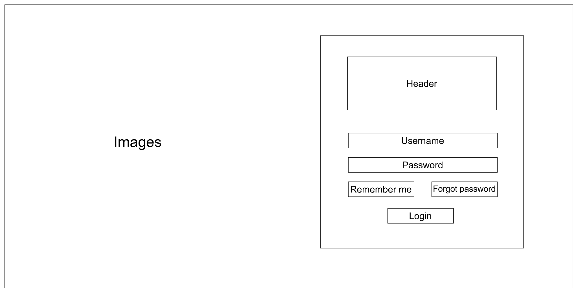
Figure 3.1.1 - Login Screen
# | Field Name | Type | Mandatory | Max Length | Description
1 | Images | Image | No | - | Logo
2 | Header | Container | No | - | Contains the system acronym ("HT"), main title ("Quản lý Nhà Trọ"), and subtitle ("Hệ thống quản lý thông minh").
3 | Username | Input Field | Yes | 50 | User identifier (username) input for system authentication
4 | Password | Password Field | Yes | 50 | User password input, masked by default. Includes a visibility toggle icon (Eye Icon).
5 | Remember me | Checkbox | No | - | Toggles the option to stay logged in and save session info.
6 | Forgot password | Hyperlink | No | - | Navigates the user to the Forgot Password page
7 | Login Button | Button | Yes | - | Primary action button that validates credentials and confirms user login.

3.1.2 Forgot Password Screen
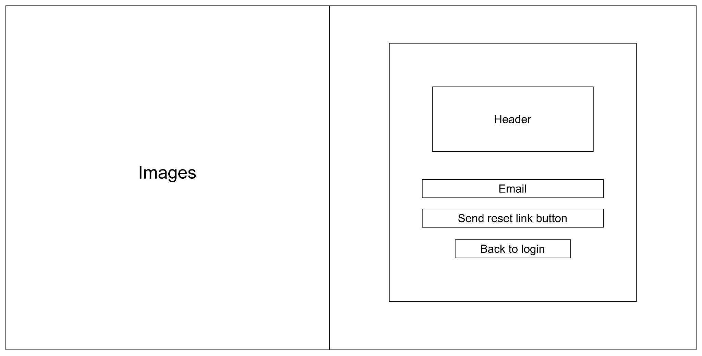
Figure 3.1.2 - Forgot Password Screen
# | Field Name | Type | Mandatory | Max Length | Description
1 | Images | Image | No | - | Logo
2 | Header | Container | No | - | Contains the system acronym ("HT"), main title ("Quên mật khẩu"), and guideline text.
3 | Email | Input Field | Yes | 200 | User's registered email input to receive the password reset link.
4 | Send Reset Link Button | Button | Yes | - | Primary action button that validates email format and triggers sending the reset link.
5 | Back to Login | Hyperlink | No | - | Secondary navigation link that returns the user to the Login page.

3.1.3 First-Time Password Change Screen
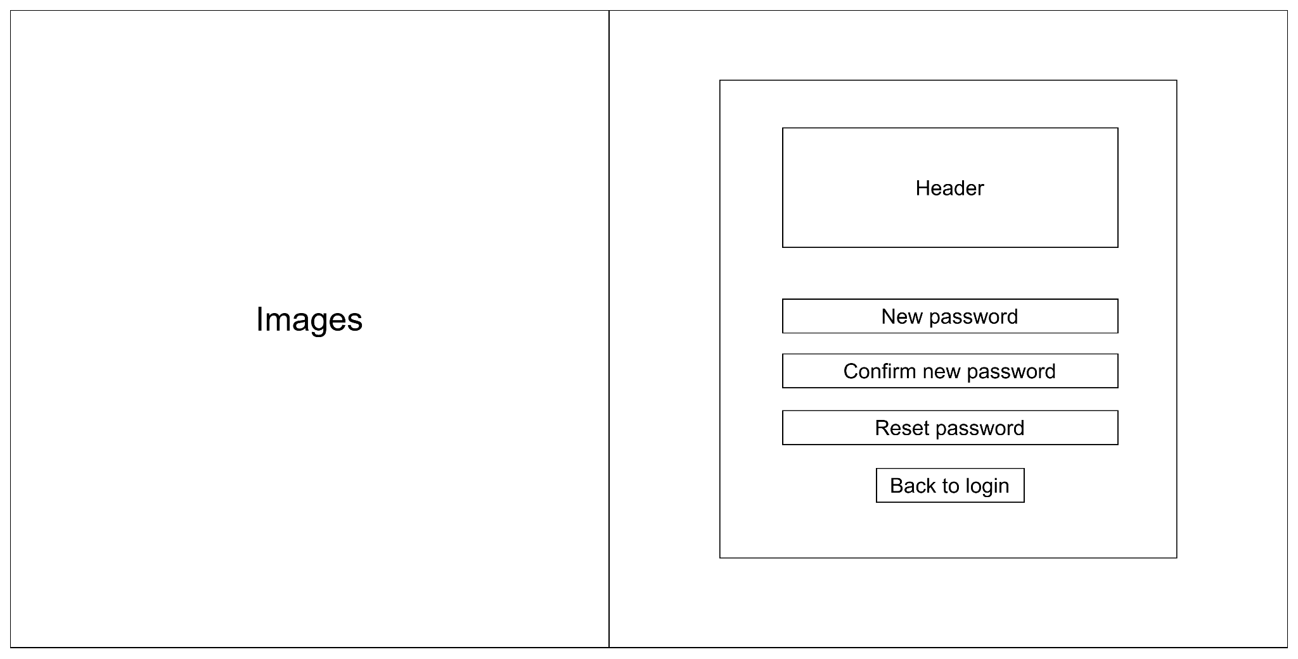
Figure 3.1.3 - First-Time Password Change Screen
# | Field Name | Type | Mandatory | Max Length | Description
1 | Images | Image | No | - | Logo
2 | Header | Container | No | - | Contains the system acronym ("HT"), main title ("Đặt lại mật khẩu"), and guideline text.
3 | New Password | Password Field | Yes | 50 | Input field for the new password. Includes a policy hint text and a visibility toggle icon (Eye Icon).
4 | Send Reset Link Button | Button | Yes | 50 | Input field to re-enter the new password. Must match the "New Password" field exactly.
5 | Reset Password | Button | Yes | - | Primary action button that saves the new password to the database upon successful validation.
6 | Back to Login | Hyperlink | No | - | Secondary navigation link that discards changes and returns to the Login page.

3.1.4 Administrator Dashboard
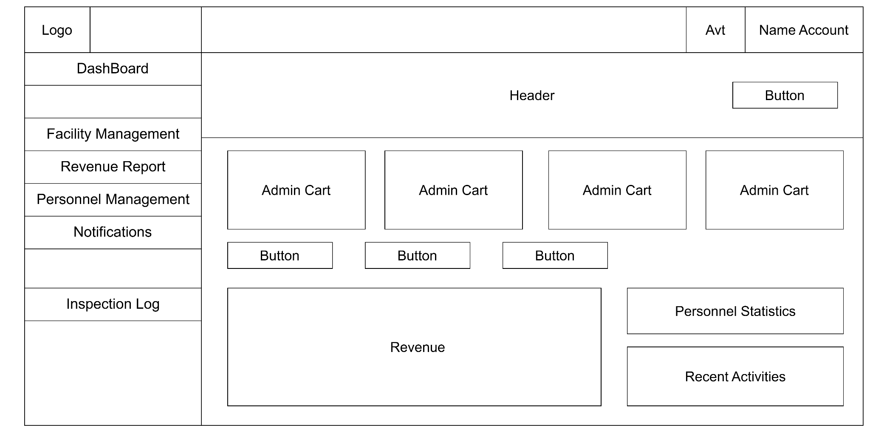
Figure 3.1.4 - Administrator Dashboard
# | Field Name | Type | Mandatory | Max Length | Description
1 | Logo | Image / Icon | Yes | - | The system brand logo displayed in the upper-left corner of the screen.
2 | Dashboard, Facility Management, Revenue Report, Personnel Management, Notifications, Inspection Log | Menu Item | Yes | 50 | Navigation link to the page.
3 | Avatar | Image | No | - | Displays the profile picture (avatar) of the currently logged-in user.
4 | Account Name | Text | Yes | 100 | Displays the name of the currently logged-in administrator in the top-right corner of the navigation bar.
5 | Header | Text | Yes | 200 | Displays the main page heading, including the greeting and current reporting period information.
6 | (Header) Button | Button | Yes | 50 | Primary action button in the header (e.g., Revenue Report).
7 | Admin Card | Widget Block | Yes | - | Displays the Current Month Revenue, Total Facilities, Total Notifications, Today's Activity Logs
8 | Button | Button | Yes | 50 | Quick action button to Add Facility, Add Personnel, Create Notification.
9 | Revenue | Chart / Table | Yes | - | Displays a revenue chart or table showing detailed revenue information for each facility.
10 | Personnel Statistics | Widget Block | Yes | - | Displays summary statistics of personnel categories in the system.
11 | Recent Activities | Widget Block | Yes | - | Displays a list of the most recent activities performed in the system.

3.1.5 Manager Dashboard
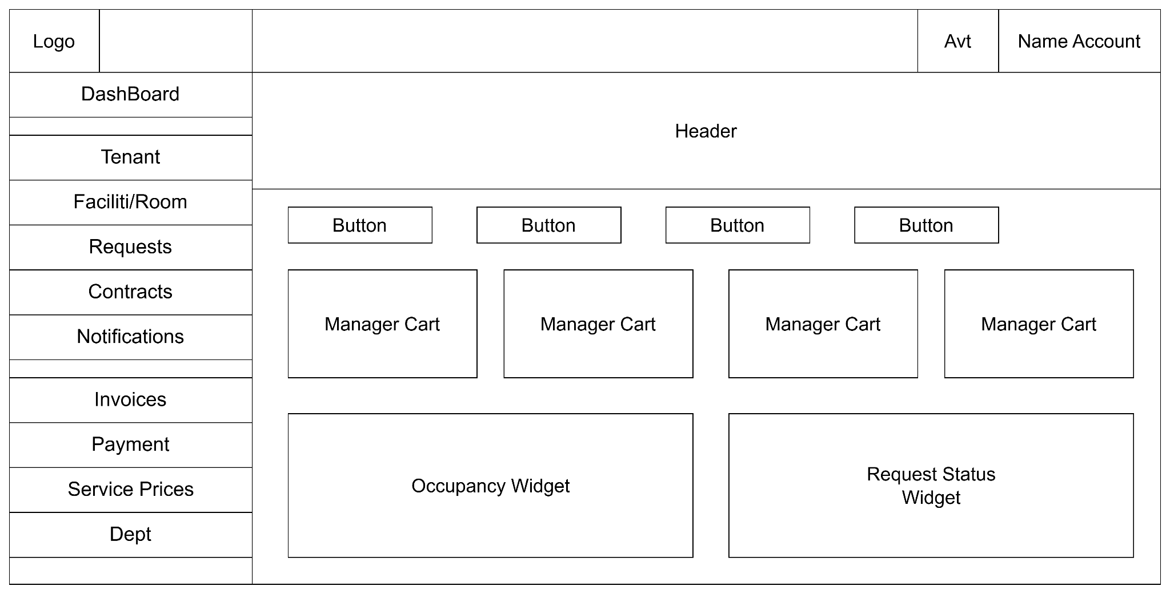
Figure 3.1.5 - Manager Dashboard
# | Field Name | Type | Mandatory | Max Length | Description
1 | Logo | Image / Icon | Yes | - | The system brand logo displayed in the upper-left corner of the screen.
2 | Dashboard, Tenant, Facility / Room, Requests, Contracts, Notifications, Invoices, Payment, Service Prices, Debt | Menu Item | Yes | 50 | Navigation link to the page.
3 | Avatar | Image | No | - | Displays the profile picture (avatar) of the currently logged-in manager.
4 | Account Name | Text | Yes | 100 | Displays the name of the currently logged-in manager in the top navigation bar.
5 | Header | Text | Yes | 200 | Displays the main page heading, including the greeting and current reporting period information.
6 | Button | Button | Yes | 50 | Quick action button to Create Notification, Create New Contract, View Apartment List, View Processing Requests.
7 | Manager Card | Widget Block | Yes | - | Displays room statistics, including Total Rooms, Occupied Rooms, and Vacant Rooms.  Displays tenant statistics, including Tenants and Dependents.  Displays the KPI for the number of Processing Requests.  Displays the KPI for the number of Sent Notifications.
8 | Occupancy Widget | Component | Yes | - | Displays the Occupancy Rate progress bar showing the ratio of occupied and vacant rooms.
9 | Request Status Widget | Component | Yes | - | Displays request statistics grouped by status (New, Processing, Completed, and Rejected).

3.1.6 Operator Dashboard
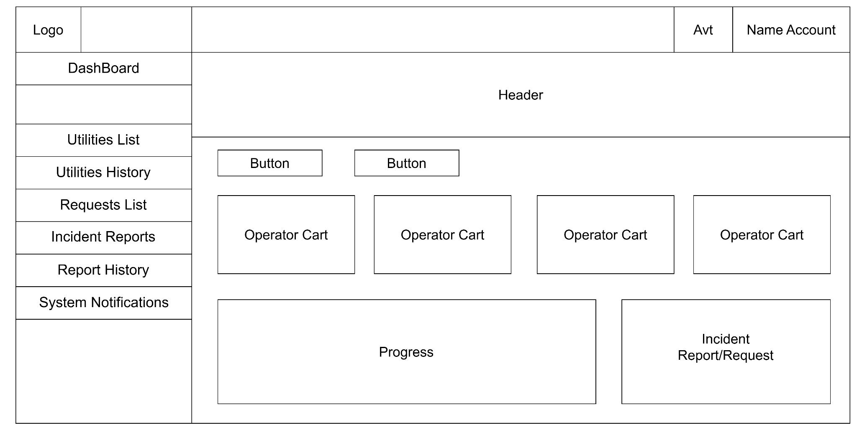
Figure 3.1.6 - Operator Dashboard
# | Field Name | Type | Mandatory | Max Length | Description
1 | Logo | Image / Icon | Yes | - | The system brand logo displayed at the top of the sidebar.
2 | Dashboard, Utilities List, Utilities History, Requests List, Incident Reports, Report History, System Notifications | Menu Item | Yes | 50 | Navigation link to the page.
3 | Avatar | Image | No | - | Displays the profile picture (avatar) of the currently logged-in operator.
4 | Account Name | Text | Yes | 100 | Displays the name of the currently logged-in operator in the top navigation bar.
5 | Header | Text | Yes | 200 | Displays the main page heading, including the greeting and current reporting period information.
6 | Button | Button | Yes | 50 | Quick action button to Create New Incident Report, Update Utility Meter Readings, Assigned Rooms, Updated Utility Meter Readings, Pending Utility Meter Readings, Requests in Progress
7 | Operator Card | Widget Block | Yes | - | Displays the KPI for Assigned Rooms, Updated Utility Meter Readings, Pending Utility Meter Readings, Requests in Progress
8 | Progress | Component | Yes | - | Displays the monthly utility meter update progress along with the Top 5 rooms that have not yet updated their meter readings.
9 | Incident Report / Request | Component | Yes | - | Displays a summary of Requests and Incident Reports grouped by status (New, Processing, and Completed).

3.1.7 Tenant Dashboard
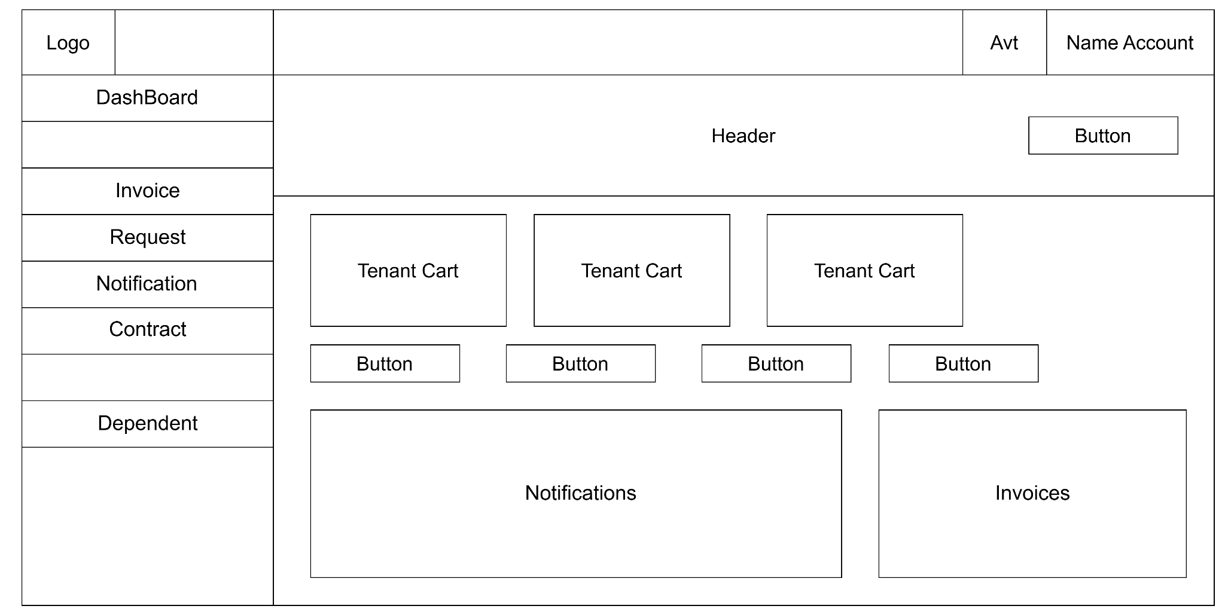
Figure 3.1.7 - Tenant Dashboard
# | Field Name | Type | Mandatory | Max Length | Description
1 | Logo | Image / Icon | Yes | - | The system brand logo displayed in the upper-left corner of the sidebar.
2 | Dashboard, Invoice, Request, Notification, Contract, Dependent | Menu Item | Yes | 50 | Navigation link to the page.
3 | Avatar | Image | No | - | Displays the profile picture (avatar) of the currently logged-in tenant.
4 | Account Name | Text | Yes | 100 | Displays the name of the currently logged-in tenant in the top navigation bar.
5 | Header | Text / Title | Yes | 200 | Displays the page header, including the tenant's greeting (fullName), room code (roomCode), and facility name (facilityName).
6 | (Header) Button | Button | Yes | 50 | Primary action button in the header: Pay Outstanding Invoice or View Invoice, depending on the outstanding balance status.
7 | Tenant Card | Widget Block | Yes | - | Displays the KPI for Unread Notifications, Pending Support Requests, Outstanding Invoice Amount
8 | Button | Button | Yes | 50 | Quick action button to Submit a Support Request, View Notifications, View Invoices, Manage Dependents
9 | Notifications | Component | Yes | - | Displays the monthly utility meter update progress along with the Top 5 rooms that have not yet updated their meter readings.
10 | Invoices | Component | Yes | - | Displays the Current Billing Period Invoice details, together with the VNPAY online payment button and the Room Information section.

3.2 User Authentication
Screen | Tenant | Operator | Manager | Admin
Role-based Dashboard | x | x | x | x
Login | x | x | x | x
Forgot Password | x | x | x | x
Change Password | x | x | x | x
Update Profile | x | x | x | x
View Profile | x | x | x | x
First Login Password Change | x | x | x
Logout | x | x | x | x
Manage Personnel Accounts |  |  |  | x
Manage Tenant Accounts |  |  | x

3.3 System Administration
ID | Name | Description | Input | Output | Business Rules | Priority
FR-3.3.1 | Personnel Management | Allows the Administrator to view personnel accounts, lock/unlock accounts, and reassign user roles. | User ID, Action (Lock/ Unlock, Role Assignment) | - Success confirmation message.  - Locked users cannot log into the system. | - Only Administrators are authorized to perform this function.  - Users must change their password upon their first login. | High
FR-3.3.2 | Facility Management | Allows the Administrator to create, update, activate, or deactivate facilities. | Facility Code, Facility Name, Address, Number of Floors, Number of Rooms | - The facility list is updated successfully.  - Displays an error if the facility name already exists or the input data is invalid. | - Facility Code must be unique.  - A facility cannot be deactivated if it currently has active tenants. | Medium
FR-3.3.3 | Update Room Information | Allows the Administrator to update room information, including room area and rental price. | Room Price, Room Area | - Room information is updated successfully.  - Displays an error if the input data is invalid. | - Room Price and Room Area must be numeric values.  - Only Administrators are authorized to perform this function. | Medium
FR-3.3.4 | View Revenue Report | Allows the Administrator to view the overall system revenue, revenue by facility, and revenue trends over time. This is a read-only function with no data modification. | Revenue Period, Number of Months for Trend Analysis | - Total revenue for the current month.  - Revenue by facility.  - Revenue trend for the last six months. | - Revenue reports are view  - Only and cannot be modified. | Medium
FR-3.3.5 | View Audit Logs | Allows the Administrator to monitor system audit logs, including data changes and profile updates. | Filters: User ID, Date, Action | - Displays the audit log table.  - Audit logs cannot be modified or deleted. | - Audit logs are read-only and cannot be edited or removed. | Medium
FR-3.3.6 | Notification Management | Allows the Administrator to manage system notifications (in-app notifications). | Notification Title, Notification Content | - Notification is successfully saved and distributed throughout the system. | - Sent notifications cannot be edited or deleted. | Low –  Medium

4. Non-Functional Requirements

4.1 External Interfaces
Interface | Direction | Protocol/Data | Auth | Purpose | Timeout/Retry | Degrade/Fallback
VNPAY Gateway | BE/FE → VNPAY | HTTP Redirect | HMAC SHA512 (vnp_HashSecret) | Processes payments for room rent, electricity, and water invoices by generating a payment URL and handling IPN (Return URL). | 15 seconds, retry once | If QR code or payment URL generation fails, the user can proceed with cash payment or manual bank transfer. The invoice status remains PENDING.
Gmail SMTP | BE → SMTP | SMTP over TLS 1.2 (Port 587) | App Password (a2k55ndu@gmail.com) | Sends automated email notifications (temporary password and password reset) through the EmailService. | 10 seconds (connection), 10 seconds (timeout) | Emails are sent asynchronously in a background thread. If sending fails, the error is logged using SLF4J without interrupting the user's primary workflow.
Microsoft SQL Server | BE → Database | TCP/IP (JDBC) | Database Username / Password | Stores core business data (Users, Requests, Invoices, Rooms) using the mssql-jdbc driver. | 15 seconds (login timeout) | If the database connection is lost, the DAO layer catches the exception, returns the generic error message (MSG003), and the system becomes temporarily unavailable.

4.2 Quality Attributes

4.2.1 Usability
- Responsive: Supports all device types (Mobile, Tablet, and Desktop), allowing Tenants and Operators to access the system and perform tasks directly on-site.
- Locale & Format: The default interface language is Vietnamese. Date and time are displayed in the format dd/MM/yyyy HH:mm using the Asia/Ho_Chi_Minh time zone. Currency is displayed in VND.
- UX/UI: The user interface follows the Mintlify design guidelines. Data entry is minimized through the use of select boxes and smart filtering mechanisms.

4.2.2 Performance
- Latency (P95): CRUD APIs/Servlets and list display operations must respond within 600 ms (using server-side pagination with SQL Server).
- Throughput: The system supports approximately 100 concurrent users during peak periods, such as the beginning of each month when utility meter readings are finalized.
- File Upload: The image upload feature (e.g., invoice attachments and incident reports) must complete within 3 seconds under a standard 4G network connection.
- Background Tasks: Email sending (password reset and temporary password delivery) is processed asynchronously using background threads and must complete within 1 second to avoid blocking the user interface.

4.2.3 Reliability & Availability
- Service Availability: The system must achieve 99% uptime during critical business operation periods.
- Data Integrity: The system does not allow utility meter readings to be updated if the invoice for that billing period has already been paid. It also prevents the deletion of rooms that currently have active tenants.
- Atomicity (Transaction Integrity): The VNPAY payment workflow must guarantee idempotency, ensuring that duplicate payments are never recorded even if two IPN (Instant Payment Notification) requests are received.

4.2.4 Security & Privacy
- Role-Based Access Control (RBAC): Implements strict four-level authorization through RoleFilter, including Tenant, Operator, Manager, and Admin.
- Encryption: User passwords must be hashed using the Blowfish algorithm (via the jbcrypt library) before being stored.
- Web Attack Protection:
- All POST and PUT requests are protected by CsrfFilter.
- SQL Injection attacks are completely prevented by using PreparedStatement for 100% of database operations in the DAO layer.
- Rate Limiting: Spam attacks are mitigated using RateLimitManager (e.g., one password reset request every five minutes per user).

4.2.5 Scalability
- Architecture: The Tomcat web server follows a stateless servlet architecture, making it easy to scale vertically by upgrading server hardware.
- Database: Database queries are optimized through appropriate indexes on the requests and invoices tables (e.g., indexes on status and tenant_id).

4.2.6 Maintainability
- Technology Stack: The system uses widely adopted technologies, including Java 17, Jakarta EE 10 (Servlet, JSP, JSTL), and Microsoft SQL Server.
- Source Code Structure: The source code is strictly organized according to the classic MVC architecture (Controller → Service → DAO → Model → View).
- Dependency Management: All project dependencies are centrally managed using Maven (pom.xml).

4.2.7 Compatibility & Portability
- Browsers: Fully compatible with Google Chrome, Microsoft Edge, Mozilla Firefox, and Safari (versions released within the last two years).
- Devices: Operates reliably on both desktop computers and mobile web browsers.
- Deployment: The application is packaged as a .war file and can be flexibly deployed on Apache Tomcat 10 servers running Windows or Linux.

4.2.8 Observability
- Logging: Integrates the SLF4J logging library to record exceptions and email/VNPAY processing activities, facilitating system monitoring and troubleshooting.
- Transaction Tracking: Every transaction received from VNPAY (including Return URL and IPN requests) is stored in the database for reconciliation and dispute resolution.

4.2.9 Compliance & Legal
- Housing Rental Compliance: The system stores invoices and maintenance request histories as supporting records in accordance with Vietnamese regulations governing residential property rental.
- Data Retention: Images attached to utility invoices and incident reports are retained permanently together with the corresponding invoices to support dispute resolution when necessary.

5. Requirement Appendix

5.1 Business Rules
ID | Rule Definition
BR-01 | Reset link expires in 15 minutes.
BR-02 | Passwords must be encrypted/hashed. Max failed attempts policy applies.
BR-03 | Displayed information is read-only and cannot be modified unless the authorized user selects the corresponding Edit function.
BR-04 | Data shown must be strictly filtered by the user's role and permissions.
BR-05 | All session data must be cleared securely from the client side and server side.
BR-06 | Only administrators are permitted to create personnel accounts.
BR-07 | Each staff member is allowed only one account.
BR-08 | Temporary passwords are generated in accordance with the system's security policy.
BR-09 | Accounts are activated immediately upon successful creation.
BR-10 | Only Administrators are allowed to view employee details.
BR-11 | Each Manager or Operator is only assigned to one facility at a time.
BR-12 | The system must not display passwords or any other account security information.
BR-13 | Only the Admin is authorized to edit personnel information.
BR-14 | Email, National ID number, and Phone Number must be unique within the system.
BR-15 | The selected Role must be one of the roles supported by the system.
BR-16 | Only facilities with Active status and without an assigned manager are available for selection.
BR-17 | Only the Admin is authorized to view revenue reports.
BR-18 | Revenue is calculated based on invoices/payments recorded in the system.
BR-19 | The report is read-only and cannot be modified.
BR-20 | The current month's report is displayed by default.
BR-21 | Only the Admin is authorized to create facilities.
BR-22 | Facility Code must be unique and contain only uppercase letters (A–Z).
BR-23 | Facility Name is required.
BR-24 | Address is required.
BR-25 | Maximum Number of Floors must be between 1 and 99.
BR-26 | Maximum Number of Rooms per Floor must be between 1 and 99.
BR-27 | A newly created facility has the default status of Inactive.
BR-28 | When the facility is activated, the system automatically generates rooms based on the configured maximum number of floors and maximum number of rooms per floor.
BR-29 | Only Administrators are allowed to view property details.
BR-30 | The room list only includes rooms belonging to the property currently being viewed.
BR-31 | Each room appears only once in the list.
BR-32 | Room status must accurately reflect the current system data (e.g., Vacant, Occupied, Under Maintenance).
BR-33 | Only Administrators may access audit logs, and audit logs are read-only.
BR-34 | Audit logs can be filtered by the user who performed the action, role, target object, and time range.
BR-35 | Filter results must satisfy all selected criteria simultaneously.
BR-36 | Audit log entries are sorted in descending order by timestamp (newest first).
BR-37 | The notification title and content are required.
BR-38 | The notification title must not exceed 100 characters.
BR-39 | The notification content must not exceed 1,000 characters.
BR-40 | The notification is sent to all residents in the system.
BR-41 | The notification is stored in the system after it is sent successfully.
BR-42 | Only administrators are permitted to view the details of all system notifications.
BR-43 | Only administrators are allowed to access the System Configuration function.
BR-44 | SMTP passwords must not be displayed in plain text but must be masked.
BR-45 | The Hash Secret must not be displayed as plain text but must be masked.
BR-46 | Only Management is authorized to approve or reject payment transactions.
BR-47 | Only payments with Pending status can be approved or rejected.
BR-48 | When a payment is approved, its status is updated to Paid and the corresponding invoice is marked as settled.
BR-49 | When a payment is rejected, management must provide a rejection reason.
BR-50 | The system must notify the tenant after the payment is approved or rejected.
BR-51 | All payment verification actions must be recorded in the audit log.
BR-52 | The Manager is only permitted to access, view, and manipulate data (Rooms, Tenants, Contracts, Requests, Notifications) belonging to the facilities assigned by the Admin. Any out-of-scope access request is denied by the system.
BR-53 | The Manager has read-only access to room lists and room details. They cannot create, edit, or delete rooms.
BR-54 | When creating a new contract, the user is not allowed to select a room that currently has an ACTIVE contract.
BR-55 | The contract code is automatically generated by the system using a standard format. Manual entry or editing is not permitted.
BR-56 | The End Date of a contract must be greater than or equal to the Signed Date. If the Start Date is not provided, the system defaults it to the Signed Date.
BR-57 | Required fields for creating a contract are: Tenant Full Name, ID Card/Passport Number, Valid Room, Signed Date, and End Date.
BR-58 | Support requests (Tickets) must follow a strict linear state flow: NEW → RECEIVED → IN_PROGRESS → RESOLVED.
BR-59 | When rejecting a support request, the Manager must provide a reason. Requests that are in the REJECTED or RESOLVED states cannot be received again.
BR-60 | The Manager is only permitted to view and process support requests that are explicitly directed to the "Manager" role by the tenant. Requests directed to an "Operator" are excluded from the Manager's view.
BR-61 | The target audience for a notification must be restricted to either the Facility level or a specific Room level. The Manager is not permitted to send notifications to all tenants across the entire system. Additionally, notifications can only be directed to occupied rooms
BR-62 | Only tenants with an ACTIVE status can receive notifications. The notification content must not exceed 1,000 characters.
BR-63 | Only authorized Management users can view invoice information, and all invoice details are read-only.
BR-64 | Management must confirm before deleting an invoice.
BR-65 | Deleted invoices are removed from the invoice list and recorded in the audit log.
BR-66 | The exported PDF must contain the complete invoice information shown on the detail page.
BR-67 | Reporting an issue automatically links the report to the selected invoice and assigns it to the Operator for handling.
BR-68 | A debt is created only when an invoice remains unpaid after its due date.
BR-69 | The system automatically calculates the number of overdue days based on the current date and the invoice due date.
BR-70 | The system automatically calculates the overdue penalty according to the configured penalty policy.
BR-71 | Each debt record must be linked to exactly one invoice.
BR-72 | Management can only view debt information and cannot modify debt records from this use case.
BR-73 | Selecting View Invoice shall open the corresponding invoice details.
BR-74 | Each room can have only one invoice for the same billing period.
BR-75 | Room, billing period, and payment due date are mandatory fields.
BR-76 | Tax and additional fees are optional and are included in the total invoice amount if provided.
BR-77 | The system automatically calculates the total invoice amount.
BR-78 | Newly created invoices are assigned the Pending status.
BR-79 | Every invoice creation action must be recorded in the audit log.
BR-80 | Only invoices with Pending status can be updated.
BR-81 | Only the following fields are editable: Payment due date Tax Additional fees Notes
BR-82 | Room, tenant, billing period, and invoice amount generated from the billing period cannot be modified.
BR-83 | If tax or additional fees are updated, the system must automatically recalculate the total invoice amount.
BR-84 | Every invoice update must be recorded in the audit log.
BR-85 | Only authorized Management users can view invoice information, and all invoice details are read-only.
BR-86 | Every service price update must be recorded in the history, including: old price new price effective date update reason updated by update time
BR-87 | Any modification of service prices must be performed through UC: Update Service Price only.
BR-88 | Only authorized Management users can update service prices.
BR-89 | The new unit price must be greater than zero.
BR-90 | An update reason is mandatory for every price change.
BR-91 | The updated service price is applied only to invoices created after the update and does not affect existing invoices.
BR-92 | Users with the Manager role can only perform write operations (create, edit, delete articles/posts) when their assigned Facility status is ACTIVE. Write requests are blocked if the facility status is INACTIVE.
BR-93 | Every community post must have a non-empty Title and Content.
BR-94 | The title of a community post must not exceed 250 characters.
BR-95 | Attached images are optional. If provided, they must be in .jpg, .jpeg, or .png format, and the file size must not exceed 5 Megabytes (5 MB).
BR-96 | All new community posts default to PENDING status. If created by a Manager, the reviewer field (reviewed_by) is automatically set to the Manager's own user ID.
BR-97 | Only Managers are authorized to approve posts in PENDING status. Upon approval, the status changes to APPROVED, recording the reviewer's ID (reviewed_by) and update timestamp (updated_at).
BR-98 | When a post is deleted by a Manager or authorized actor, the system assigns a timestamp to deleted_at (soft delete) instead of permanent physical deletion. Soft-deleted posts are excluded from normal queries.
BR-99 | Managers can only view details of community posts that exist in the system (deleted_at IS NULL) and belong to their managed facility scope or assigned review queue.
BR-100 | The News Feed displays only non-deleted (deleted_at is NULL), APPROVED posts published within the last 24 hours. The list is sorted in chronological descending order (newest first).
BR-101 | The top interactive posts list displays up to 5 posts with the highest combined interactions (total likes + non-deleted comments count) approved within the last 24 hours.
BR-102 | The like reaction uses a toggle mechanism. A user can only like a post once. Re-submitting the like removes the reaction.
BR-103 | Comments on community posts must contain non-empty text content.
BR-104 | A single comment must not exceed 1000 characters.
BR-105 | The tenant may ONLY view dependents whose tenant_id matches their own account.
BR-106 | The system must never display dependent records that have been soft deleted.
BR-107 | The Citizen ID/Identity Card number must be partially masked before being displayed to the tenant (e.g., 0790******123) to comply with personal data protection regulations.
BR-108 | Within the scope of this function, the tenant is not allowed to create, edit, delete, or submit approval requests for dependent information. All functionality is read-only.
BR-109 | The tenant may only view and pay invoices that belong to the room they are renting.
BR-110 | The system does not allow payment for invoices that are already in the "Processing" or "Paid" status.
BR-111 | Before updating an invoice to the PAID status, the system must verify that the vnp_SecureHash signature is valid and that the received payment amount matches the total invoice amount.
BR-112 | Updating the status in the invoices table and inserting a payment history record into the payments table must be executed within the same database transaction. If any error occurs, the entire transaction must be rolled back.
BR-113 | The system must implement an Idempotency mechanism when processing VNPAY IPN (Instant Payment Notification) requests to ensure that duplicate transactions are not processed if the IPN is received multiple times.
BR-114 | The tenant may ONLY view personal notifications addressed specifically to them or public notifications intended for all residents of the hostel.
BR-115 | The notification list must be sorted in chronological order from the newest to the oldest.
BR-116 | The tenant is not allowed to create, edit, recall, or delete any notifications in the system.
BR-117 | A tenant may only view their own contracts.
BR-118 | A tenant must not be allowed to view contracts belonging to other tenants.
BR-119 | A tenant is not permitted to create, edit, delete, or change the status of any contract.
BR-120 | The contract information displayed must exactly match the data created and confirmed by the Management Board.
BR-121 | The entire user interface and all contract data must be displayed in read-only mode.
BR-122 | Every newly created request must be associated with the ID of the currently logged-in tenant.
BR-123 | The default status of every newly created request must always be "Pending".
BR-124 | Title and Content are mandatory fields. The Category must be selected from the predefined list configured by the Management Board.
BR-125 | Attached images (if any) are only allowed in JPG, JPEG, or PNG formats, and the maximum file size must not exceed 5 MB.
BR-126 | The tenant may ONLY view requests that they have created. The system must strictly prevent access to requests created by other tenants.
BR-127 | On the request list screen, requests must be sorted by submission time from the newest to the oldest by default.
BR-128 | The tenant is only allowed to view the request status and is not permitted to change the status of any request.
BR-129 | When a Tenant creates a new post, the post defaults to PENDING status, and the system automatically assigns the reviewed_by field to the ID of the Manager overseeing the Tenant's facility.
BR-130 | Tenants are eligible to create community posts only if they hold an active room tenancy contract in a facility currently in ACTIVE status.
BR-131 | Tenants are authorized to view details of community posts that are in APPROVED status or posts authored by themselves (in any status: PENDING, APPROVED, REJECTED) that have not been soft-deleted (deleted_at IS NULL).
BR-132 | Tenants are only permitted to soft-delete posts authored by themselves that have NOT yet been approved (status != 'APPROVED'). Approved posts cannot be deleted by tenants.
BR-133 | Only active rooms are displayed.
BR-134 | Cannot modify a meter reading if the corresponding invoice has already been paid.
BR-135 | Operators can only view requests assigned to them or within their scope.
BR-136 | Image proof is strictly mandatory to ensure transparency and prevent fraud.
BR-137 | Emergency incidents should immediately notify the Manager. Photo evidence is highly recommended/mandatory.
BR-138 | Operator notifications are strictly system-oriented and managerial task assignments.

5.2 System Messages

# | Message code | Message Type | Context | Content
1 | MSG001 | In line | Forgot password confirmation | Reset link sent if email exists
2 | MSG002 | Toast message | Email service unavailable | Unable to send email, please try again later
3 | MSG003 | In line | Incorrect credentials on sign-in | Invalid email or password
4 | MSG004 | Toast message | Account locked or inactive | Account is locked or inactive, please contact support
5 | MSG005 | Banner | Network error | Network error
6 | MSG006 | Toast message | System error | System error, please try again later
7 | MSG007 | Toast message | Data retrieval error | Unable to load profile data
8 | MSG008 | In line | Personnel not assigned to facility | Not assigned to a facility
9 | MSG009 | In red, under text box | Facility code already exists | Facility code already exists
10 | MSG010 | In line | No rooms available in facility | No rooms are available in the facility
11 | MSG011 | In line | No notification content | No notification content
12 | MSG012 | Toast message | Payment approval success | Payment approved successfully
13 | MSG013 | Toast message | Payment rejection | Payment rejected: {reason}
14 | MSG014 | Dialog | No payment records found | No payment records found
15 | MSG015 | Banner | No invoices found | No invoices found
16 | MSG016 | Toast message | PDF generation failure | Unable to generate PDF. Please try again later
17 | MSG017 | Toast message | No overdue debts found | No overdue debts found
18 | MSG018 | Toast message | Invoice unavailable | Invoice not available
19 | MSG019 | Toast message | Invoice creation success | Invoice created successfully
20 | MSG020 | Toast message | Required fields missing | Please complete all required fields
21 | MSG021 | Toast message | Invoice already exists in period | Invoice already exists for this billing period
22 | MSG022 | Toast message | Invoice update success | Invoice updated successfully
23 | MSG023 | Toast message | Paid invoice update blocked | Paid invoices cannot be modified
24 | MSG024 | Toast message | No service prices found | No service prices found
25 | MSG025 | Toast message | No update history available | No update history available
26 | MSG026 | Toast message | Service price update success | Service price updated successfully
27 | MSG027 | Toast message | Invalid service price | Invalid service price
28 | MSG028 | Toast message | Update reason required | Update reason is required
29 | MSG029 | In line | No registered dependents | There are currently no registered dependents
30 | MSG030 | In line | No rental contracts | You do not have any rental contracts
31 | MSG031 | Toast message | Request creation success | Request created successfully
32 | MSG032 | In line | No support requests | You do not have any support requests
33 | MSG033 | In red, under text box | Update meter reading success | Meter reading updated successfully
34 | MSG034 | In red, under text box | New reading lower than previous | New reading cannot be lower than the previous reading
35 | MSG035 | In red, under text box | Missing meter image | Meter image is required
36 | MSG036 | In line | No matching requests found | No requests found matching criteria
37 | MSG037 | In red, under text box | Request not found or access denied | Request not found or access denied
38 | MSG038 | Toast message | Incident reporting success | Incident reported successfully
39 | MSG039 | Toast message | File size exceeds limit or invalid format | File size exceeds limit or invalid format
40 | MSG040 | Toast message | Notification task unavailable | The task associated with this notification is no longer available
41 | MSG041 | Banner / Toast | Permission denied / Unauthorized access (HTTP 403) | You do not have permission to access this resource.

